Supplementary Material

# Methods

## mBAT-combo analysis

SNPs with effective sample sizes < 0.8 or with duplicate IDs were removed from the meta-analysed summary statistics. Default values for mBAT-combo were used as follows: the minimum proportion of the total variance in the LD matrix explained by the top principal components used in the mBAT test was 0.9 (–mBAT-svd-gamma 0.9), a gene region was defined as spanning 50 kb upstream and downstream of the gene’s untranslated region (–mBAT-wind 50), SNPs with allele frequency difference between GWAS summary and LD reference data > 0.2 were removed (–diff-freq 0.2) and the threshold for LD r-squared value for LD pruning was 0.9 (–fastBAT-ld-cutoff 0.9).

# Results

## GWAS meta-analysis

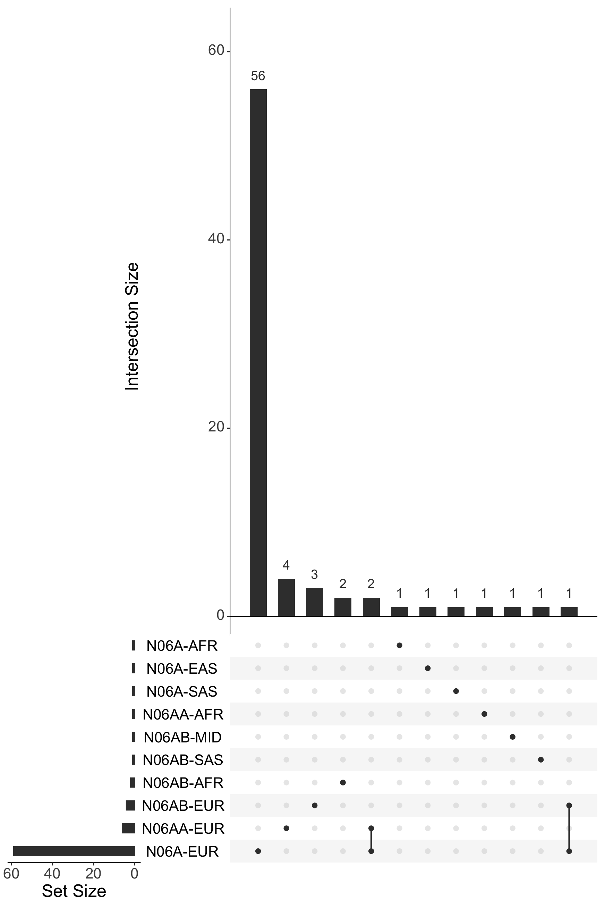

**Supplementary Figure 1. Number of idependent genome wide significant SNPs in each fixed meta-analysis.** Plot shows overlap in significant SNPs between antidepressant phenotype and ancestries. Genome wide significance is defined as p-value < 5e-8.

### Multi-ancestry meta-analysis principal components

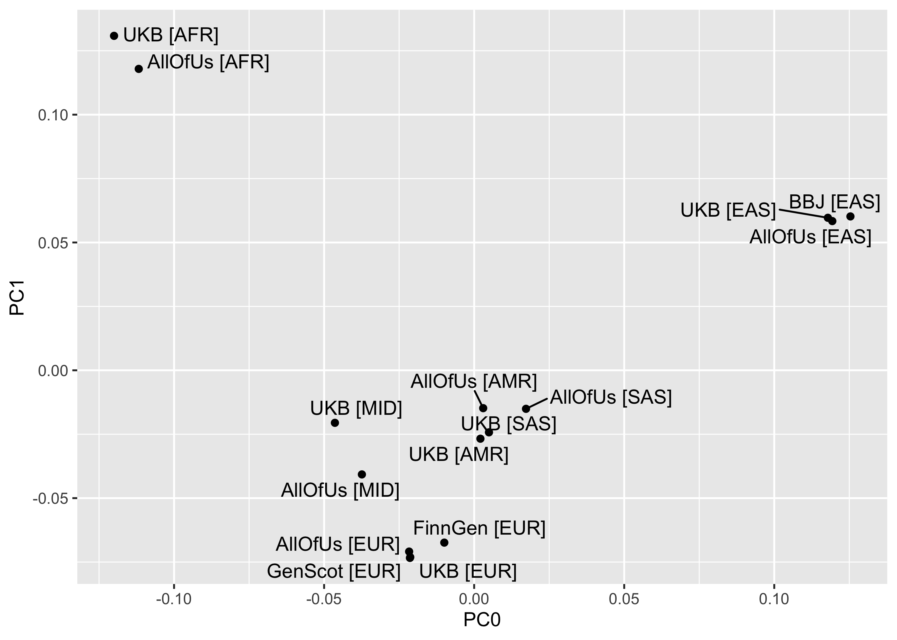

**Supplementary Figure 2. PCA plot of ancestries in MR-MEGA meta-analysis N06A.** Plot shows the first two principal components of the ancestry of the samples in the MR-MEGA meta-analysis for the antidepressant phenotype N06A.

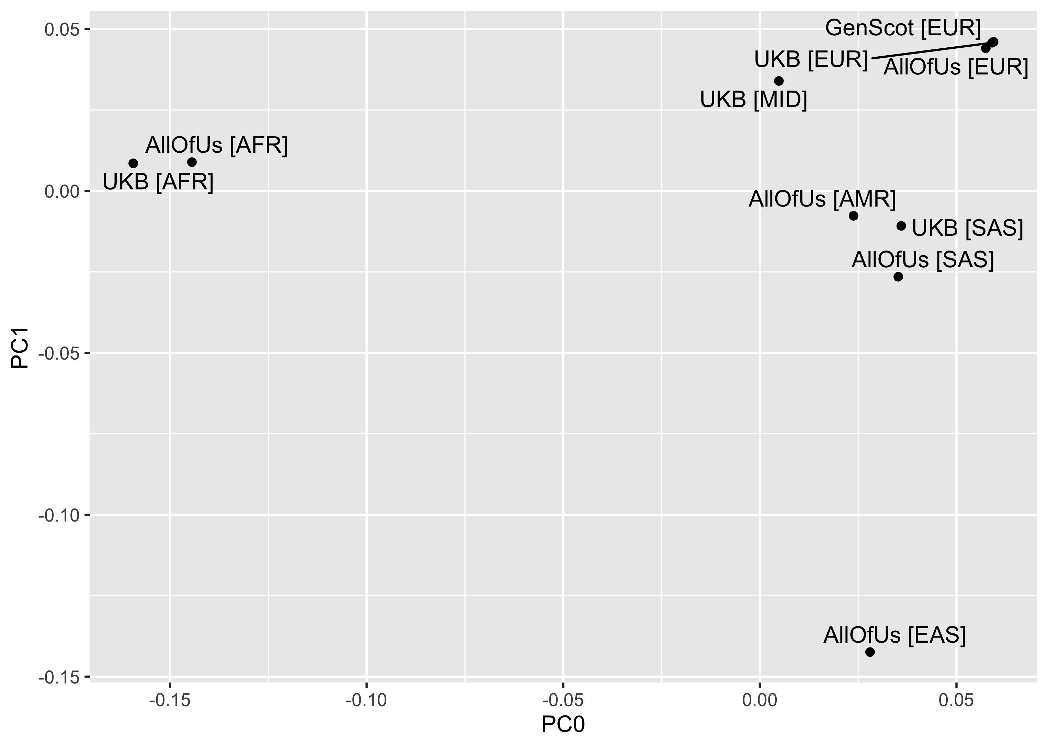

**Supplementary Figure 3. PCA plot of ancestries in MR-MEGA meta-analysis N06AA.** Plot shows the first two principal components of the ancestry of the samples in the MR-MEGA meta-analysis for the antidepressant phenotype N06AA.

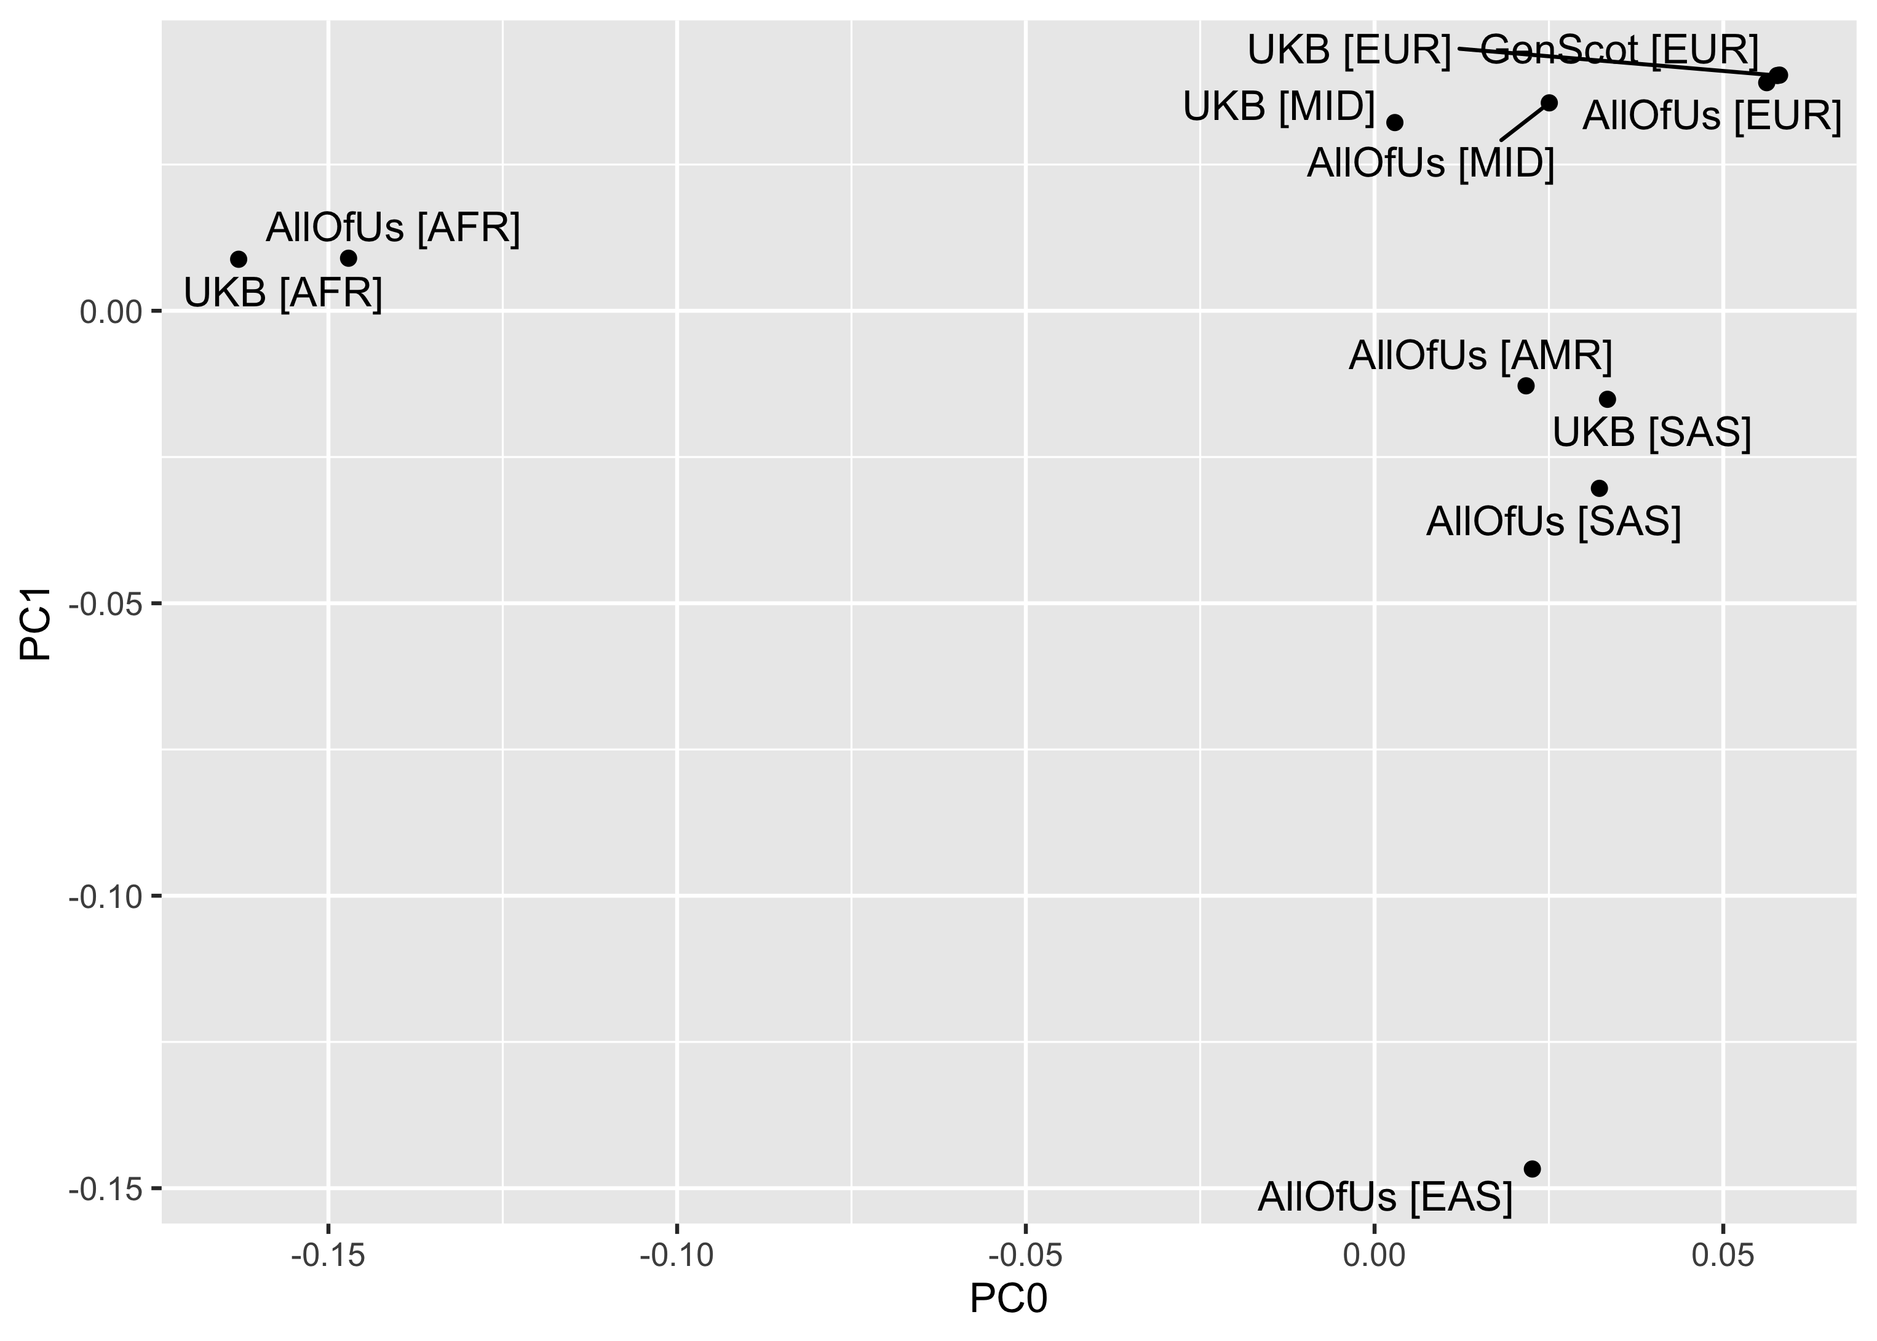

**Supplementary Figure 4. PCA plot of ancestries in MR-MEGA meta-analysis N06AB.** Plot shows the first two principal components of the ancestry of the samples in the MR-MEGA meta-analysis for the antidepressant phenotype N06AB.

### N06A fixed-effects meta-analyses

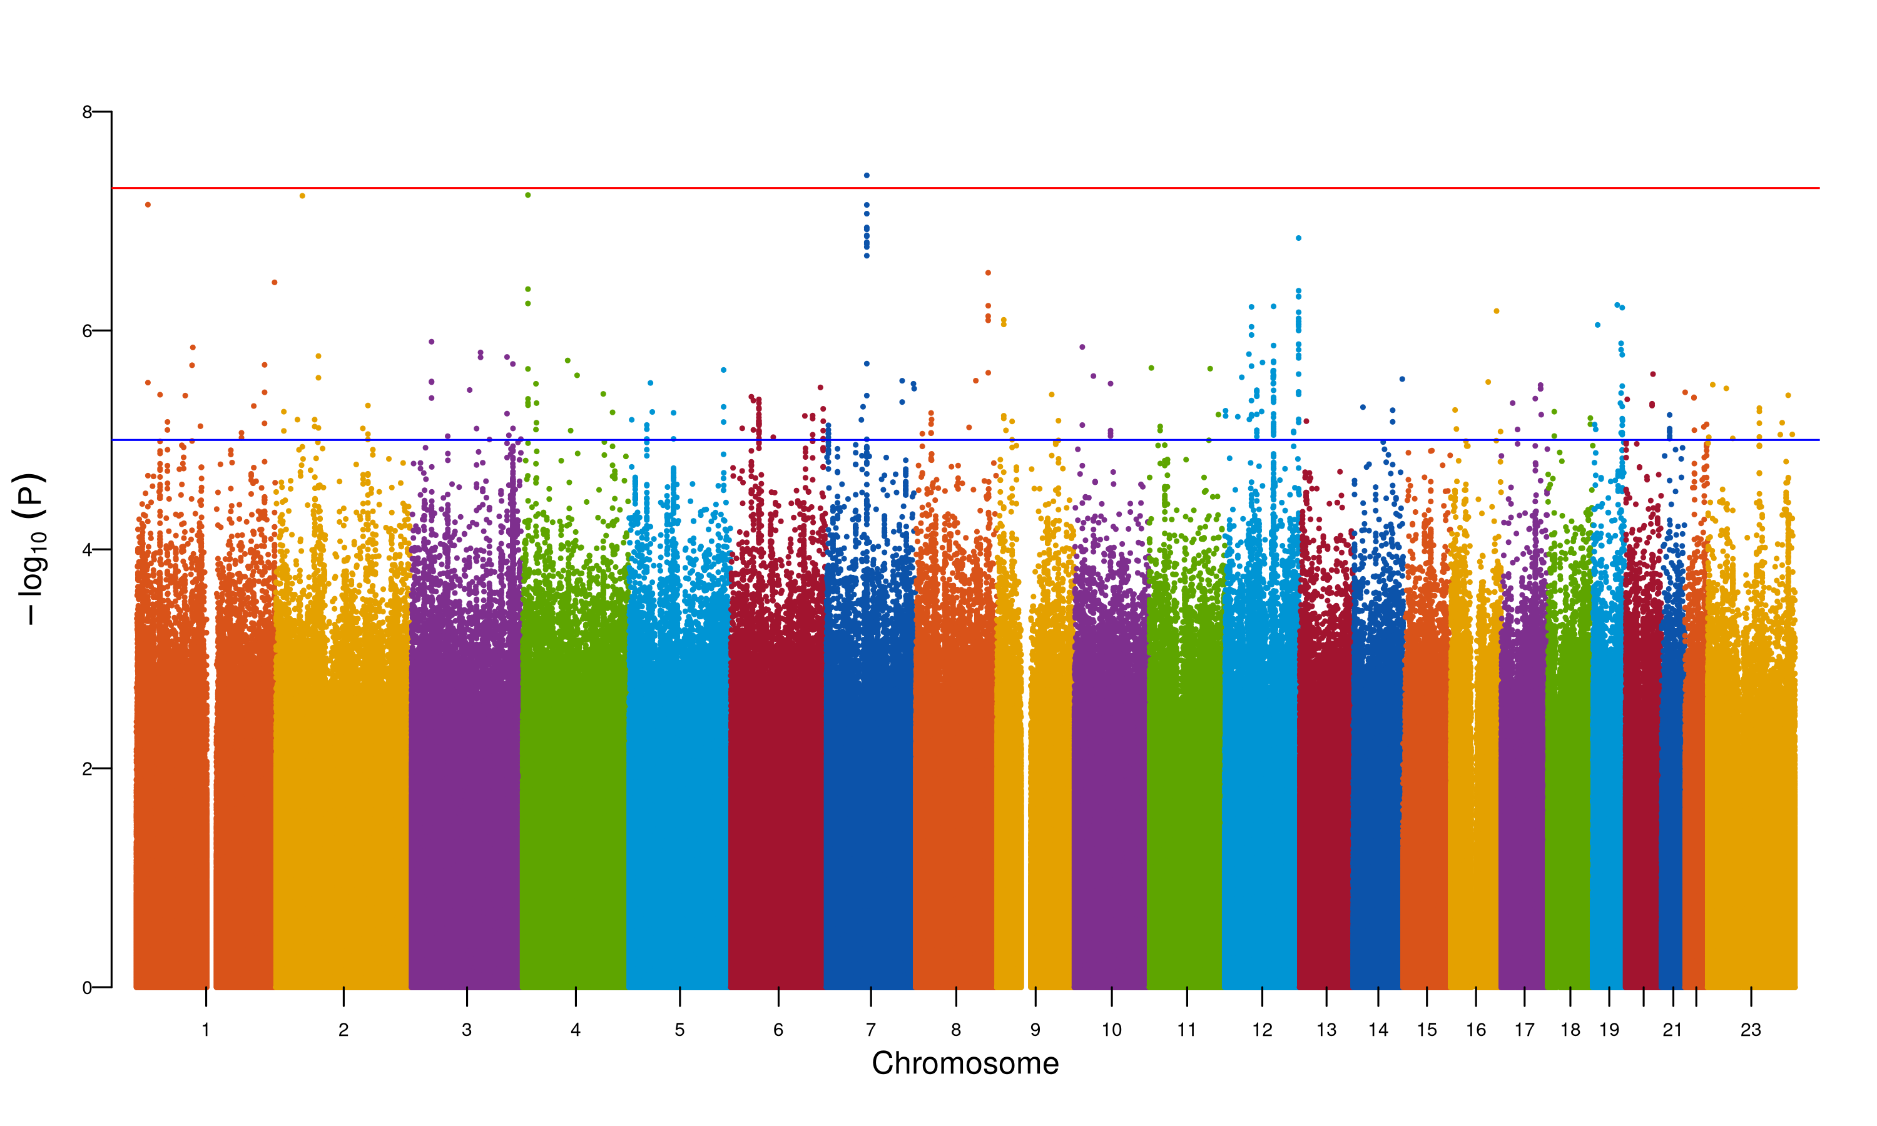

**Supplementary Figure 5. Manhattan plot for fixed meta-analysis for N06A ancestry AFR.** The Manhattan plot shows the association of SNPs with the antidepressant phenotype N06A. The x-axis represents the chromosomal position of the SNP, and the y-axis represents the -log10(p-value) of the association. The red line represents the genome-wide significance threshold (p-value = 5e-8). The blue line represents the suggestive significance threshold (p-value = 1e-5).

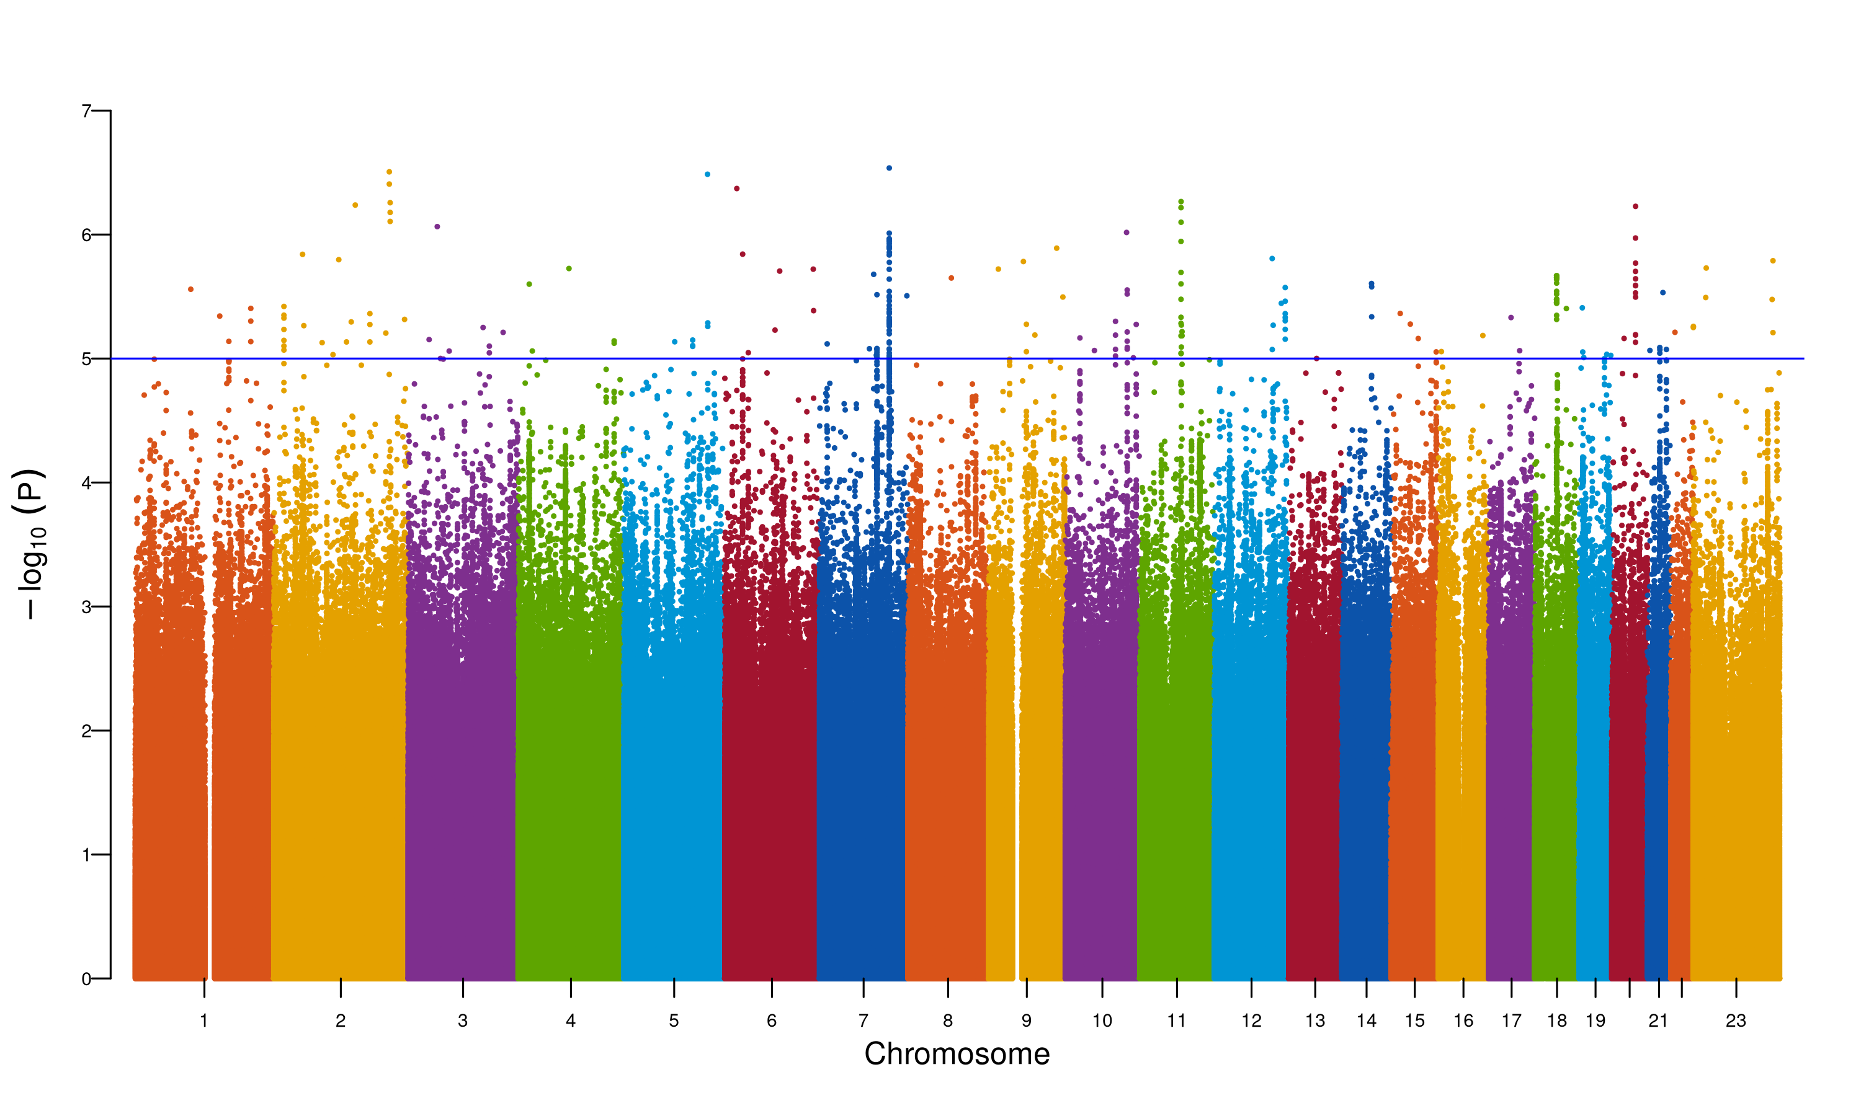

**Supplementary Figure 6. Manhattan plot for fixed meta-analysis for N06A ancestry AMR.** The Manhattan plot shows the association of SNPs with the antidepressant phenotype N06A. The x-axis represents the chromosomal position of the SNP, and the y-axis represents the -log10(p-value) of the association. The red line represents the genome-wide significance threshold (p-value = 5e-8). The blue line represents the suggestive significance threshold (p-value = 1e-5).

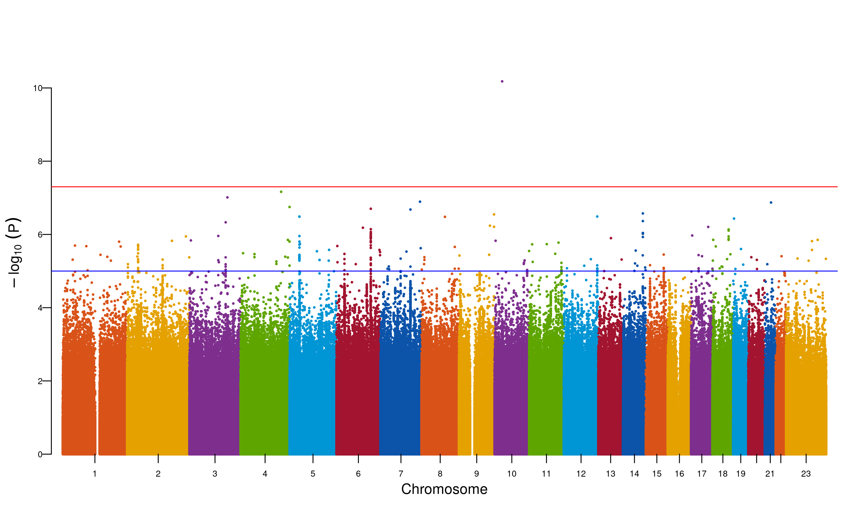

**Supplementary Figure 7. Manhattan plot for fixed meta-analysis for N06A ancestry EAS.** The Manhattan plot shows the association of SNPs with the antidepressant phenotype N06A. The x-axis represents the chromosomal position of the SNP, and the y-axis represents the -log10(p-value) of the association. The red line represents the genome-wide significance threshold (p-value = 5e-8). The blue line represents the suggestive significance threshold (p-value = 1e-5).

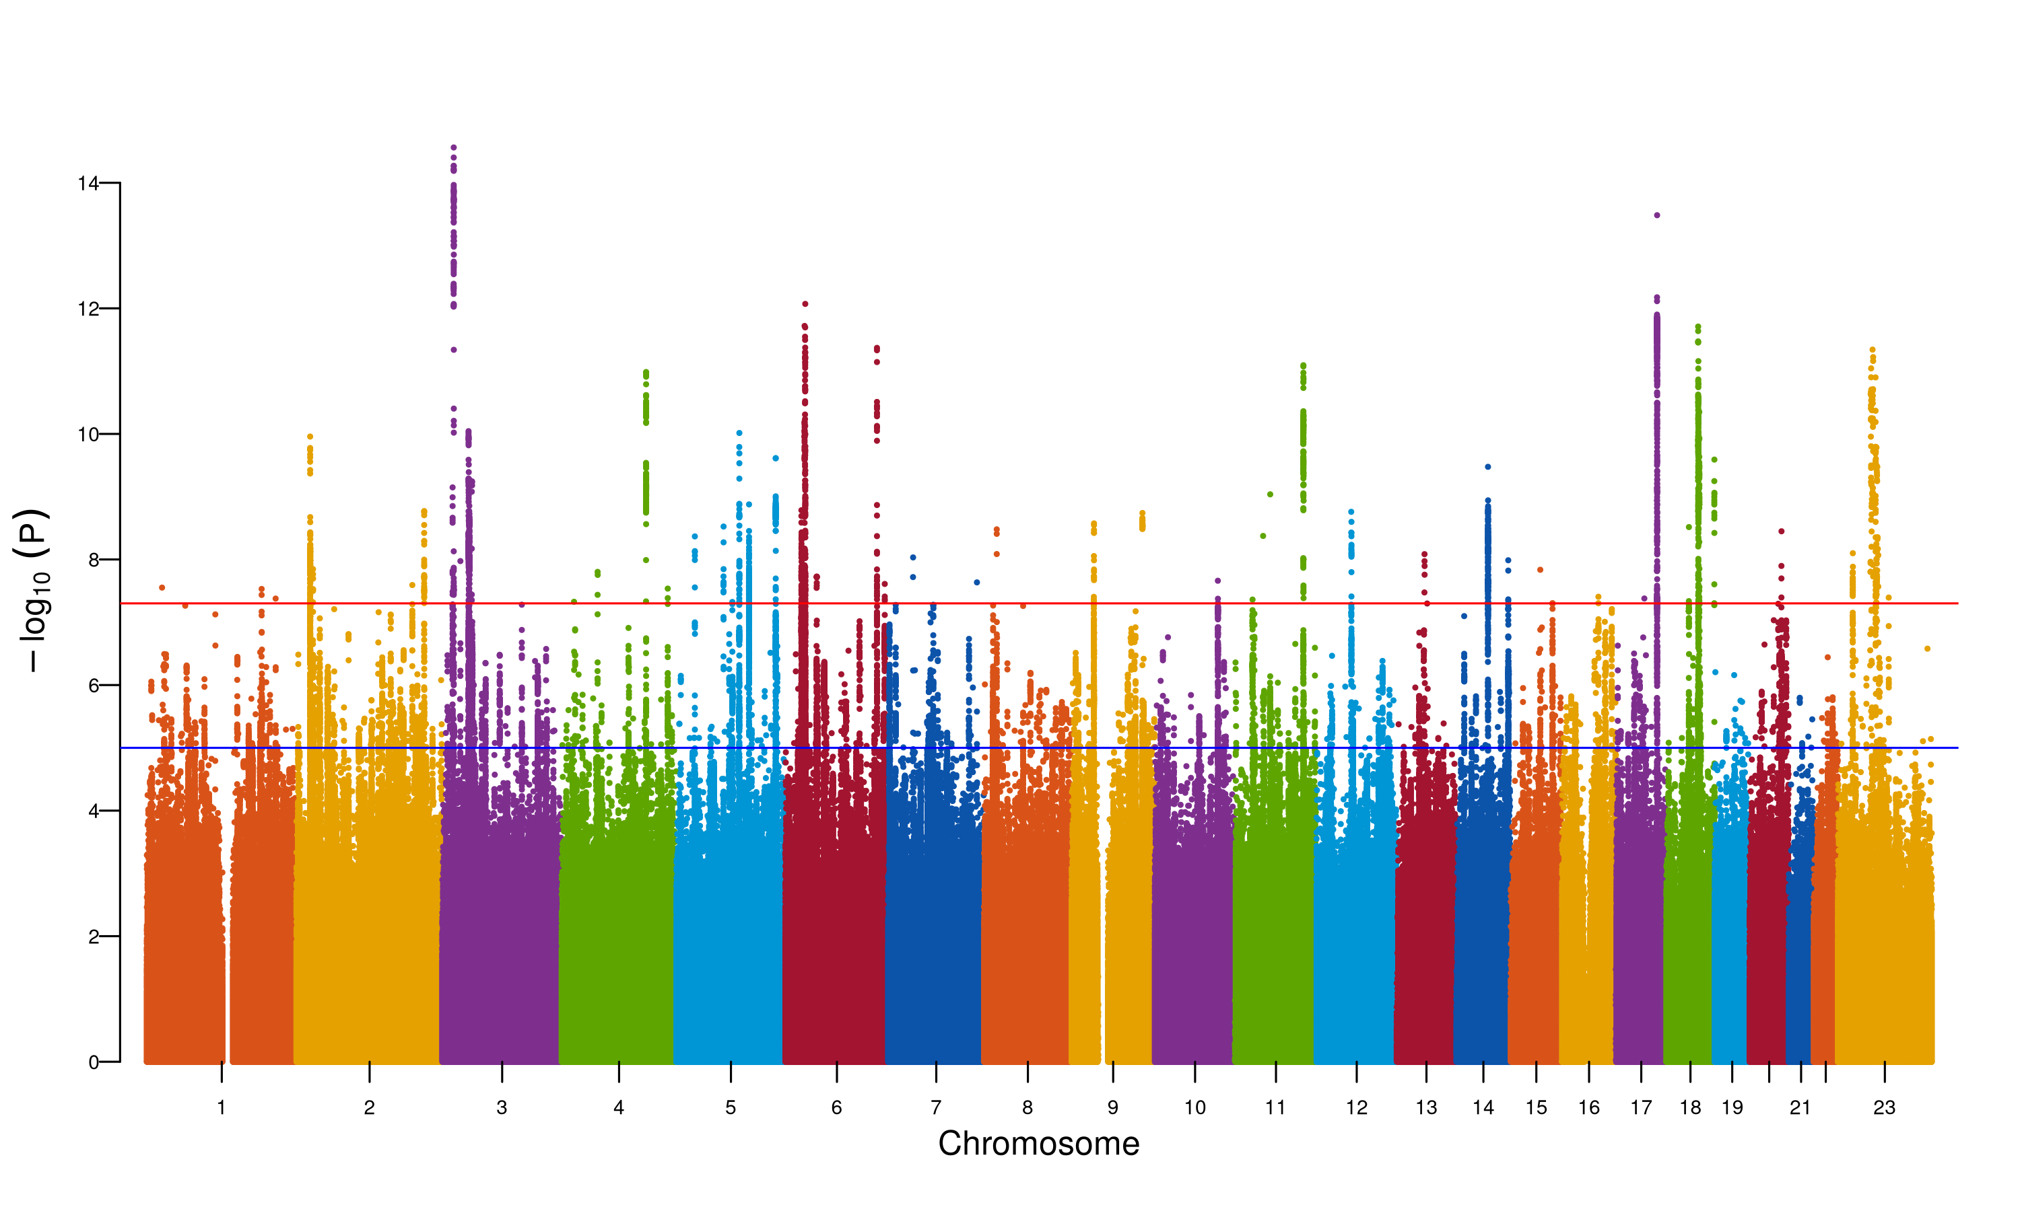

**Supplementary Figure 8. Manhattan plot for fixed meta-analysis for N06A ancestry EUR.** The Manhattan plot shows the association of SNPs with the antidepressant phenotype N06A. The x-axis represents the chromosomal position of the SNP, and the y-axis represents the -log10(p-value) of the association. The red line represents the genome-wide significance threshold (p-value = 5e-8). The blue line represents the suggestive significance threshold (p-value = 1e-5).

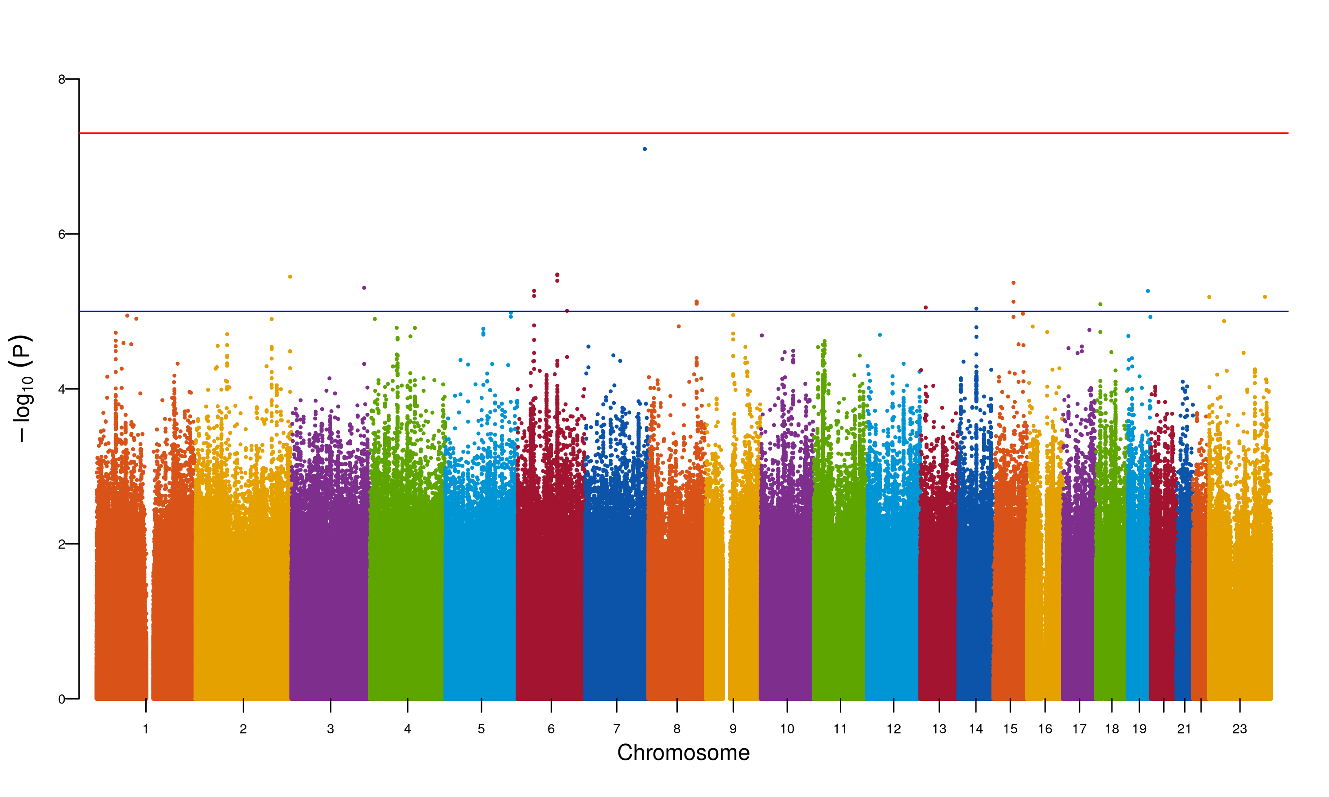

**Supplementary Figure 9. Manhattan plot for fixed meta-analysis for N06A ancestry MID.** The Manhattan plot shows the association of SNPs with the antidepressant phenotype N06A. The x-axis represents the chromosomal position of the SNP, and the y-axis represents the -log10(p-value) of the association. The red line represents the genome-wide significance threshold (p-value = 5e-8). The blue line represents the suggestive significance threshold (p-value = 1e-5).

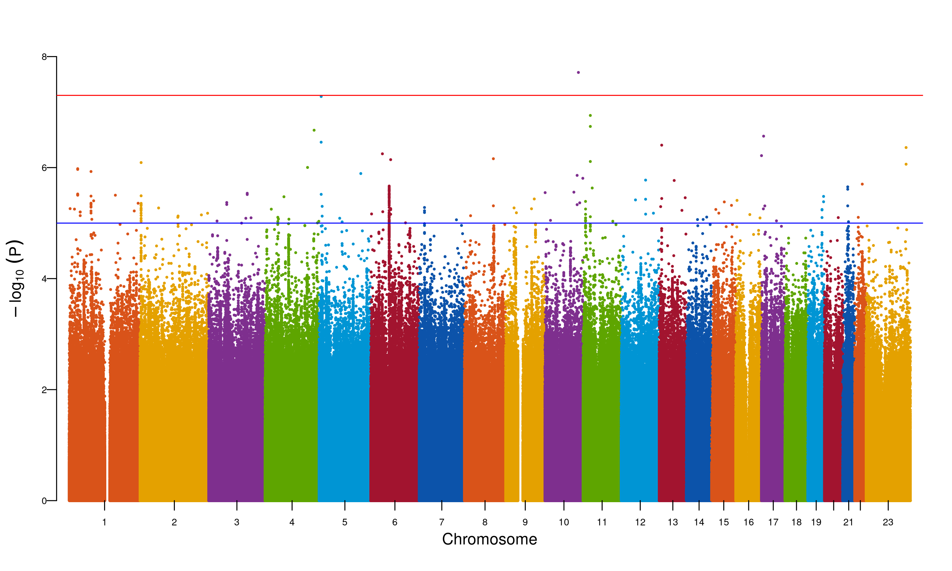

**Supplementary Figure 10. Manhattan plot for fixed meta-analysis for N06A ancestry SAS.** The Manhattan plot shows the association of SNPs with the antidepressant phenotype N06A. The x-axis represents the chromosomal position of the SNP, and the y-axis represents the -log10(p-value) of the association. The red line represents the genome-wide significance threshold (p-value = 5e-8). The blue line represents the suggestive significance threshold (p-value = 1e-5).

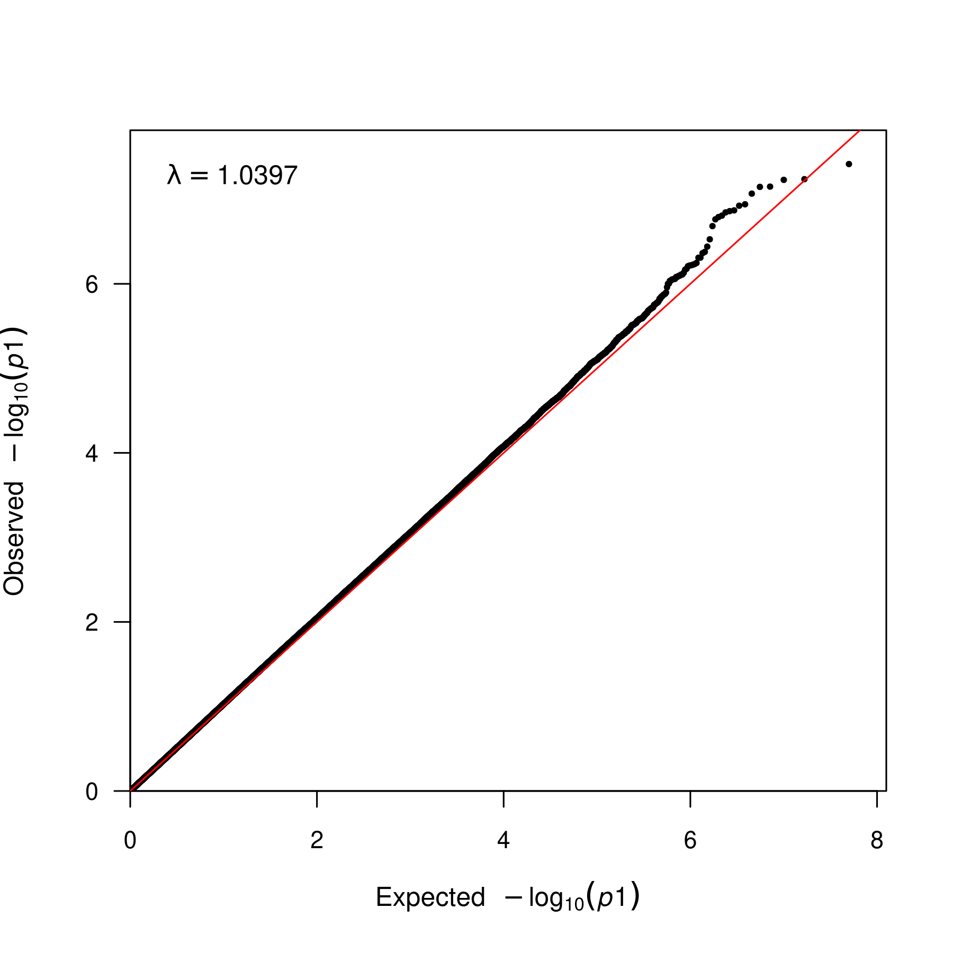

**Supplementary Figure 11. QQ plot for fixed meta-analysis for N06A ancestry AFR.** QQ plot for the association of SNPs with the antidepressant phenotype N06A. The x-axis represents the expected -log10(p-value) of the association, and the y-axis represents the observed -log10(p-value) of the association. The lambda statistic (a measure of inflated p-values) is also reported on the plot.

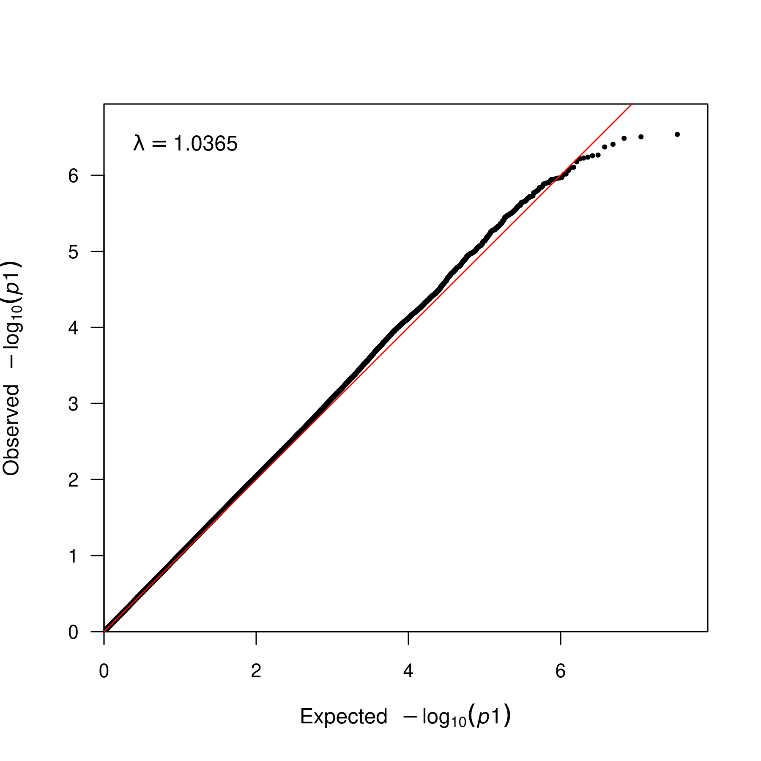

**Supplementary Figure 12. QQ plot for fixed meta-analysis for N06A ancestry AMR.** QQ plot for the association of SNPs with the antidepressant phenotype N06A. The x-axis represents the expected -log10(p-value) of the association, and the y-axis represents the observed -log10(p-value) of the association. The lambda statistic (a measure of inflated p-values) is also reported on the plot.

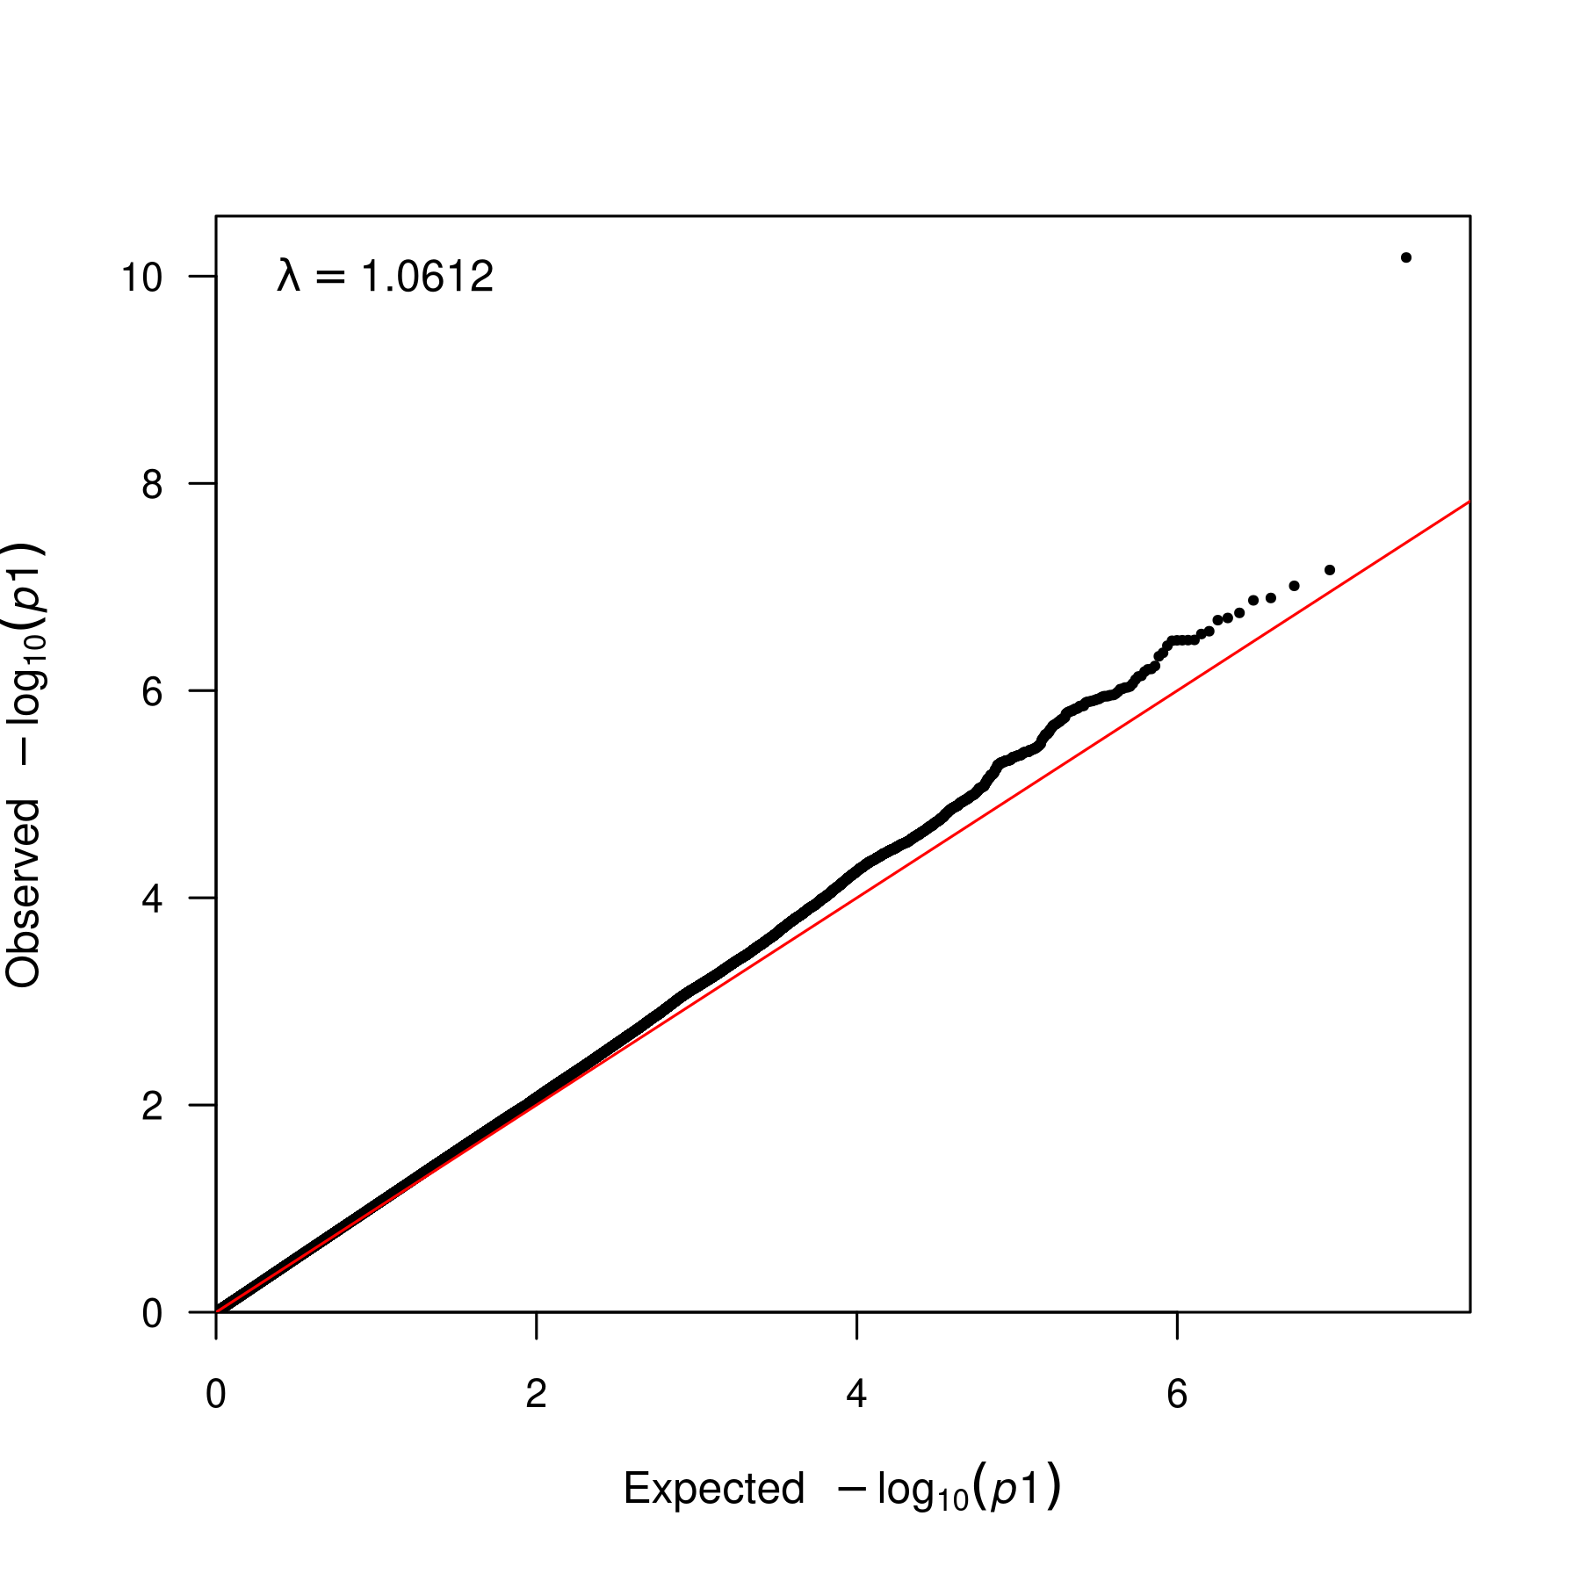

**Supplementary Figure 13. QQ plot for fixed meta-analysis for N06A ancestry EAS.** QQ plot for the association of SNPs with the antidepressant phenotype N06A. The x-axis represents the expected -log10(p-value) of the association, and the y-axis represents the observed -log10(p-value) of the association. The lambda statistic (a measure of inflated p-values) is also reported on the plot.

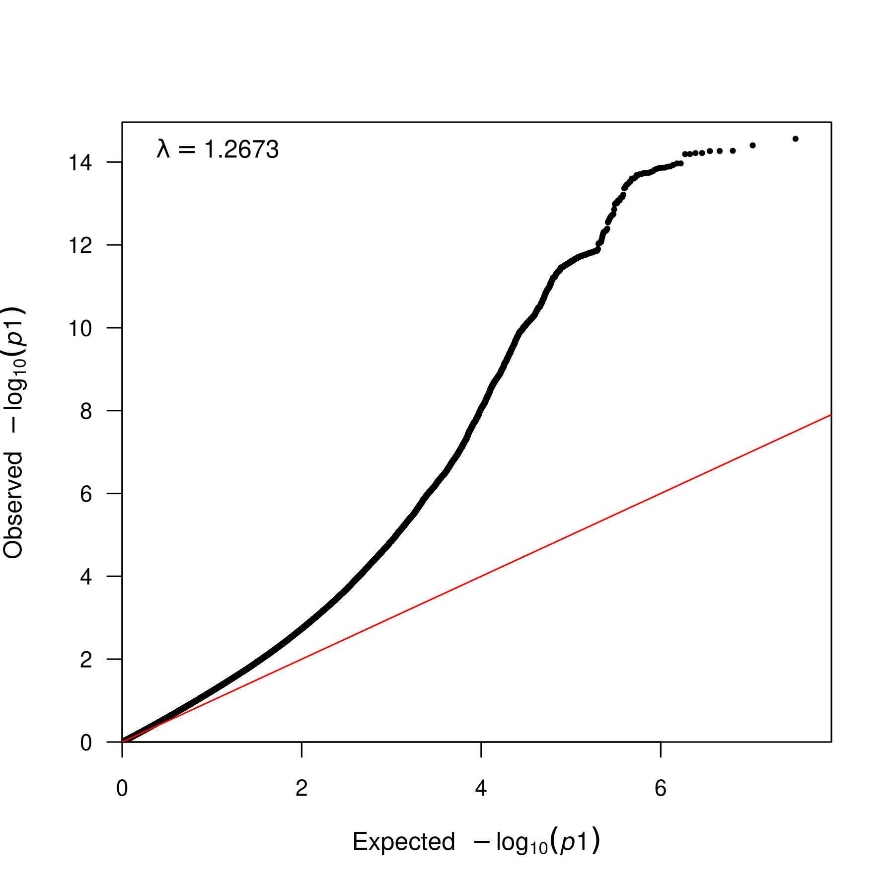

**Supplementary Figure 14. QQ plot for fixed meta-analysis for N06A ancestry EUR.** QQ plot for the association of SNPs with the antidepressant phenotype N06A. The x-axis represents the expected -log10(p-value) of the association, and the y-axis represents the observed -log10(p-value) of the association. The lambda statistic (a measure of inflated p-values) is also reported on the plot.

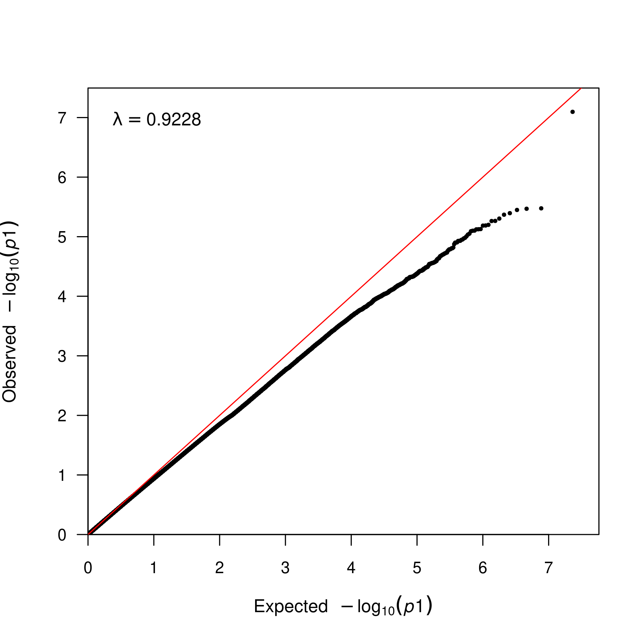

**Supplementary Figure 15. QQ plot for fixed meta-analysis for N06A ancestry MID.** QQ plot for the association of SNPs with the antidepressant phenotype N06A. The x-axis represents the expected -log10(p-value) of the association, and the y-axis represents the observed -log10(p-value) of the association. The lambda statistic (a measure of inflated p-values) is also reported on the plot.

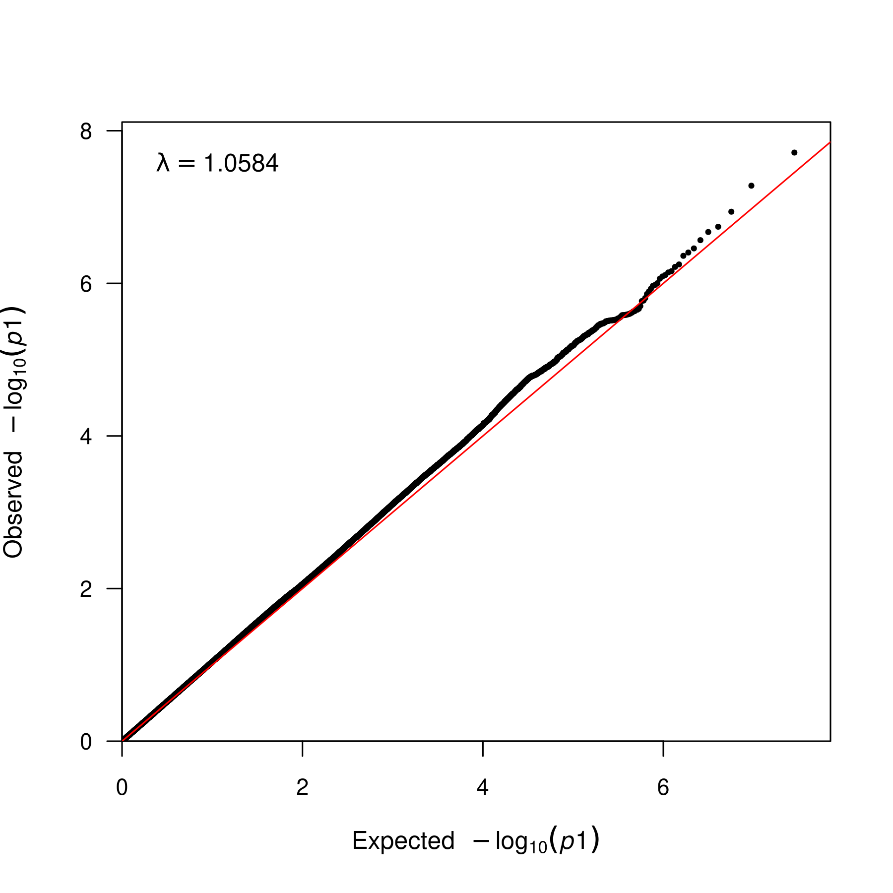

**Supplementary Figure 16. QQ plot for fixed meta-analysis for N06A ancestry SAS.** QQ plot for the association of SNPs with the antidepressant phenotype N06A. The x-axis represents the expected -log10(p-value) of the association, and the y-axis represents the observed -log10(p-value) of the association. The lambda statistic (a measure of inflated p-values) is also reported on the plot.

### N06AA fixed-effects meta-analyses

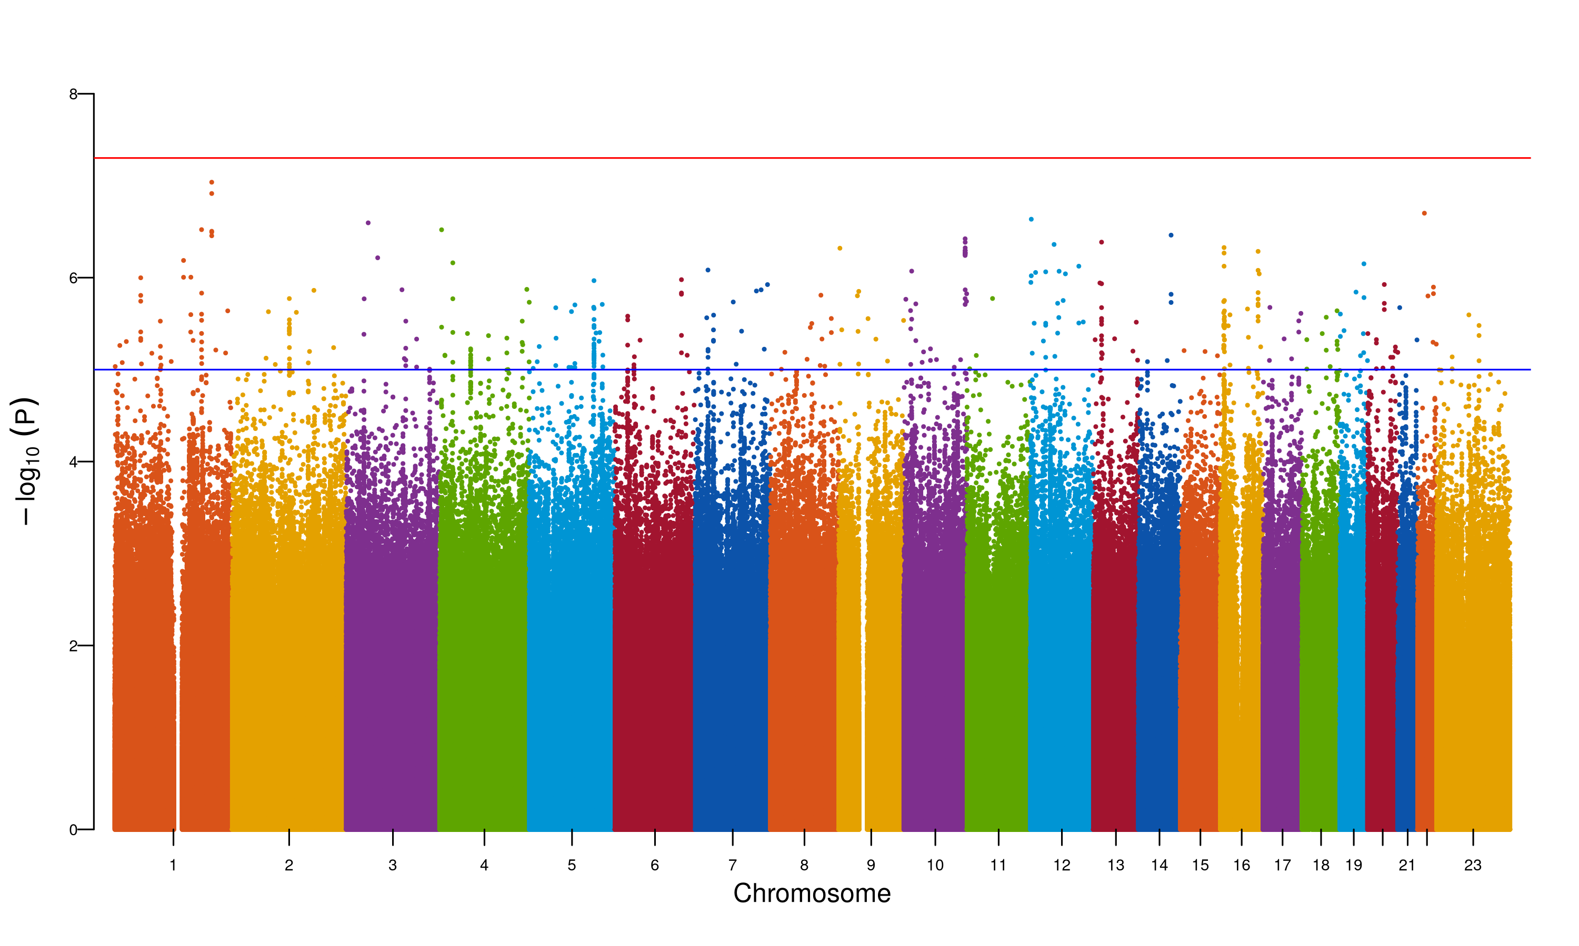

**Supplementary Figure 17. Manhattan plot for fixed meta-analysis for N06AA ancestry AFR.** The Manhattan plot shows the association of SNPs with the antidepressant phenotype N06AA. The x-axis represents the chromosomal position of the SNP, and the y-axis represents the -log10(p-value) of the association. The red line represents the genome-wide significance threshold (p-value = 5e-8). The blue line represents the suggestive significance threshold (p-value = 1e-5).

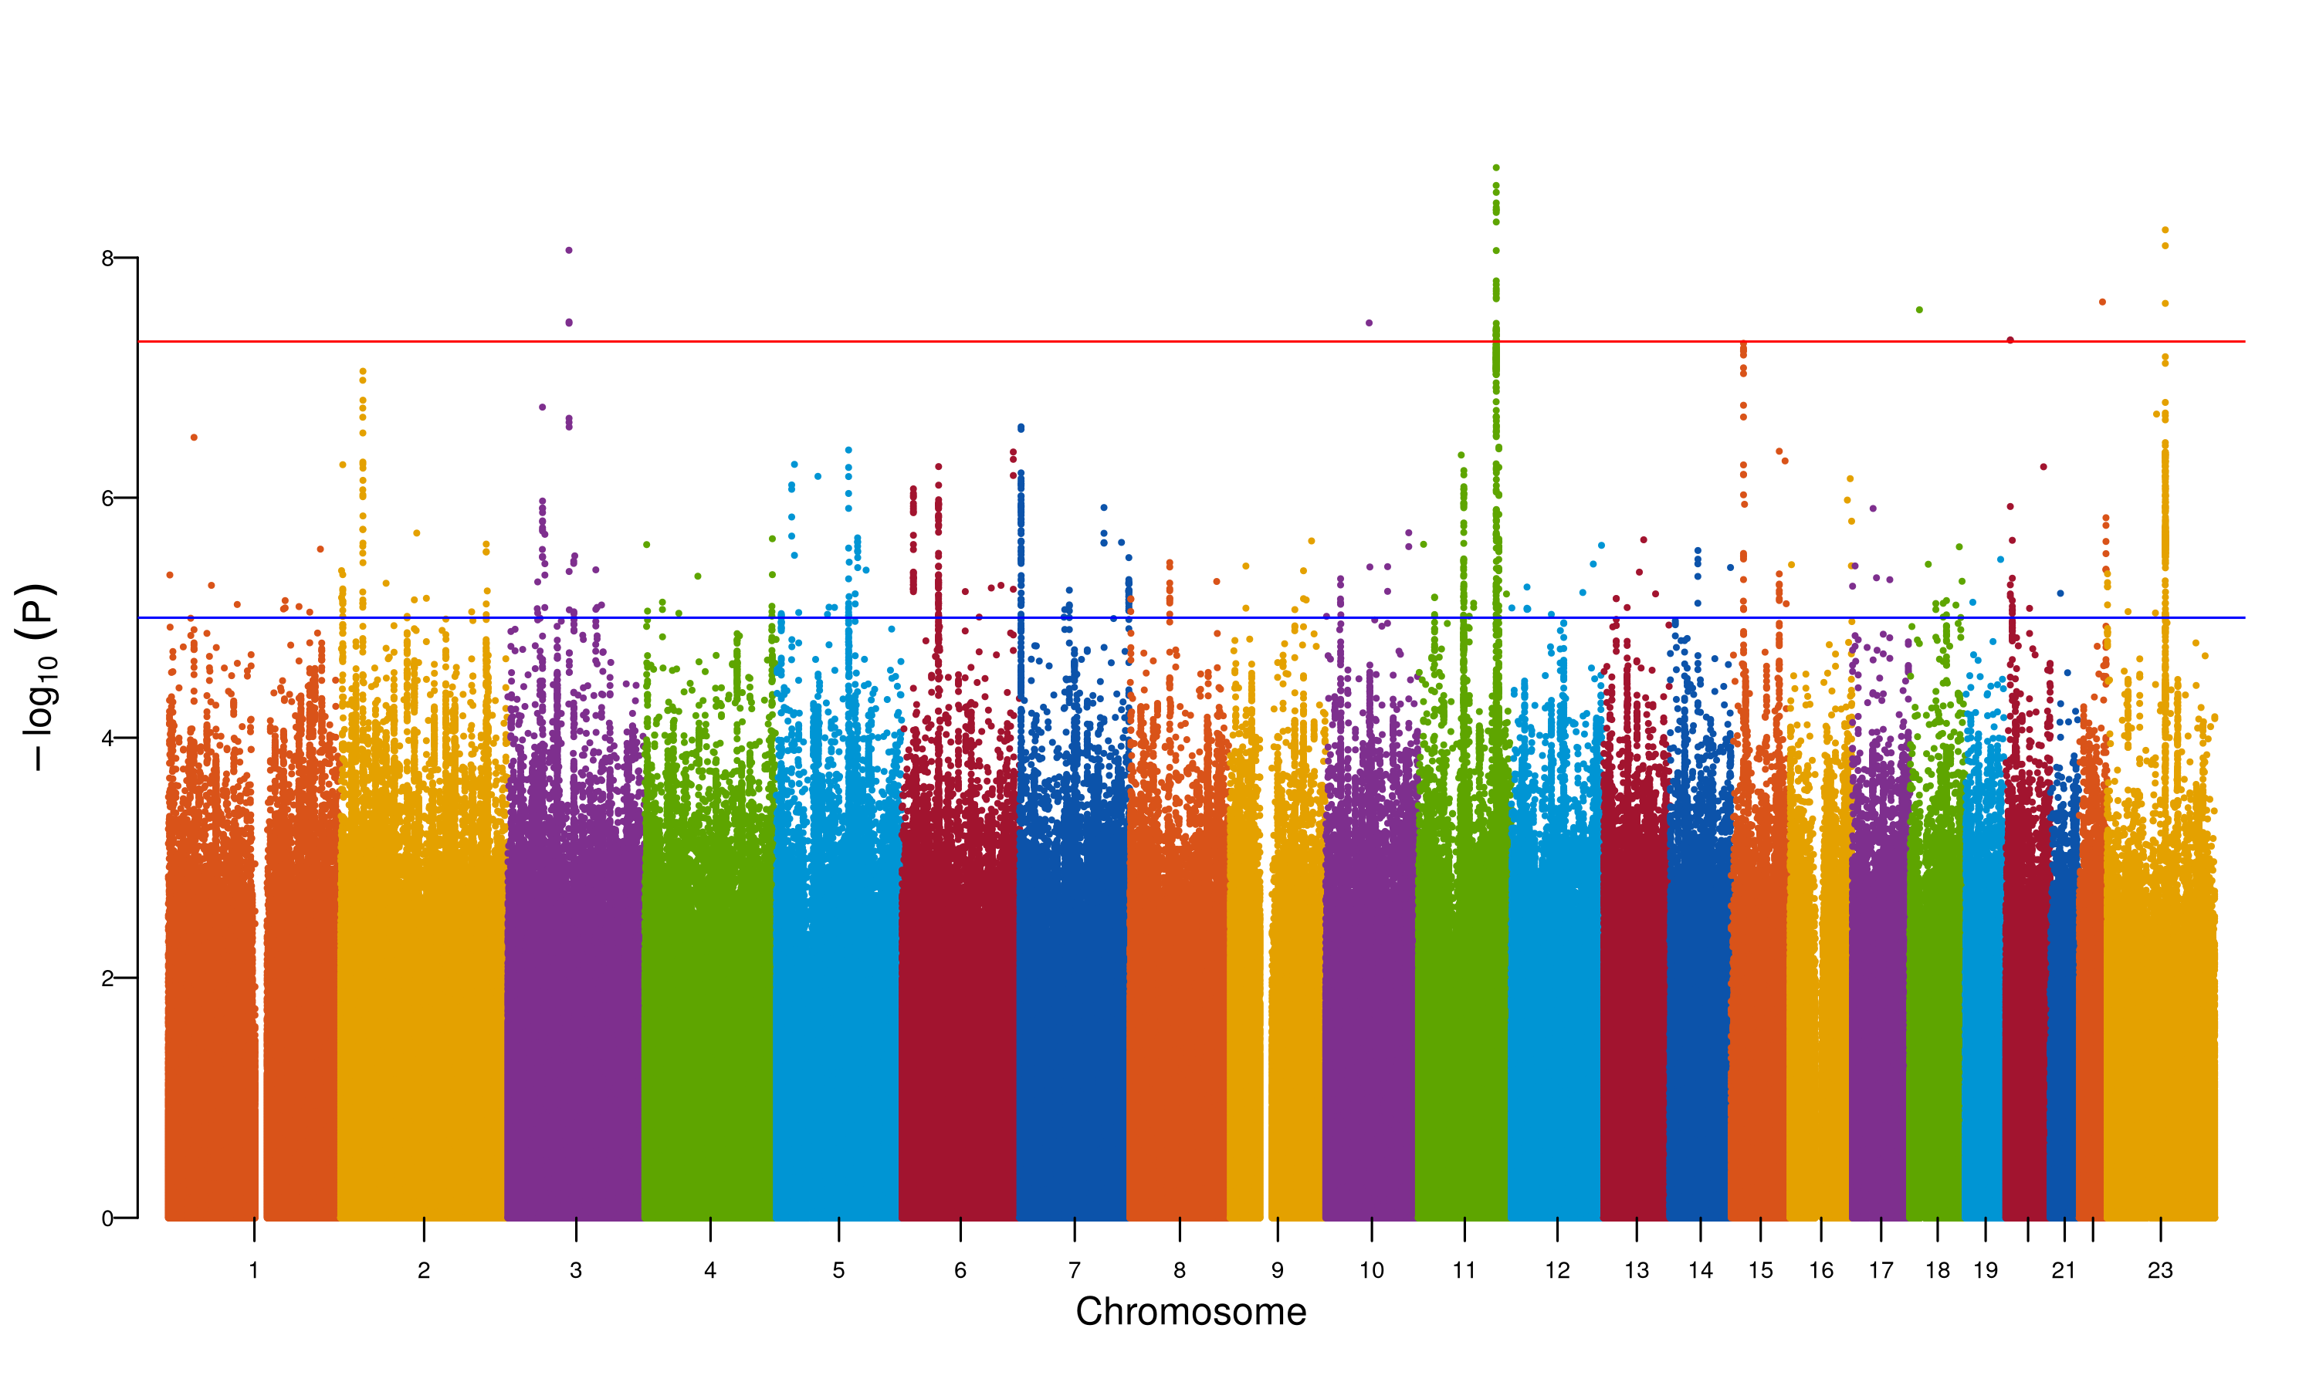

**Supplementary Figure 18. Manhattan plot for fixed meta-analysis for N06AA ancestry EUR.** The Manhattan plot shows the association of SNPs with the antidepressant phenotype N06AA. The x-axis represents the chromosomal position of the SNP, and the y-axis represents the -log10(p-value) of the association. The red line represents the genome-wide significance threshold (p-value = 5e-8). The blue line represents the suggestive significance threshold (p-value = 1e-5).

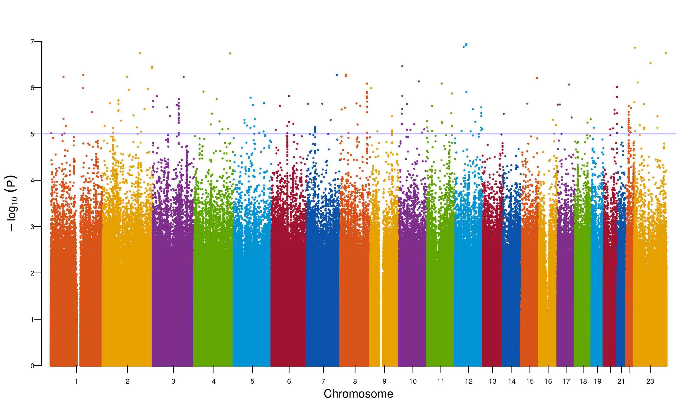

**Supplementary Figure 19. Manhattan plot for fixed meta-analysis for N06AA ancestry SAS.** The Manhattan plot shows the association of SNPs with the antidepressant phenotype N06AA. The x-axis represents the chromosomal position of the SNP, and the y-axis represents the -log10(p-value) of the association. The red line represents the genome-wide significance threshold (p-value = 5e-8). The blue line represents the suggestive significance threshold (p-value = 1e-5).

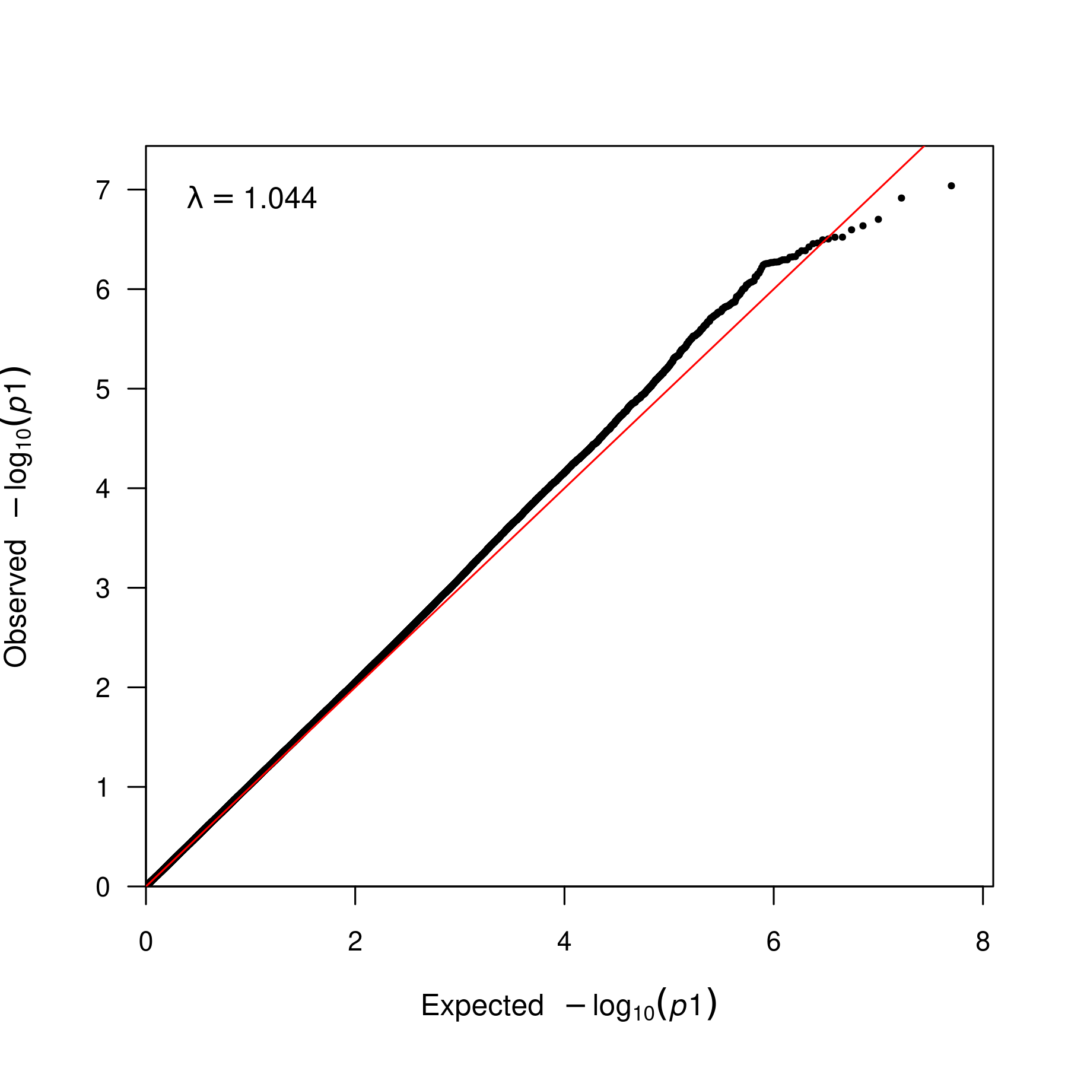

**Supplementary Figure 20. QQ plot for fixed meta-analysis for N06AA ancestry AFR.** QQ plot for the association of SNPs with the antidepressant phenotype N06AA. The x-axis represents the expected -log10(p-value) of the association, and the y-axis represents the observed -log10(p-value) of the association. The lambda statistic (a measure of inflated p-values) is also reported on the plot.

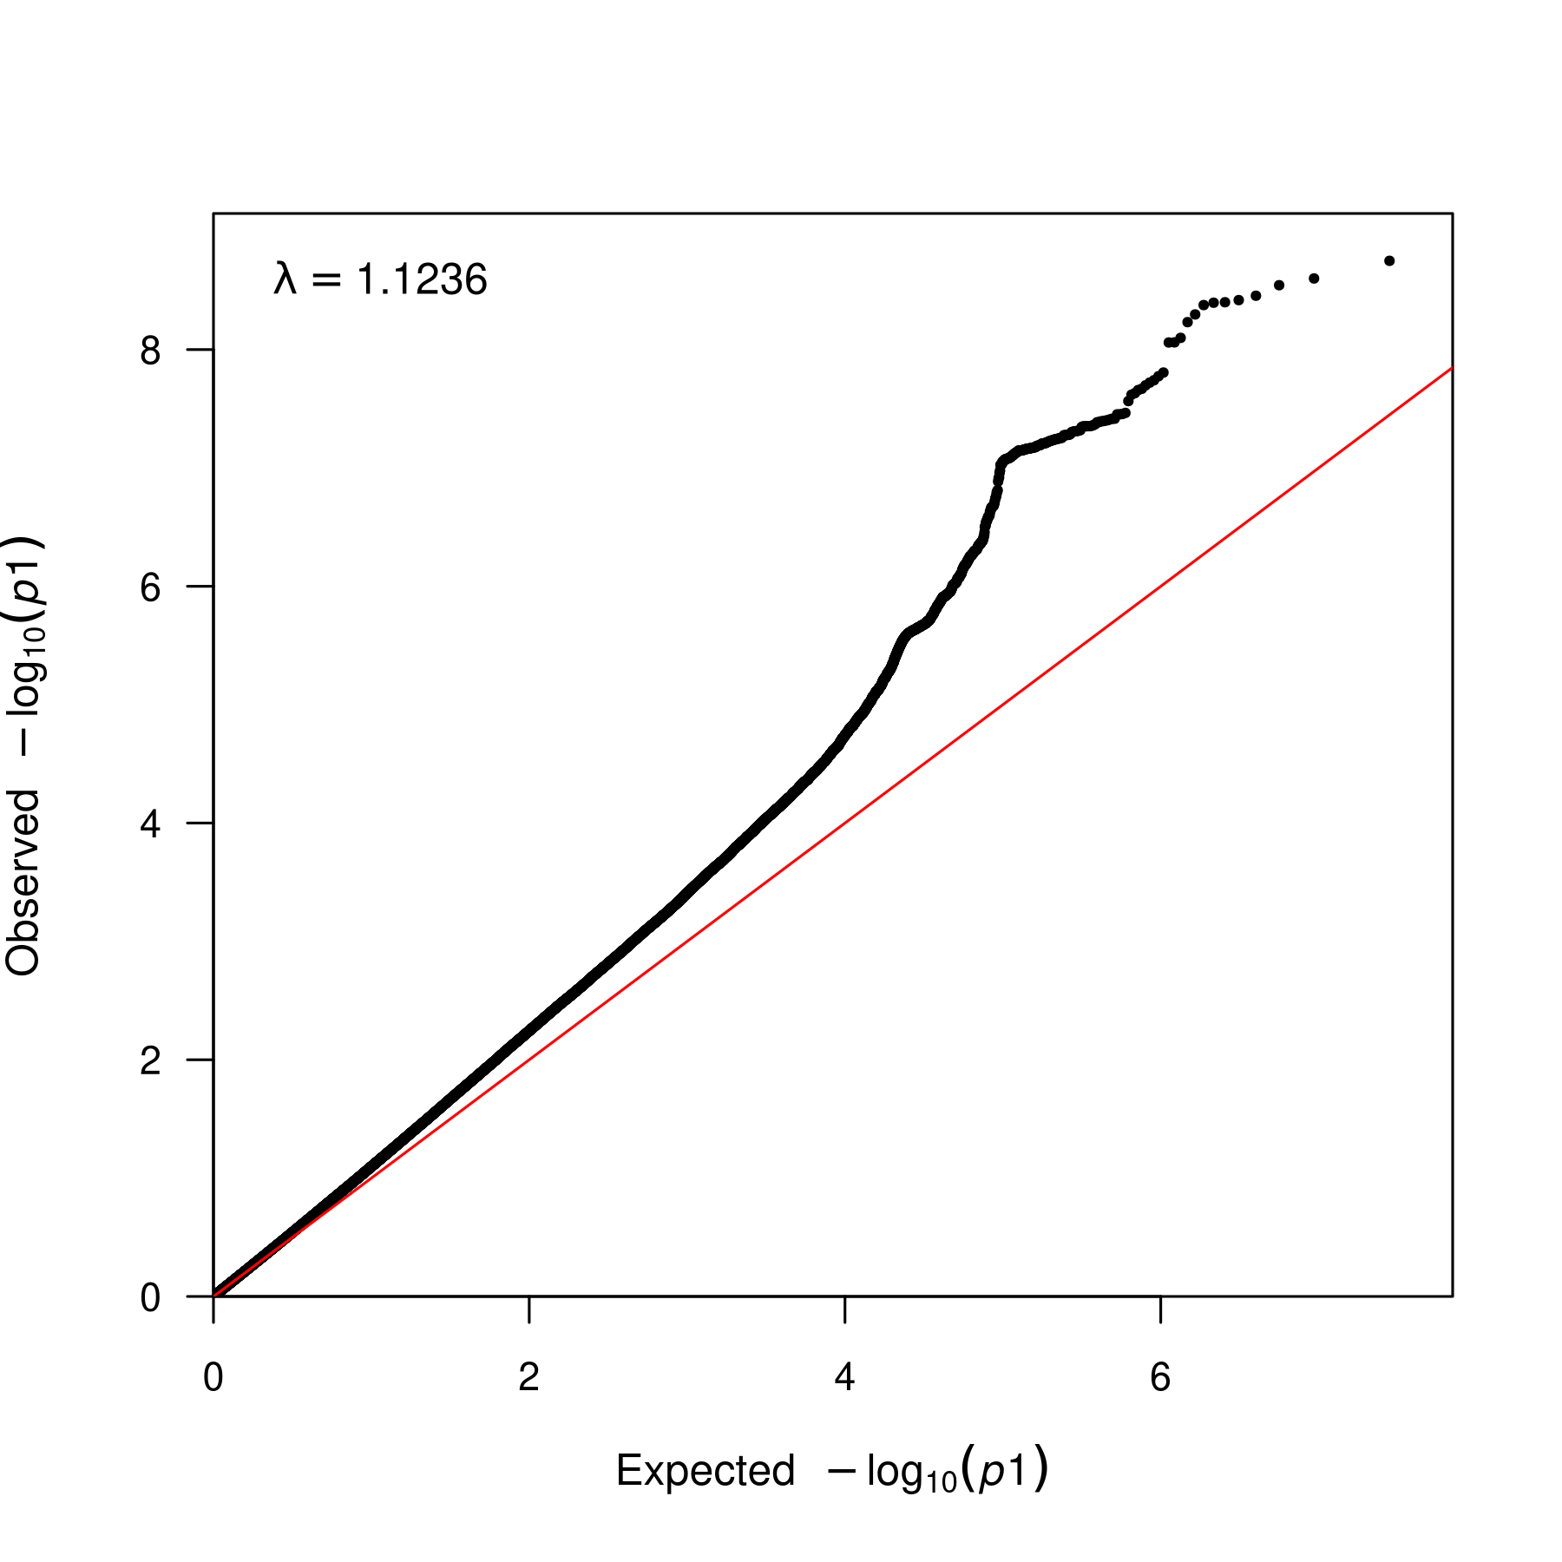

**Supplementary Figure 21. QQ plot for fixed meta-analysis for N06AA ancestry EUR.** QQ plot for the association of SNPs with the antidepressant phenotype N06AA. The x-axis represents the expected -log10(p-value) of the association, and the y-axis represents the observed -log10(p-value) of the association. The lambda statistic (a measure of inflated p-values) is also reported on the plot.

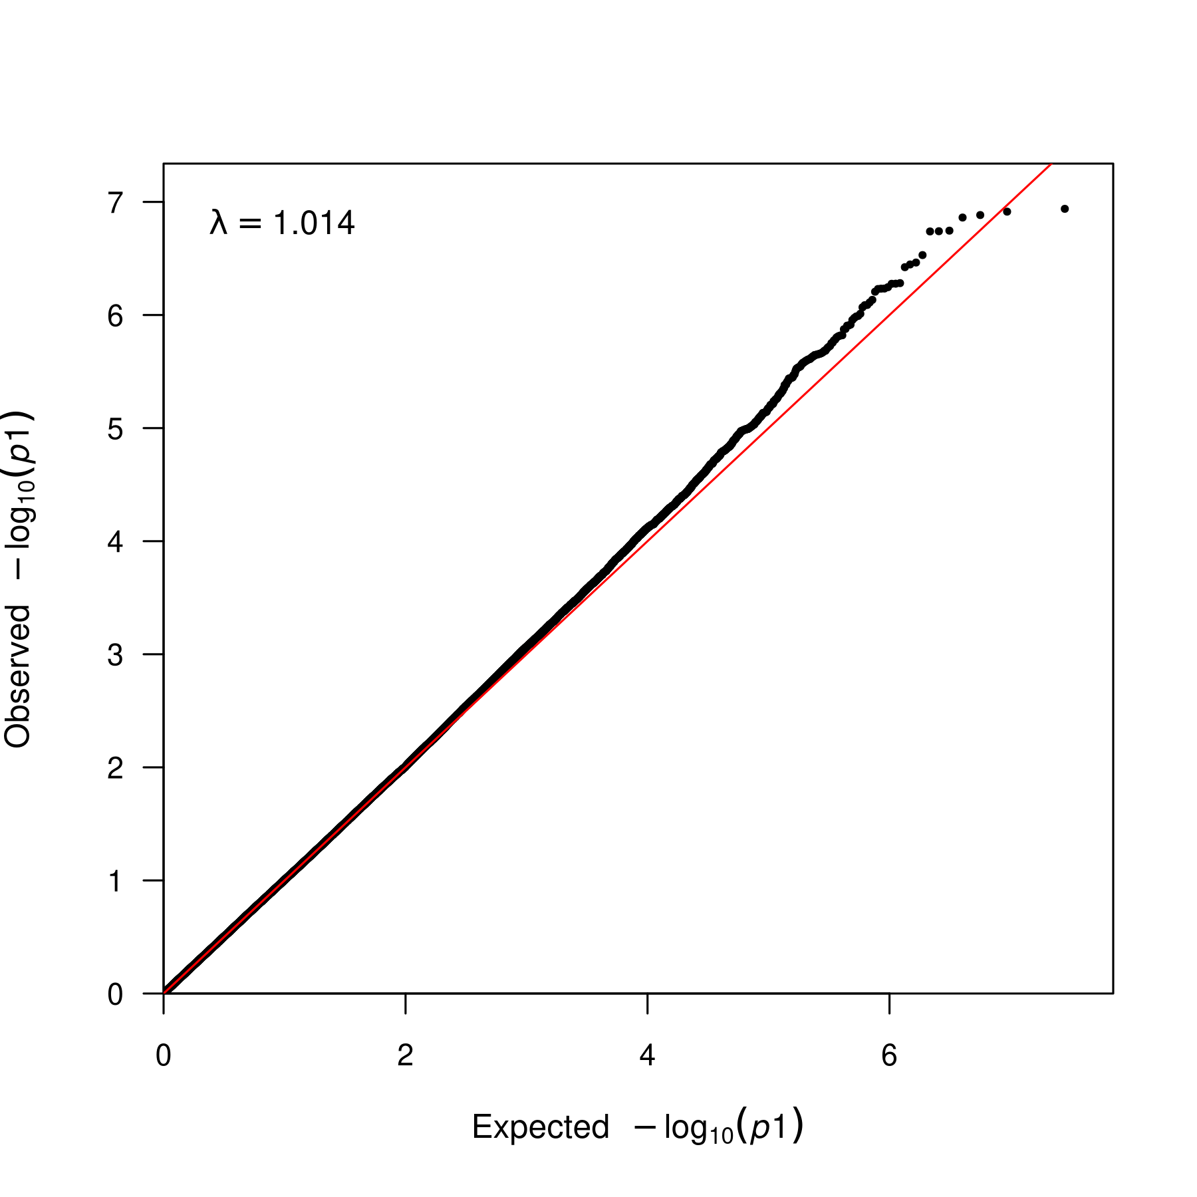

**Supplementary Figure 22. QQ plot for fixed meta-analysis for N06AA ancestry SAS.** QQ plot for the association of SNPs with the antidepressant phenotype N06AA. The x-axis represents the expected -log10(p-value) of the association, and the y-axis represents the observed -log10(p-value) of the association. The lambda statistic (a measure of inflated p-values) is also reported on the plot.

### N06AB fixed-effects meta-analyses

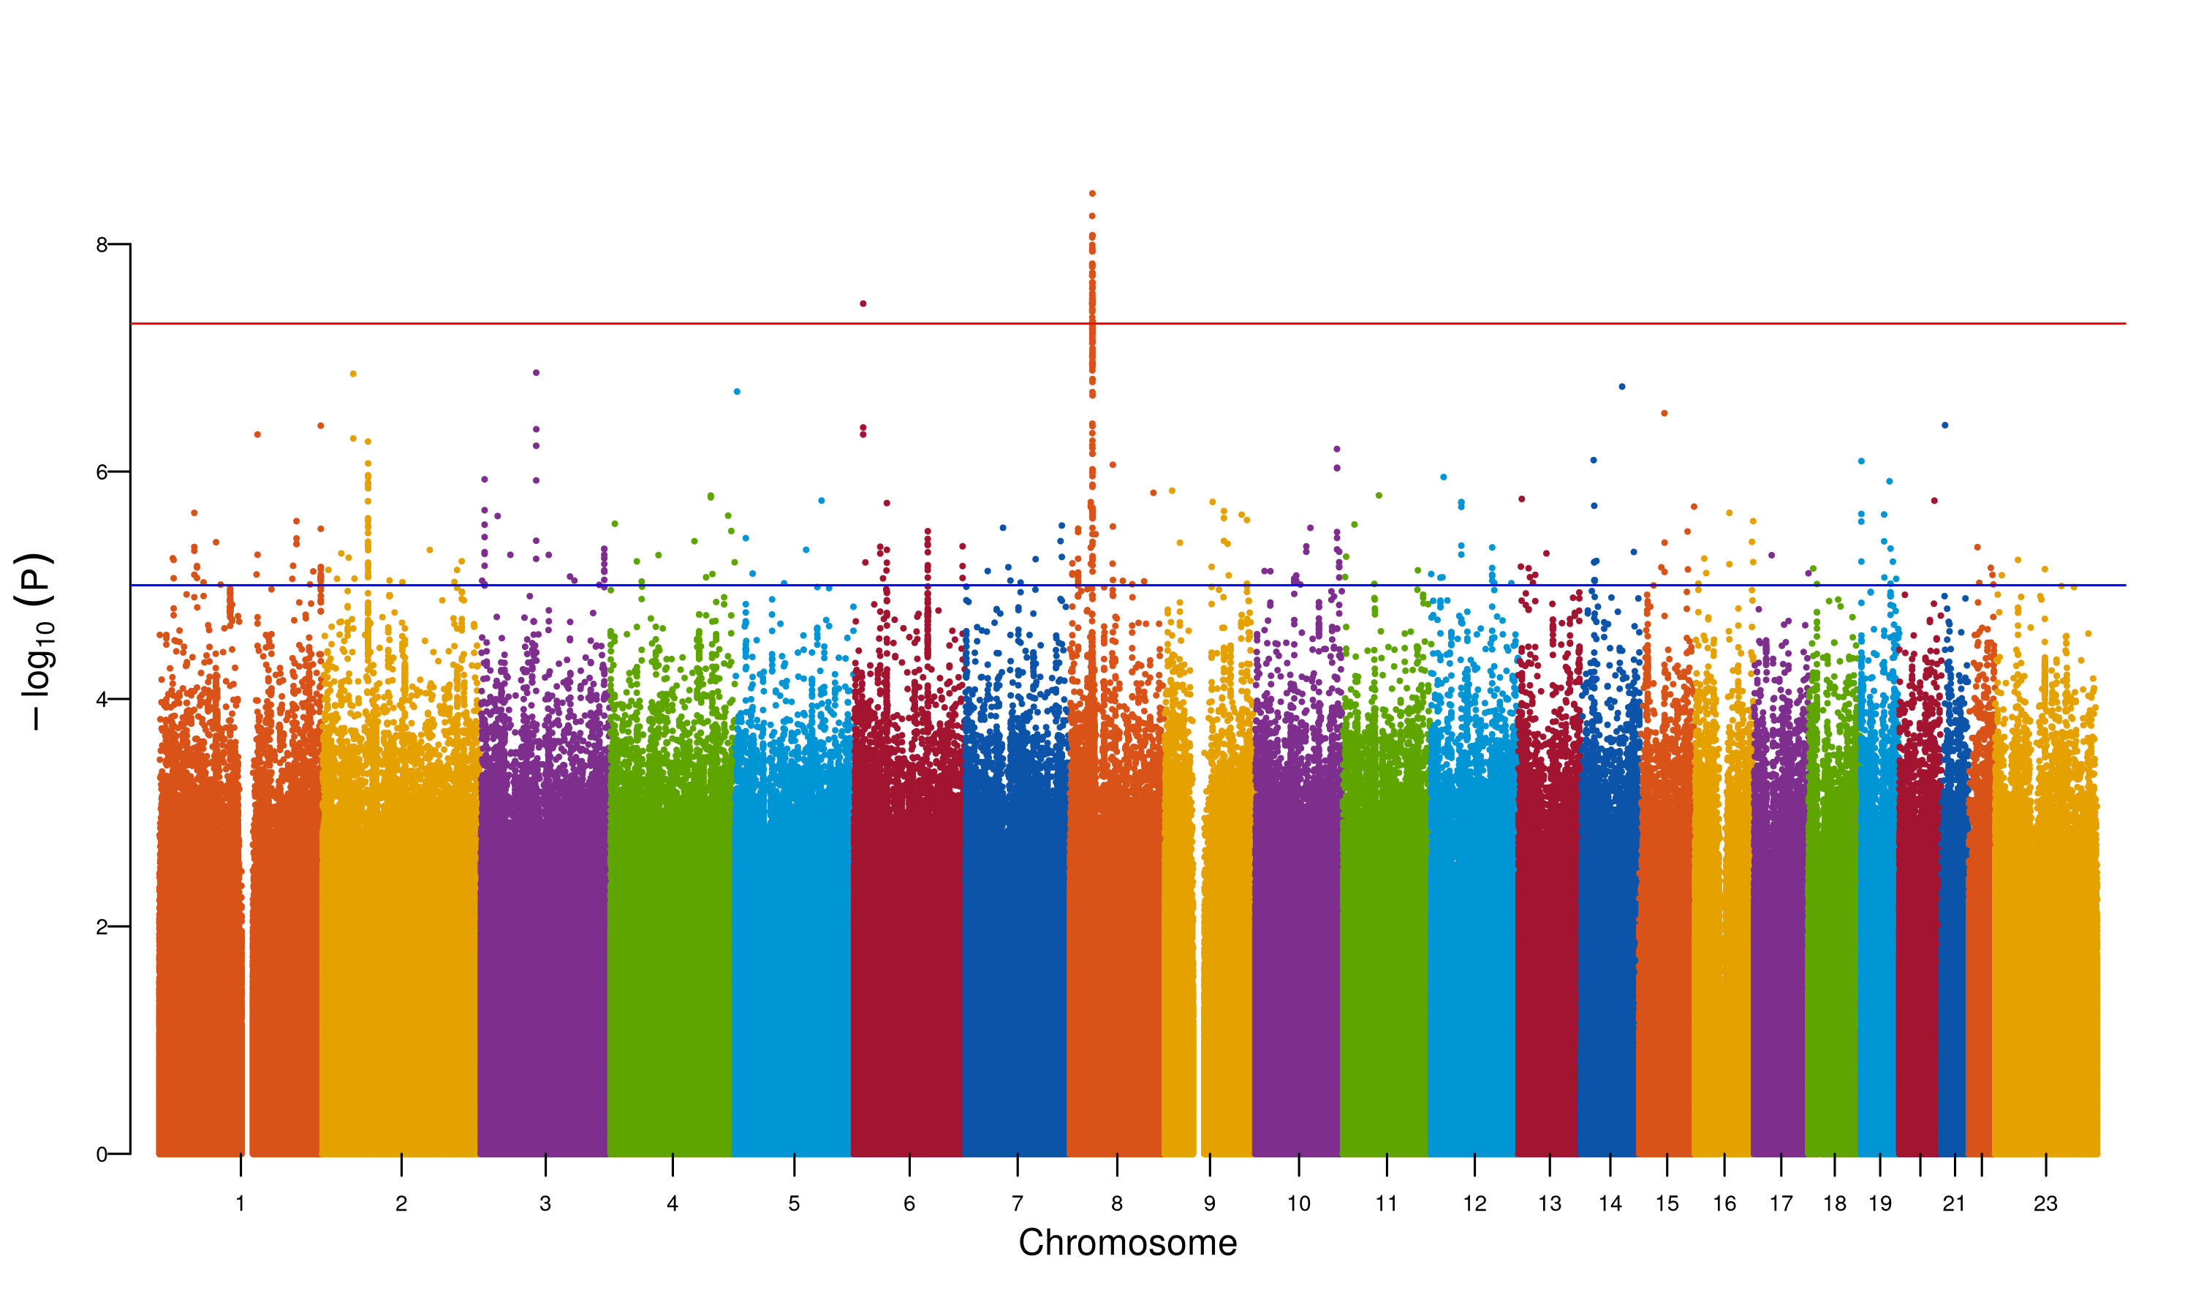

**Supplementary Figure 23. Manhattan plot for fixed meta-analysis for N06AB ancestry AFR.** The Manhattan plot shows the association of SNPs with the antidepressant phenotype N06AB. The x-axis represents the chromosomal position of the SNP, and the y-axis represents the -log10(p-value) of the association. The red line represents the genome-wide significance threshold (p-value = 5e-8). The blue line represents the suggestive significance threshold (p-value = 1e-5).

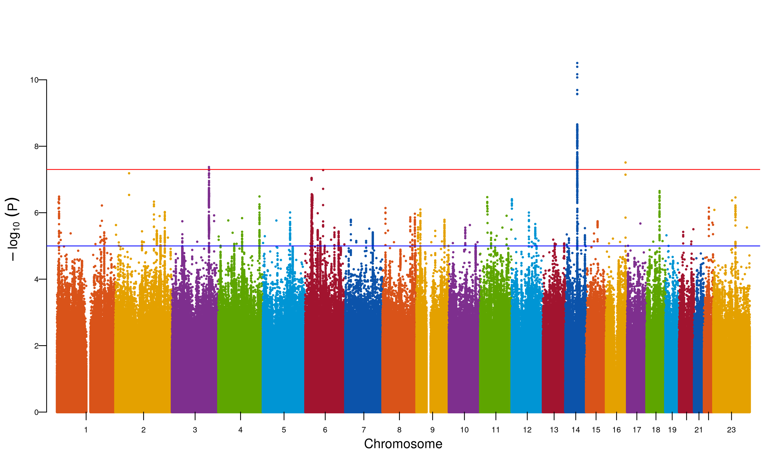

**Supplementary Figure 24. Manhattan plot for fixed meta-analysis for N06AB ancestry EUR.** The Manhattan plot shows the association of SNPs with the antidepressant phenotype N06AB. The x-axis represents the chromosomal position of the SNP, and the y-axis represents the -log10(p-value) of the association. The red line represents the genome-wide significance threshold (p-value = 5e-8). The blue line represents the suggestive significance threshold (p-value = 1e-5).

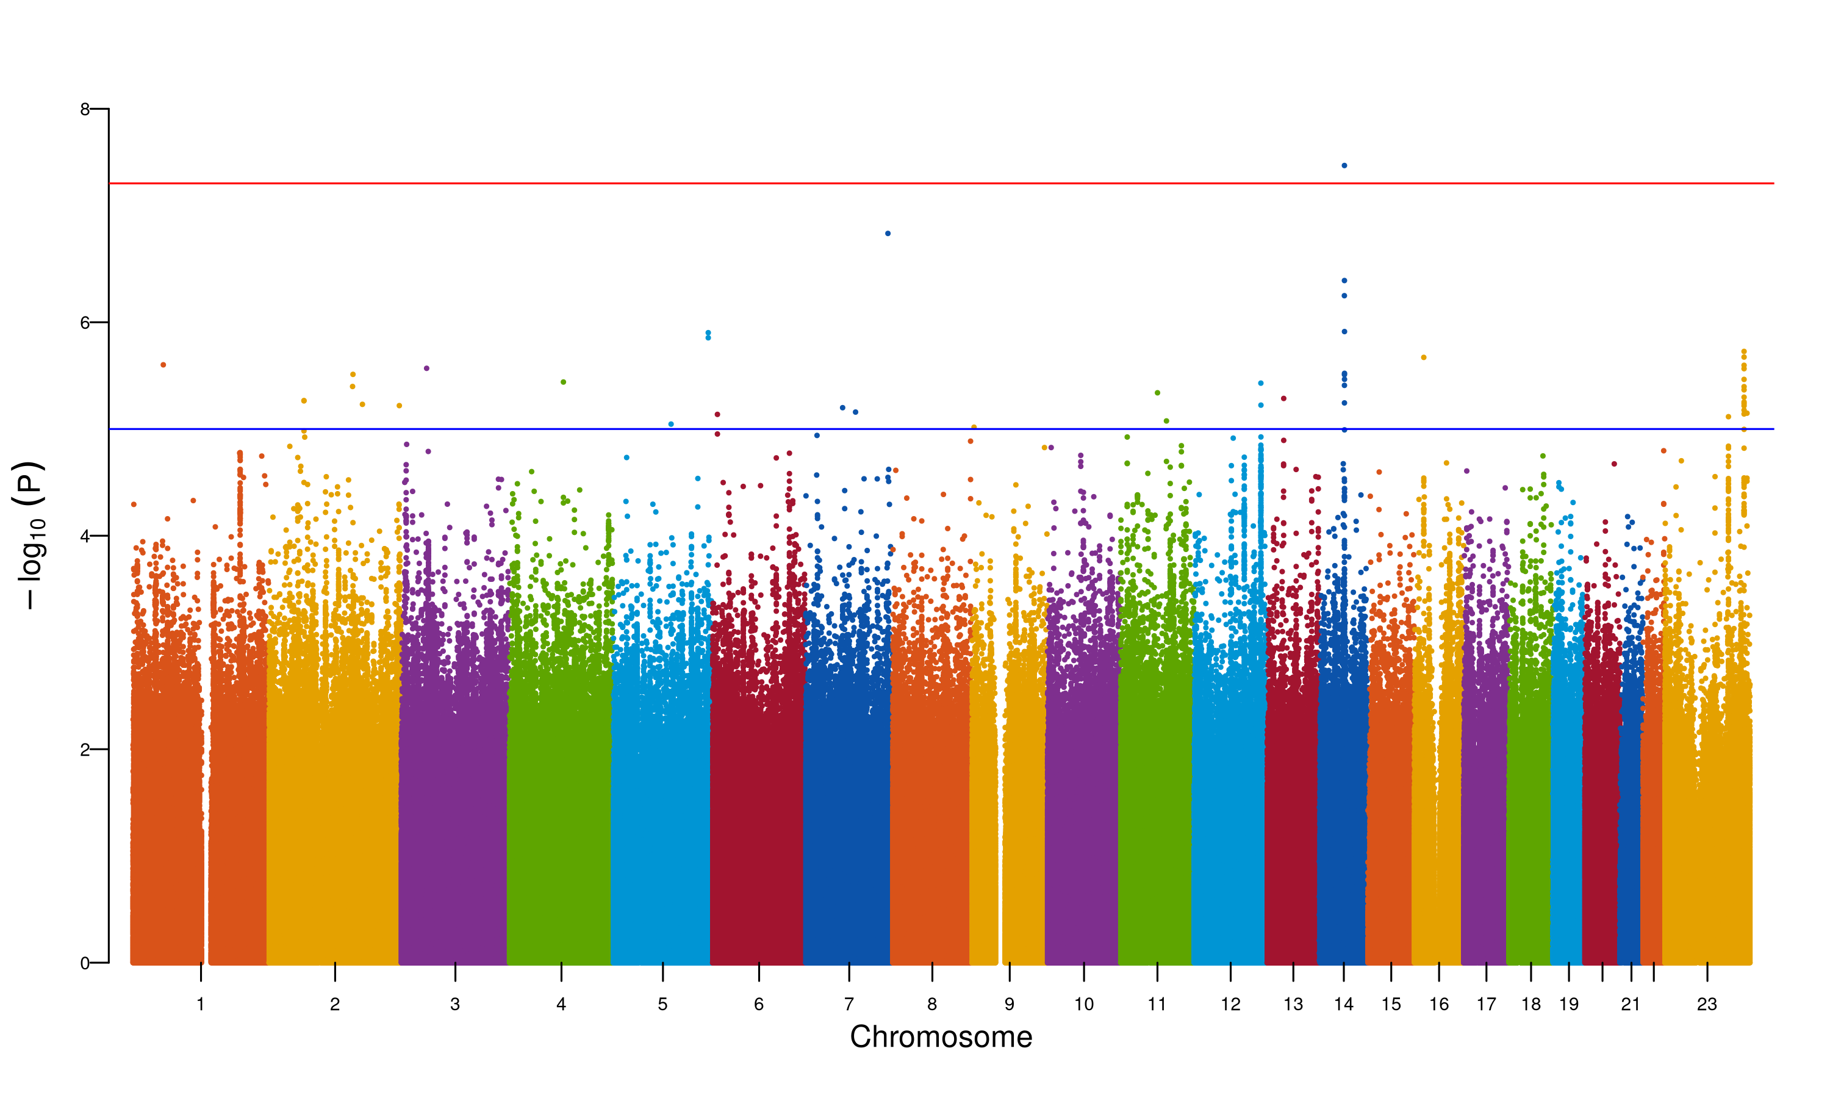

**Supplementary Figure 25. Manhattan plot for fixed meta-analysis for N06AB ancestry MID.** The Manhattan plot shows the association of SNPs with the antidepressant phenotype N06AB. The x-axis represents the chromosomal position of the SNP, and the y-axis represents the -log10(p-value) of the association. The red line represents the genome-wide significance threshold (p-value = 5e-8). The blue line represents the suggestive significance threshold (p-value = 1e-5).

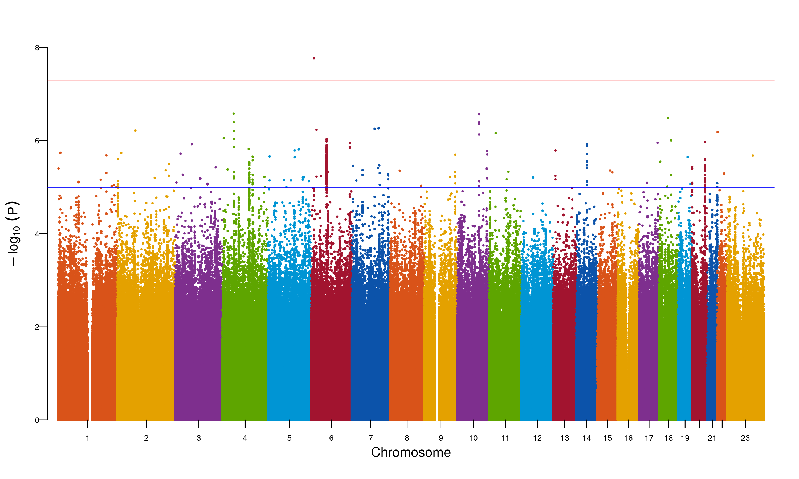

**Supplementary Figure 26. Manhattan plot for fixed meta-analysis for N06AB ancestry SAS.** The Manhattan plot shows the association of SNPs with the antidepressant phenotype N06AB. The x-axis represents the chromosomal position of the SNP, and the y-axis represents the -log10(p-value) of the association. The red line represents the genome-wide significance threshold (p-value = 5e-8). The blue line represents the suggestive significance threshold (p-value = 1e-5).

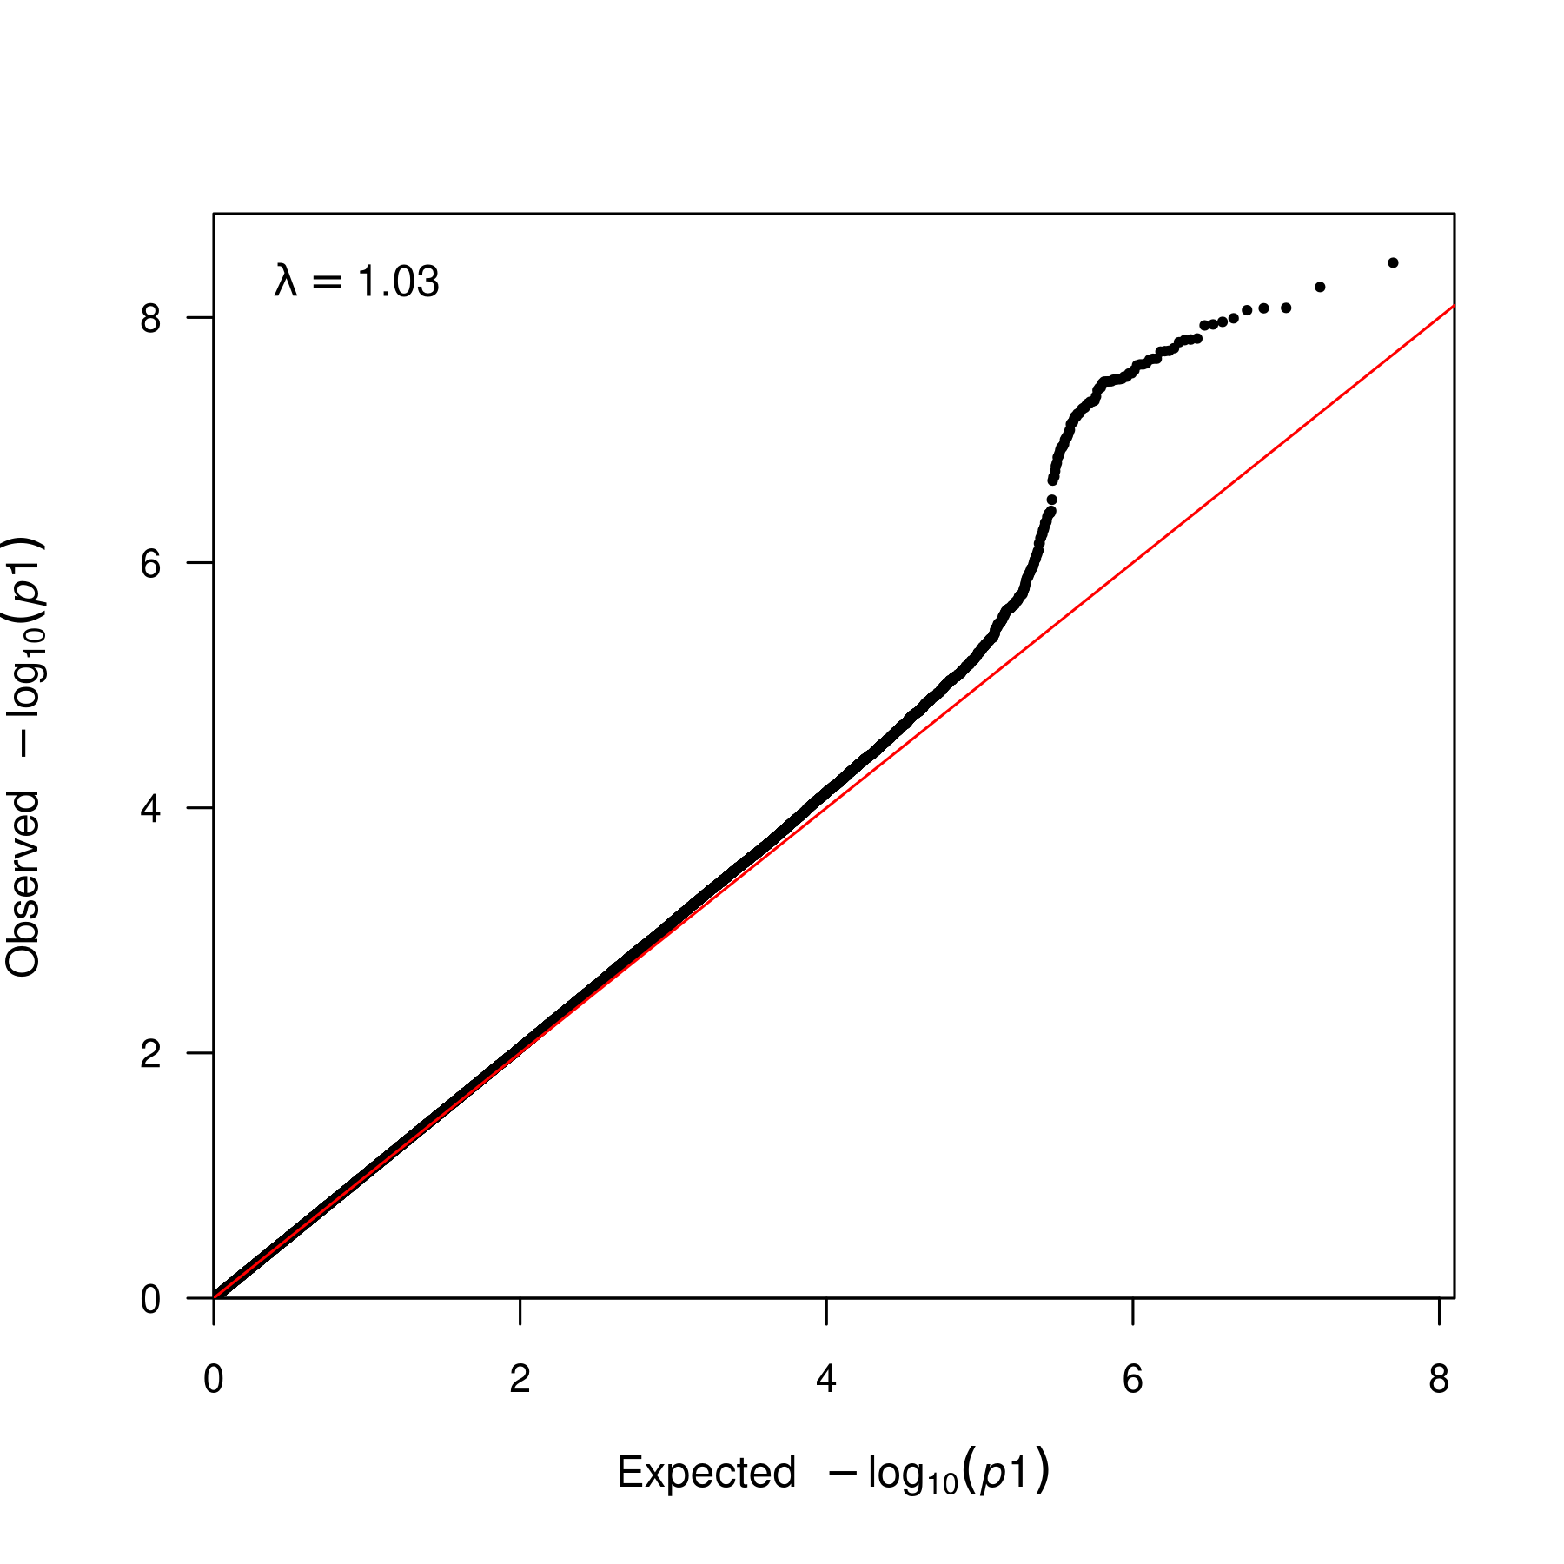

**Supplementary Figure 27. QQ plot for fixed meta-analysis for N06AB ancestry AFR.** QQ plot for the association of SNPs with the antidepressant phenotype N06AB. The x-axis represents the expected -log10(p-value) of the association, and the y-axis represents the observed -log10(p-value) of the association. The lambda statistic (a measure of inflated p-values) is also reported on the plot.

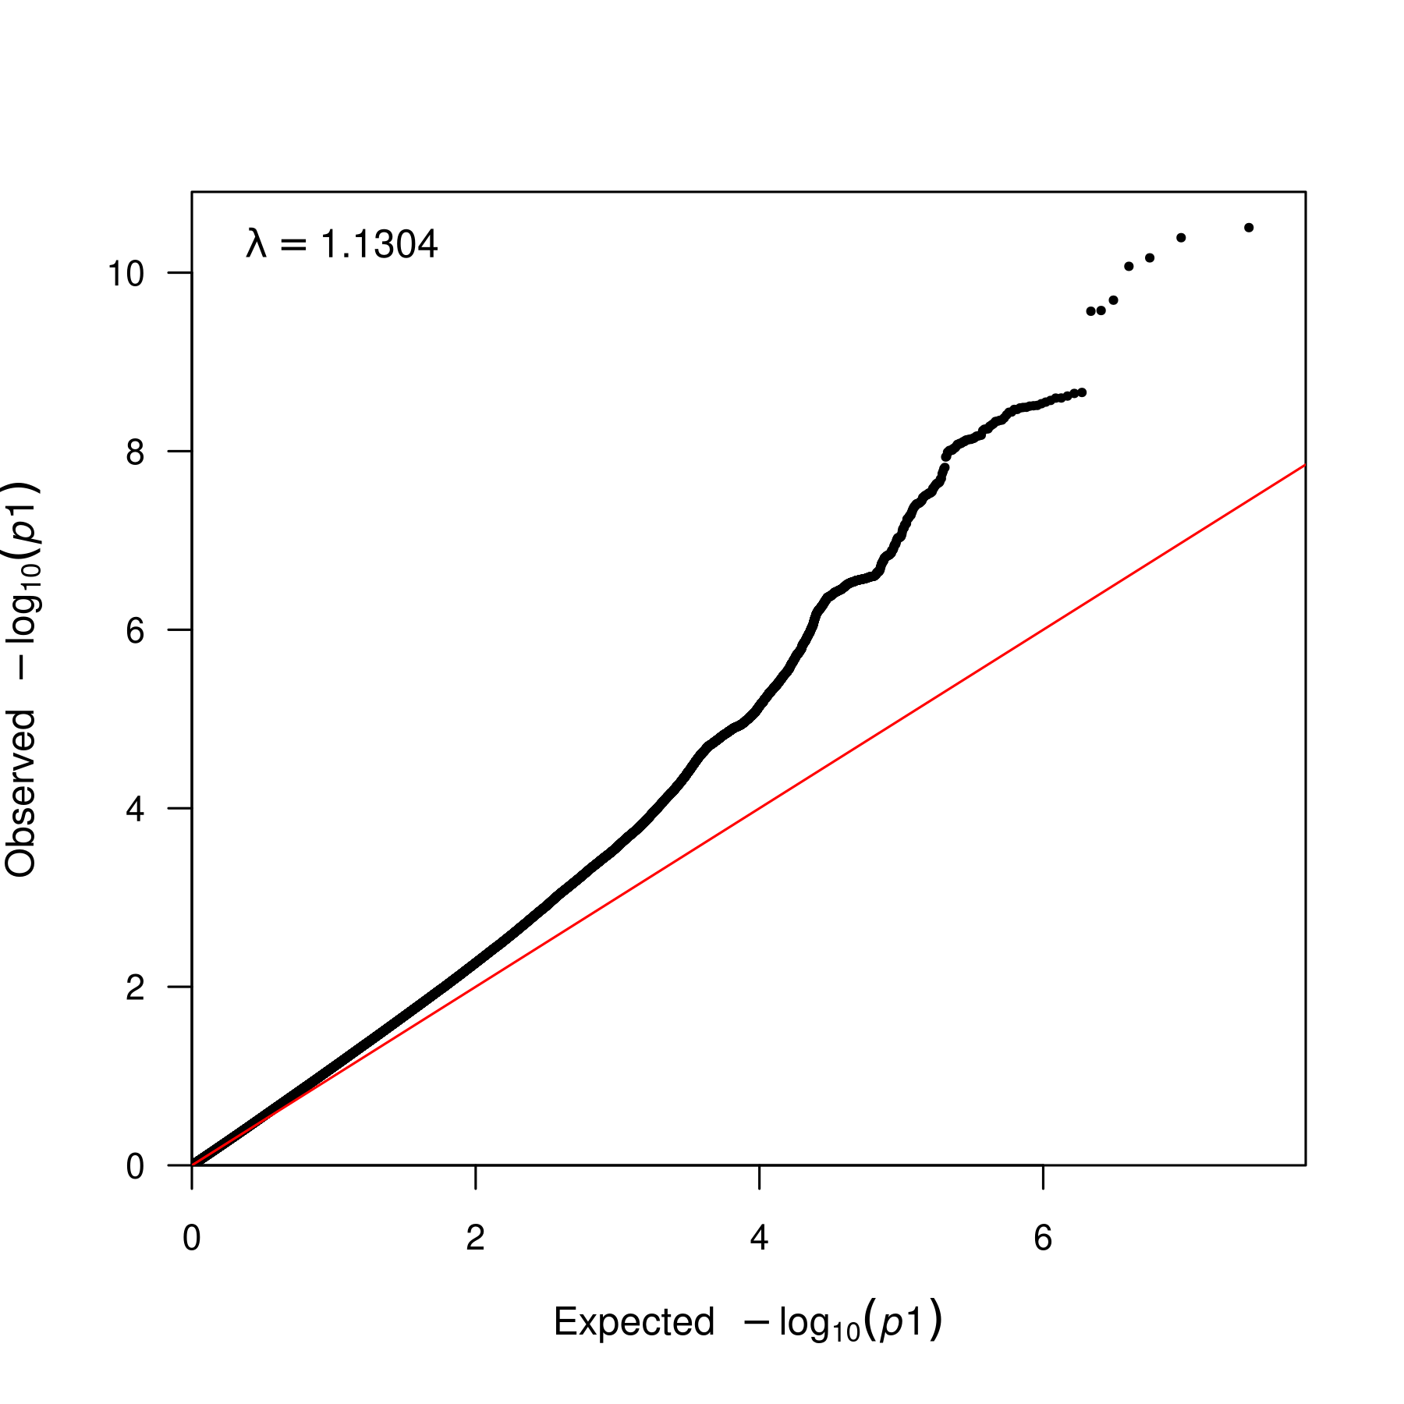

**Supplementary Figure 28. QQ plot for fixed meta-analysis for N06AB ancestry EUR.** QQ plot for the association of SNPs with the antidepressant phenotype N06AB. The x-axis represents the expected -log10(p-value) of the association, and the y-axis represents the observed -log10(p-value) of the association. The lambda statistic (a measure of inflated p-values) is also reported on the plot.

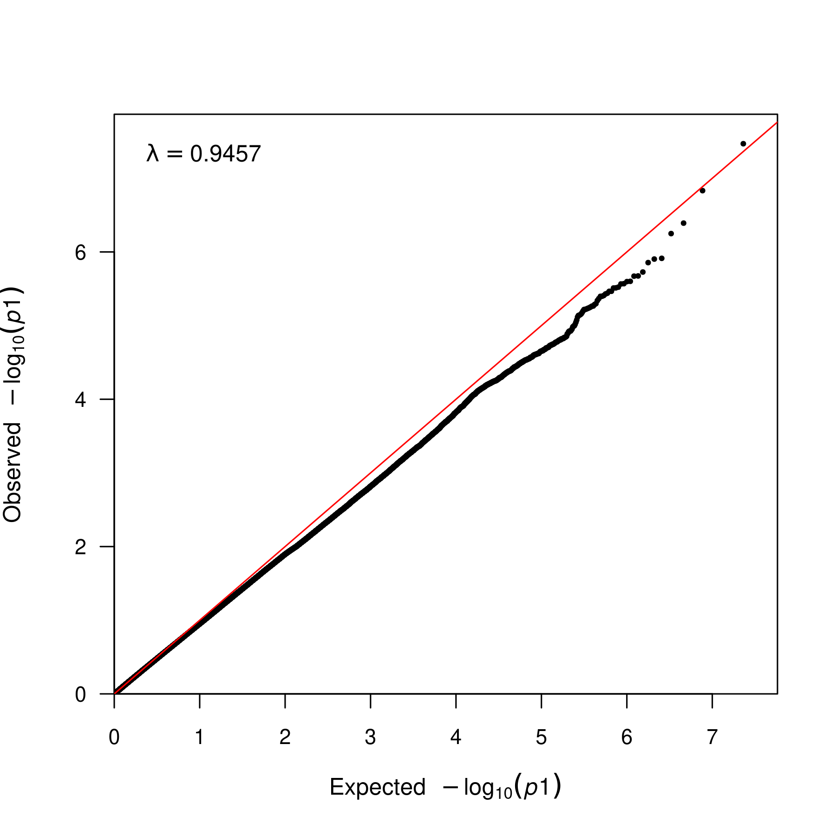

**Supplementary Figure 29. QQ plot for fixed meta-analysis for N06AB ancestry MID.** QQ plot for the association of SNPs with the antidepressant phenotype N06AB. The x-axis represents the expected -log10(p-value) of the association, and the y-axis represents the observed -log10(p-value) of the association. The lambda statistic (a measure of inflated p-values) is also reported on the plot.

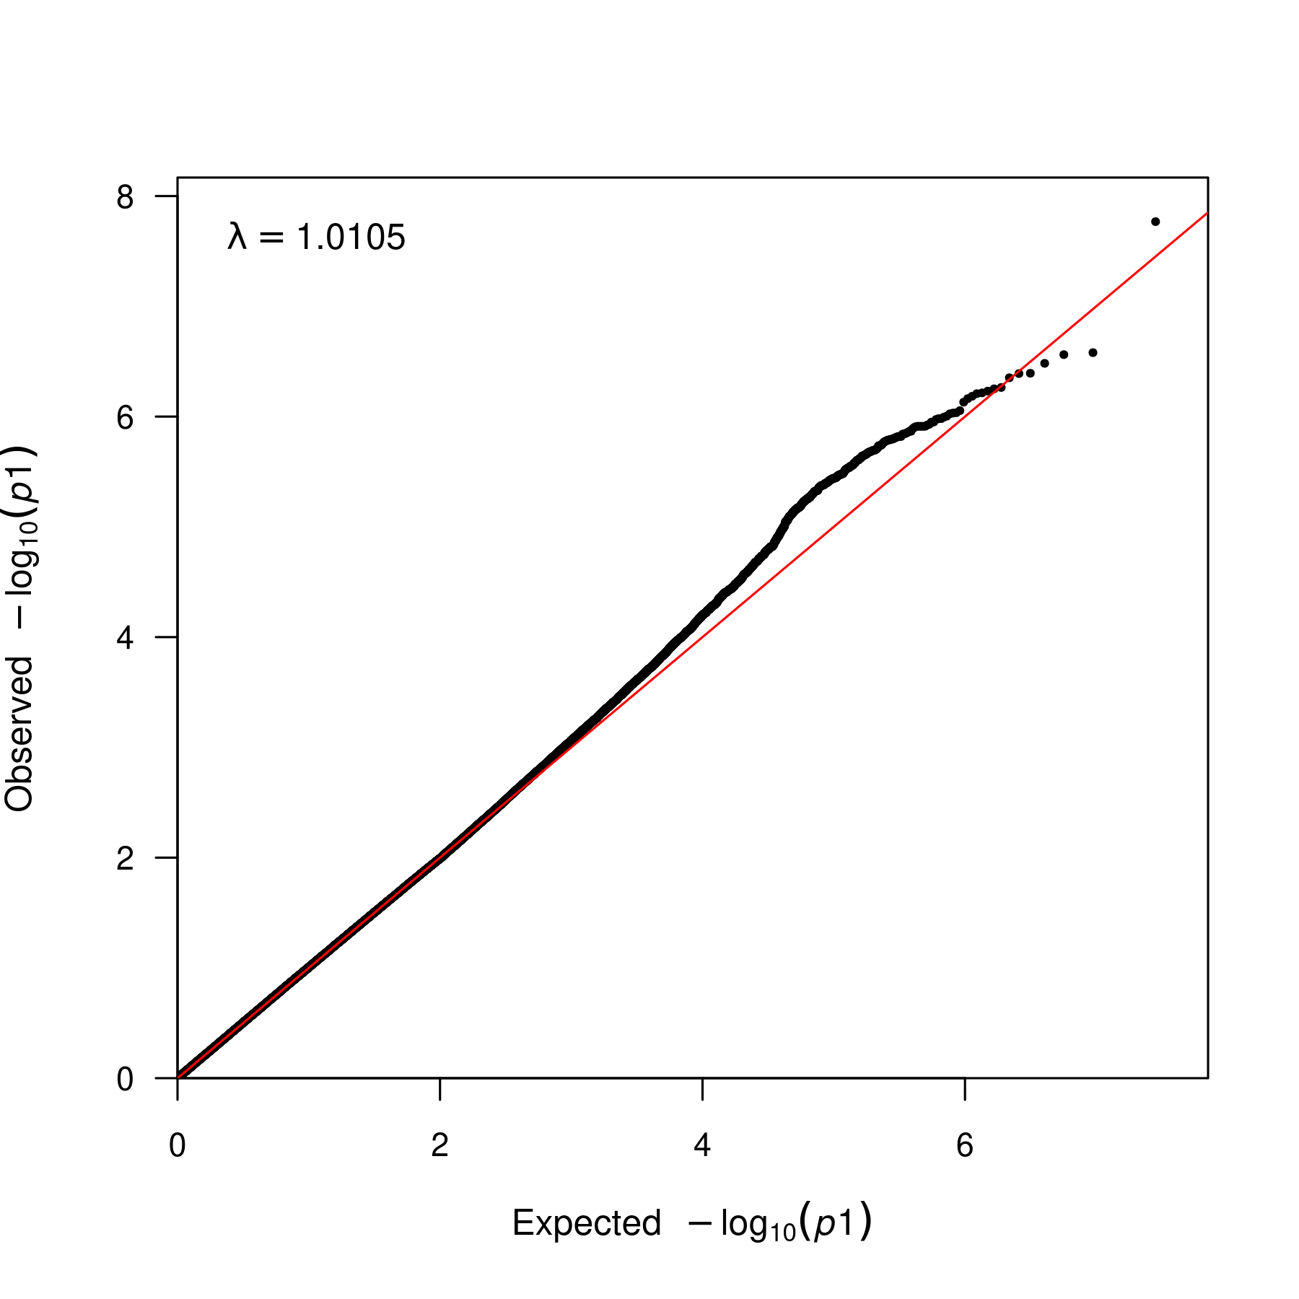

**Supplementary Figure 30. QQ plot for fixed meta-analysis for N06AB ancestry SAS.** QQ plot for the association of SNPs with the antidepressant phenotype N06AB. The x-axis represents the expected -log10(p-value) of the association, and the y-axis represents the observed -log10(p-value) of the association. The lambda statistic (a measure of inflated p-values) is also reported on the plot.

### N06A multi-ancestry meta-analyses

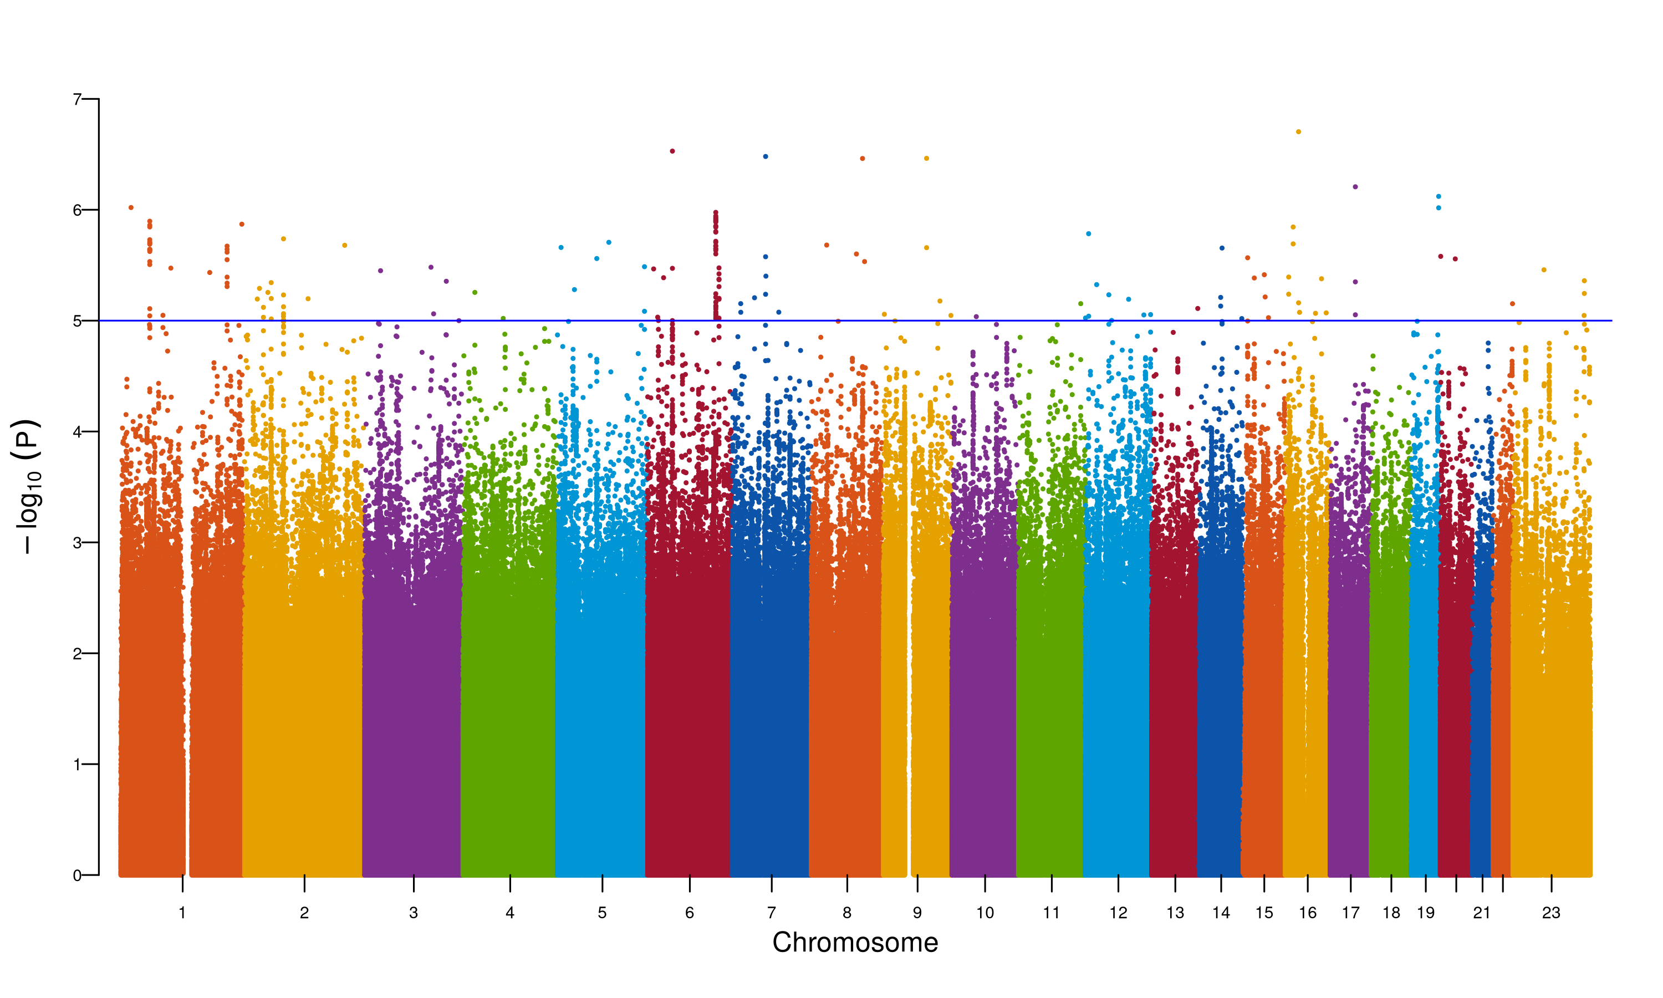

**Supplementary Figure 31. Manhattan plot for MR-MEGA meta-analysis for N06A.** The Manhattan plot shows the association of SNPs with the antidepressant phenotype N06A. The x-axis represents the chromosomal position of the SNP, and the y-axis represents the -log10(p-value) of the association. The red line represents the genome-wide significance threshold (p-value = 5e-8). The blue line represents the suggestive significance threshold (p-value = 1e-5).

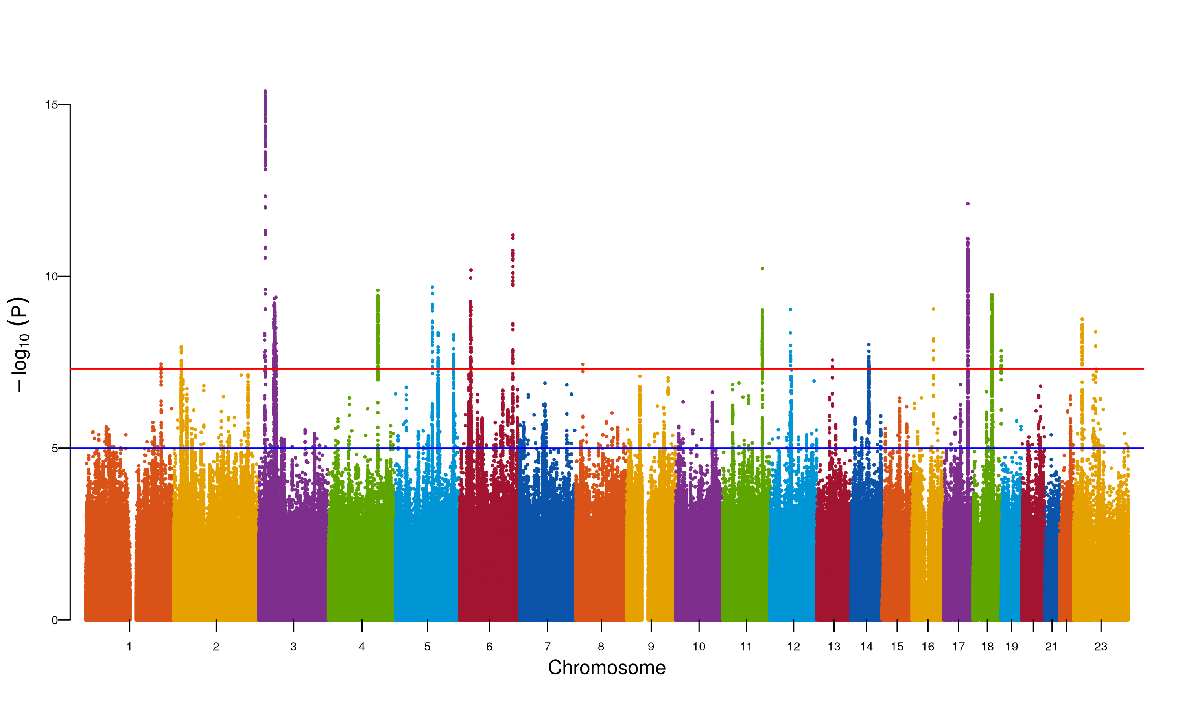

**Supplementary Figure 32. Manhattan plot for MR-MEGA meta-analysis for N06A.** The Manhattan plot shows the association of SNPs with the antidepressant phenotype N06A. The x-axis represents the chromosomal position of the SNP, and the y-axis represents the -log10(p-value) of the association. The red line represents the genome-wide significance threshold (p-value = 5e-8). The blue line represents the suggestive significance threshold (p-value = 1e-5).

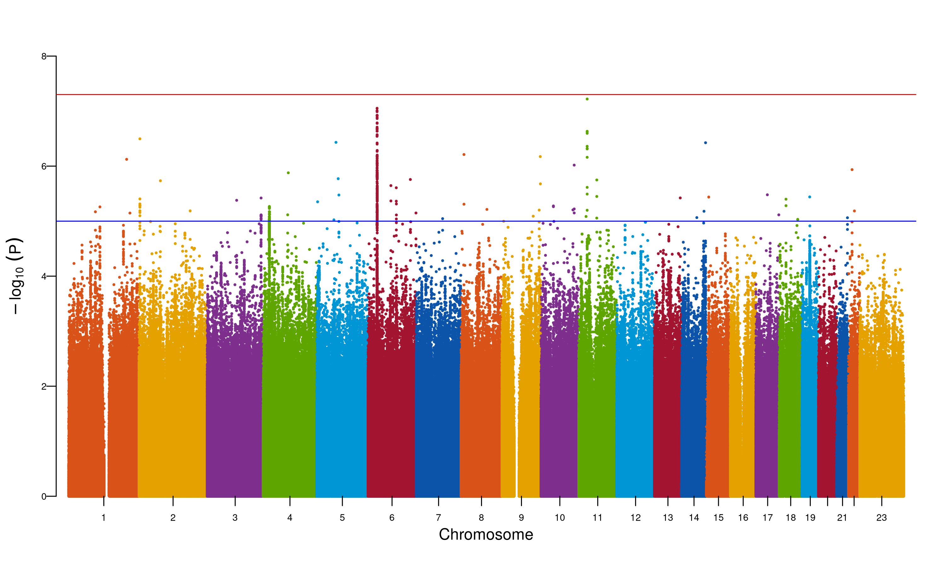

**Supplementary Figure 33. Manhattan plot for MR-MEGA meta-analysis for N06A.** The Manhattan plot shows the association of SNPs with the antidepressant phenotype N06A. The x-axis represents the chromosomal position of the SNP, and the y-axis represents the -log10(p-value) of the association. The red line represents the genome-wide significance threshold (p-value = 5e-8). The blue line represents the suggestive significance threshold (p-value = 1e-5).

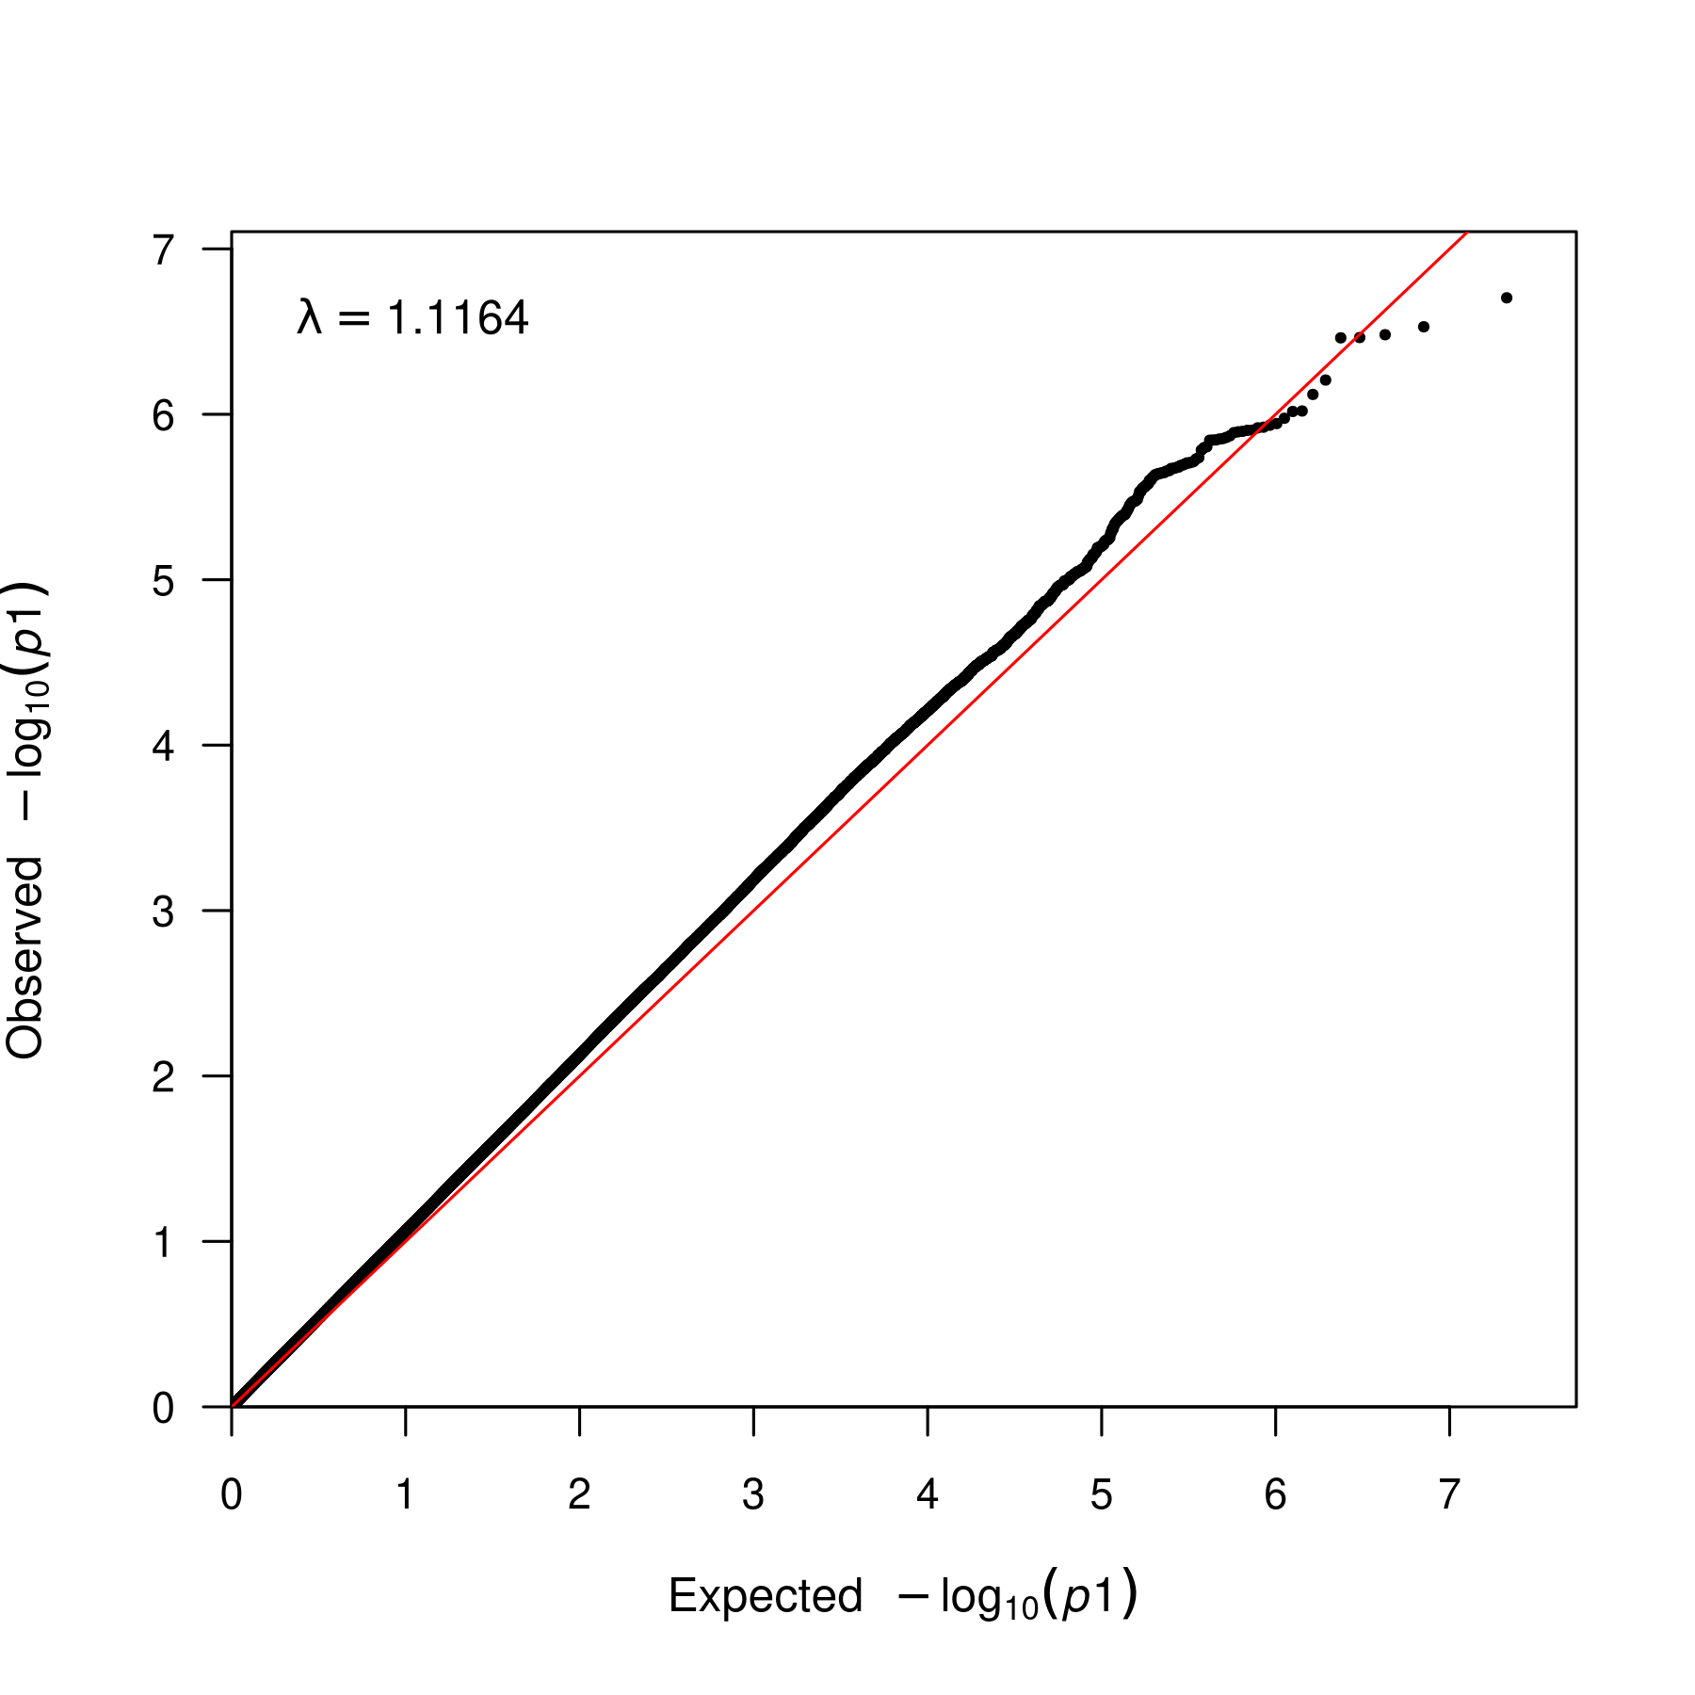

**Supplementary Figure 34. QQ plot for MR-MEGA meta-analysis for N06A.** QQ plot for the association of SNPs with the antidepressant phenotype N06A. The x-axis represents the expected -log10(p-value) of the association, and the y-axis represents the observed -log10(p-value) of the association. The lambda statistic (a measure of inflated p-values) is also reported on the plot.

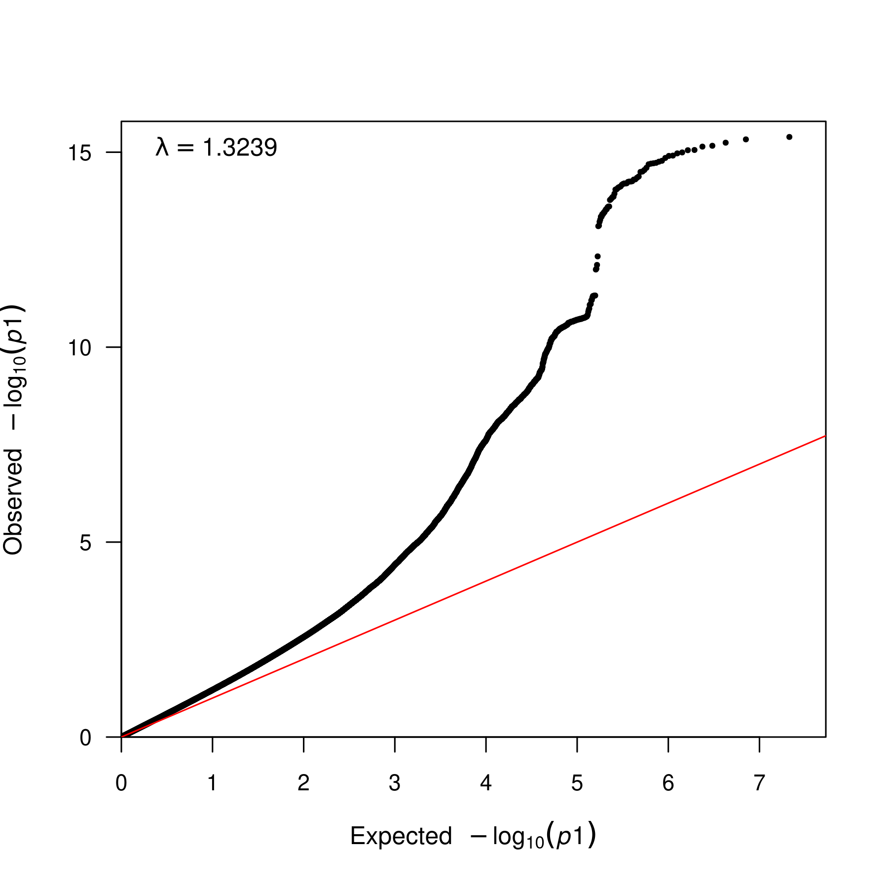

**Supplementary Figure 35. QQ plot for MR-MEGA meta-analysis for N06A.** QQ plot for the association of SNPs with the antidepressant phenotype N06A. The x-axis represents the expected -log10(p-value) of the association, and the y-axis represents the observed -log10(p-value) of the association. The lambda statistic (a measure of inflated p-values) is also reported on the plot.

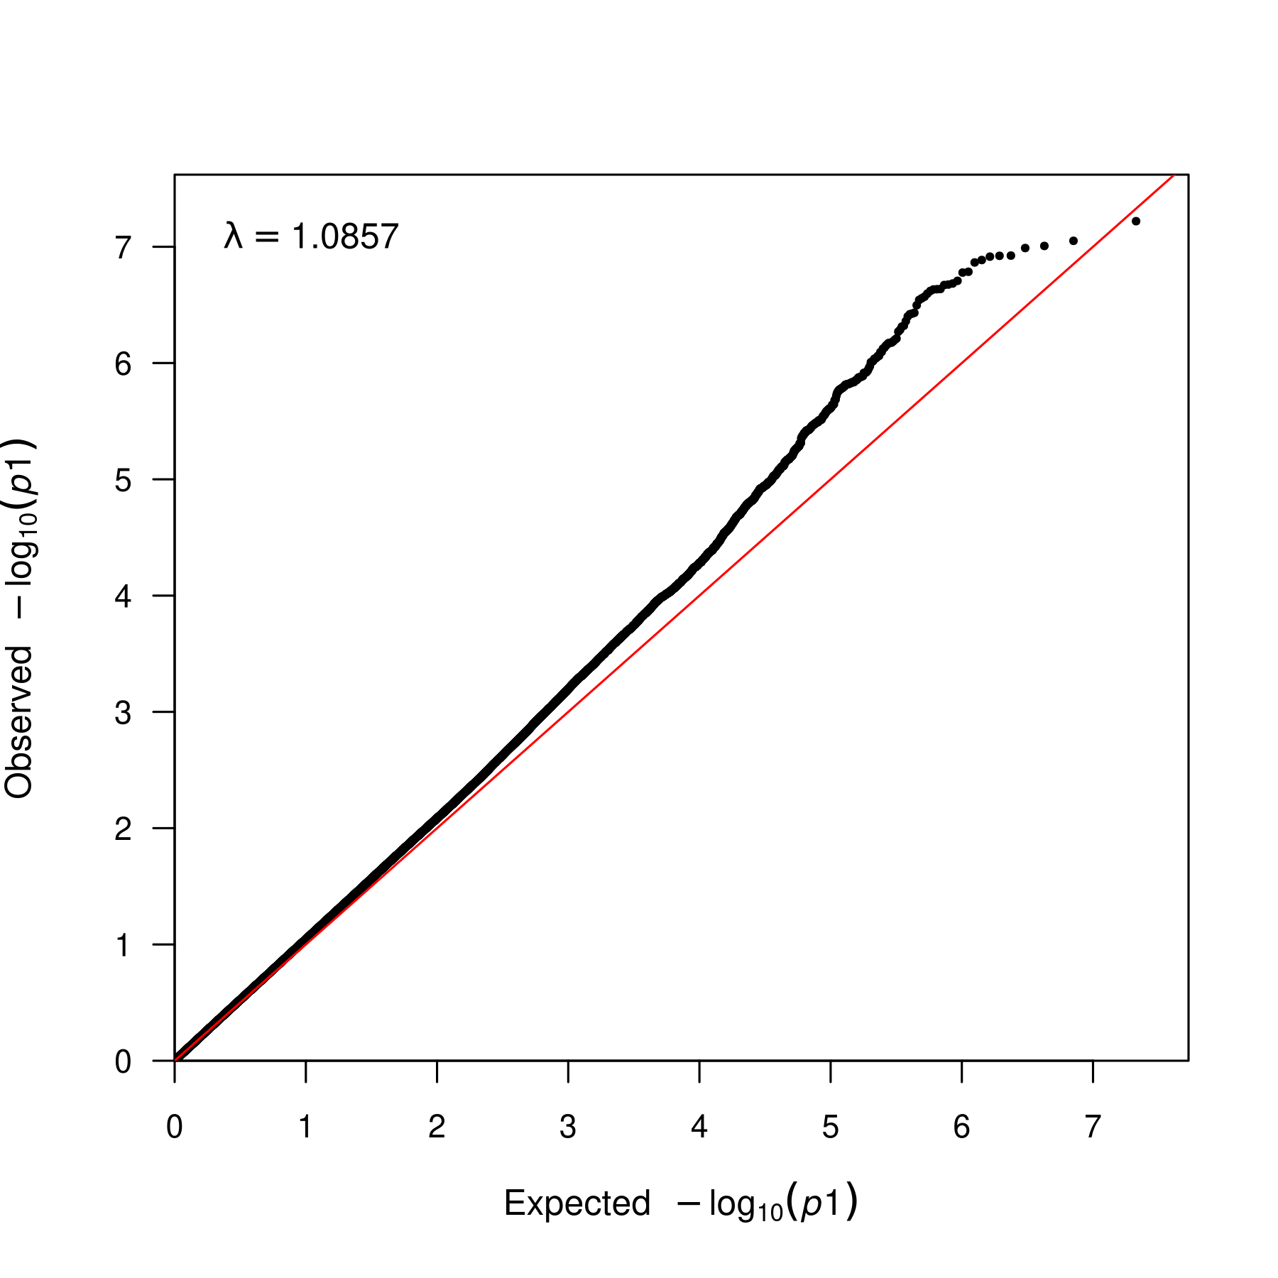

**Supplementary Figure 36. QQ plot for MR-MEGA meta-analysis for N06A.** QQ plot for the association of SNPs with the antidepressant phenotype N06A. The x-axis represents the expected -log10(p-value) of the association, and the y-axis represents the observed -log10(p-value) of the association. The lambda statistic (a measure of inflated p-values) is also reported on the plot.

### N06AA multi-ancestry meta-analyses

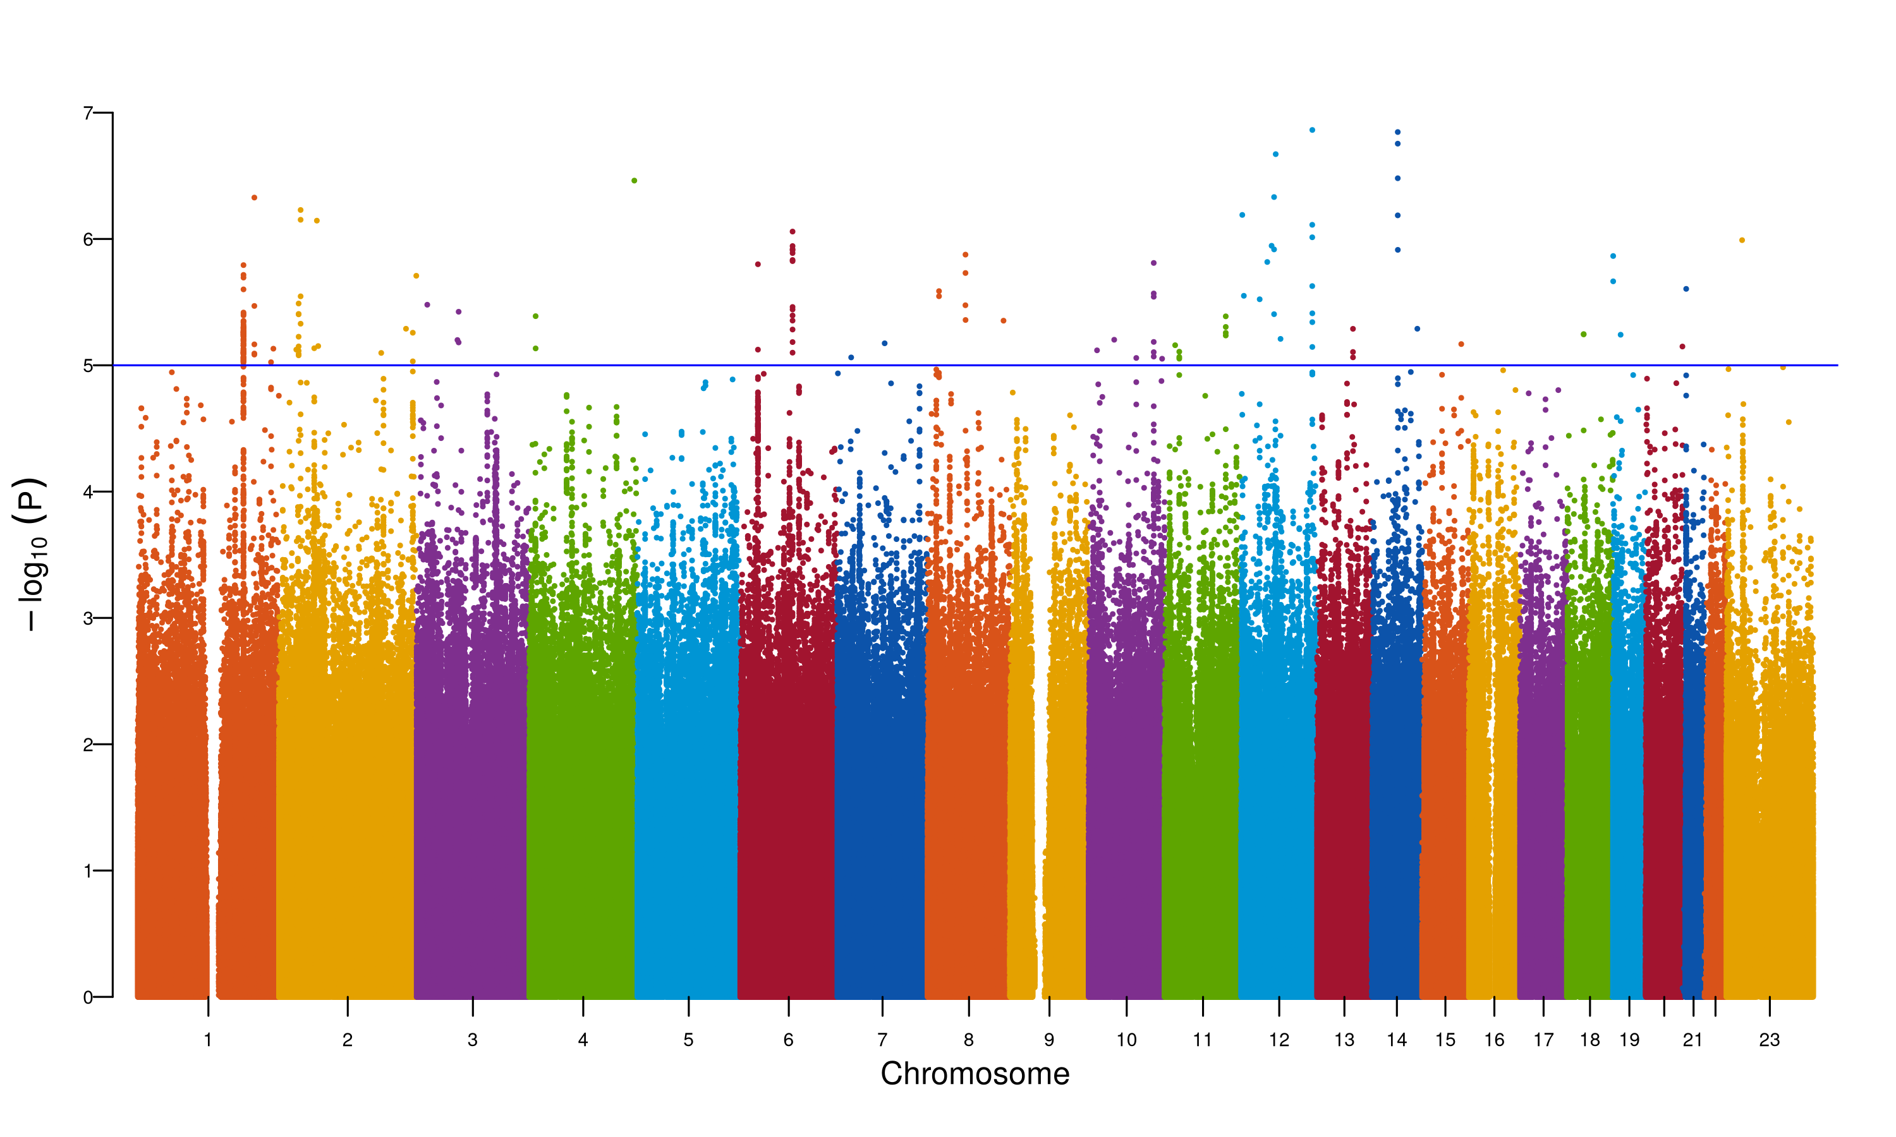

**Supplementary Figure 37. Manhattan plot for MR-MEGA meta-analysis for N06AA.** The Manhattan plot shows the association of SNPs with the antidepressant phenotype N06AA. The x-axis represents the chromosomal position of the SNP, and the y-axis represents the -log10(p-value) of the association. The red line represents the genome-wide significance threshold (p-value = 5e-8). The blue line represents the suggestive significance threshold (p-value = 1e-5).

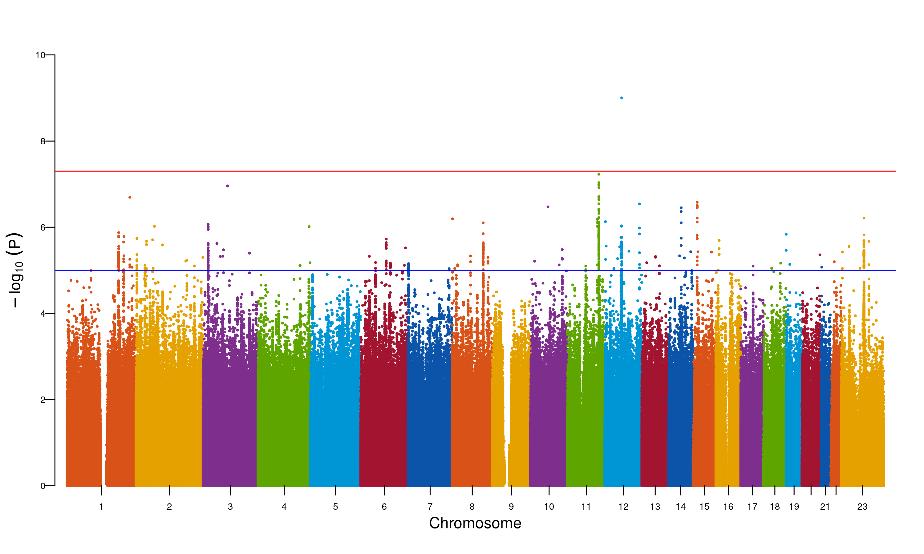

**Supplementary Figure 38. Manhattan plot for MR-MEGA meta-analysis for N06AA.** The Manhattan plot shows the association of SNPs with the antidepressant phenotype N06AA. The x-axis represents the chromosomal position of the SNP, and the y-axis represents the -log10(p-value) of the association. The red line represents the genome-wide significance threshold (p-value = 5e-8). The blue line represents the suggestive significance threshold (p-value = 1e-5).

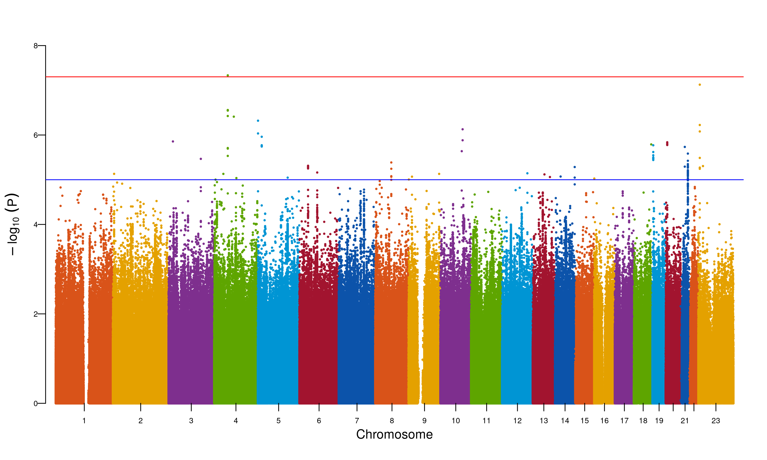

**Supplementary Figure 39. Manhattan plot for MR-MEGA meta-analysis for N06AA.** The Manhattan plot shows the association of SNPs with the antidepressant phenotype N06AA. The x-axis represents the chromosomal position of the SNP, and the y-axis represents the -log10(p-value) of the association. The red line represents the genome-wide significance threshold (p-value = 5e-8). The blue line represents the suggestive significance threshold (p-value = 1e-5).

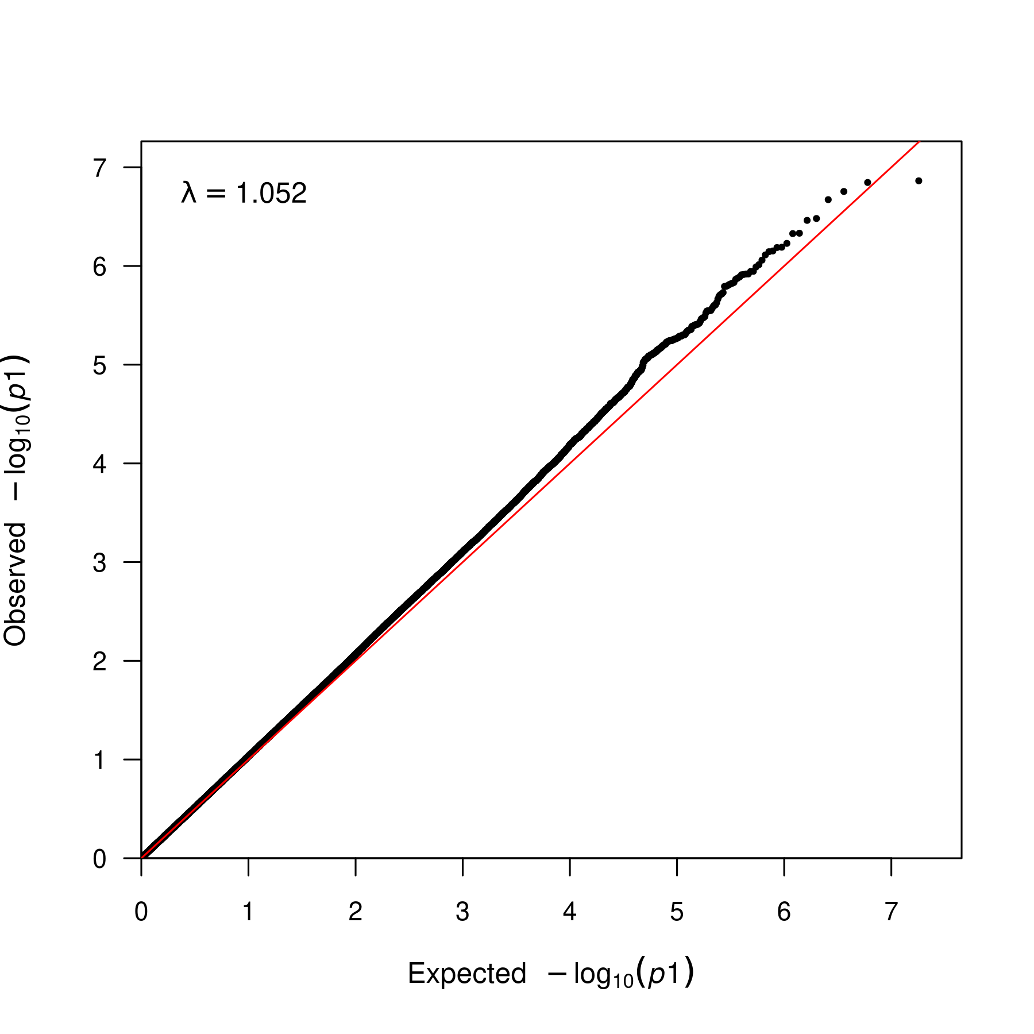

**Supplementary Figure 40. QQ plot for MR-MEGA meta-analysis for N06AA.** QQ plot for the association of SNPs with the antidepressant phenotype N06AA. The x-axis represents the expected -log10(p-value) of the association, and the y-axis represents the observed -log10(p-value) of the association. The lambda statistic (a measure of inflated p-values) is also reported on the plot.

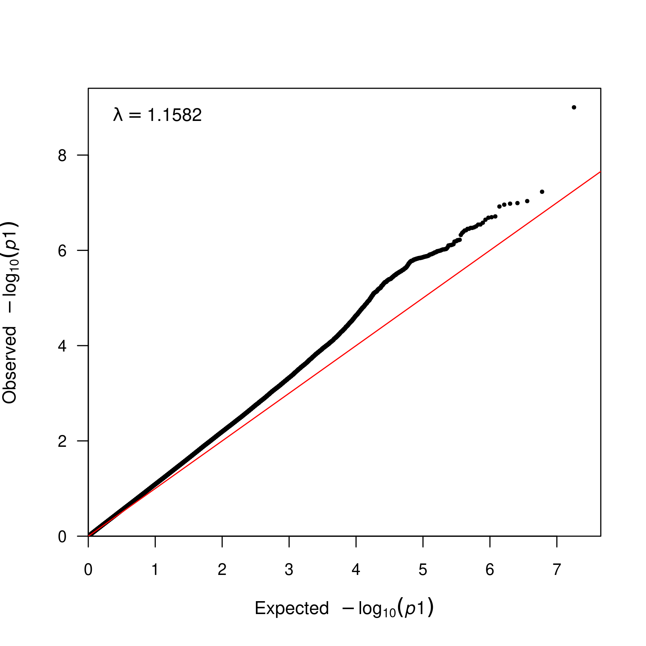

**Supplementary Figure 41. QQ plot for MR-MEGA meta-analysis for N06AA.** QQ plot for the association of SNPs with the antidepressant phenotype N06AA. The x-axis represents the expected -log10(p-value) of the association, and the y-axis represents the observed -log10(p-value) of the association. The lambda statistic (a measure of inflated p-values) is also reported on the plot.

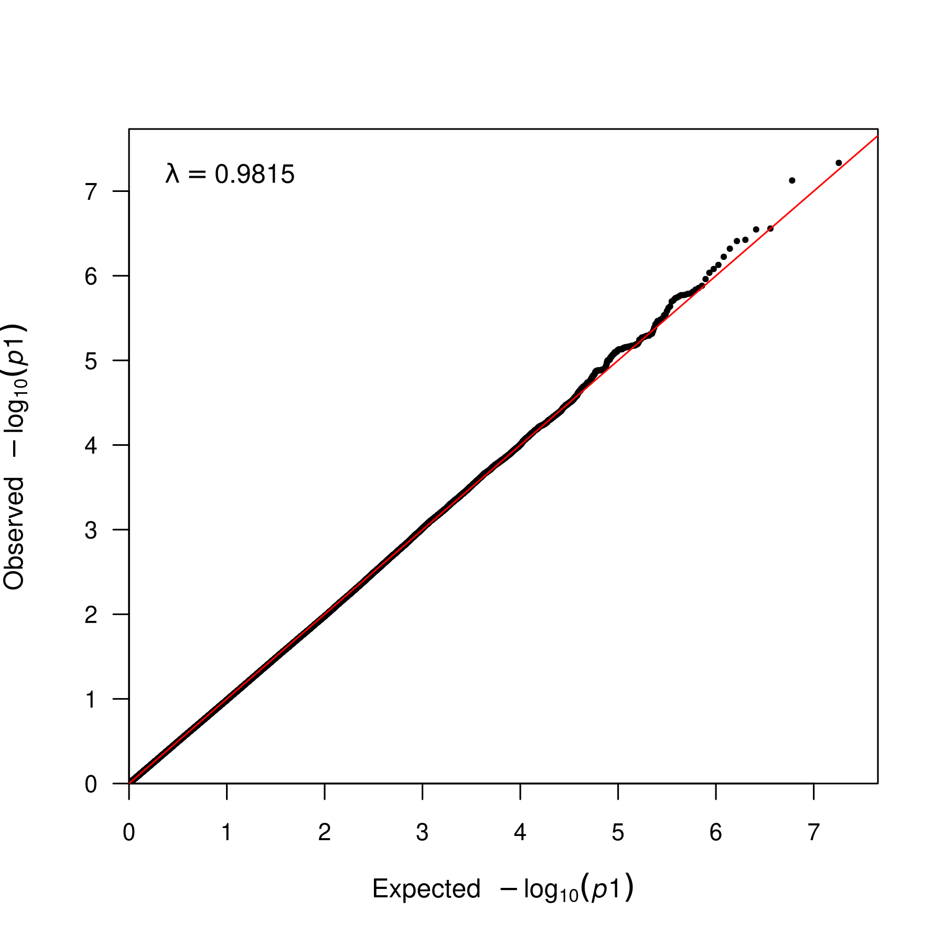

**Supplementary Figure 42. QQ plot for MR-MEGA meta-analysis for N06AA.** QQ plot for the association of SNPs with the antidepressant phenotype N06AA. The x-axis represents the expected -log10(p-value) of the association, and the y-axis represents the observed -log10(p-value) of the association. The lambda statistic (a measure of inflated p-values) is also reported on the plot.

### N06AB multi-ancestry meta-analyses

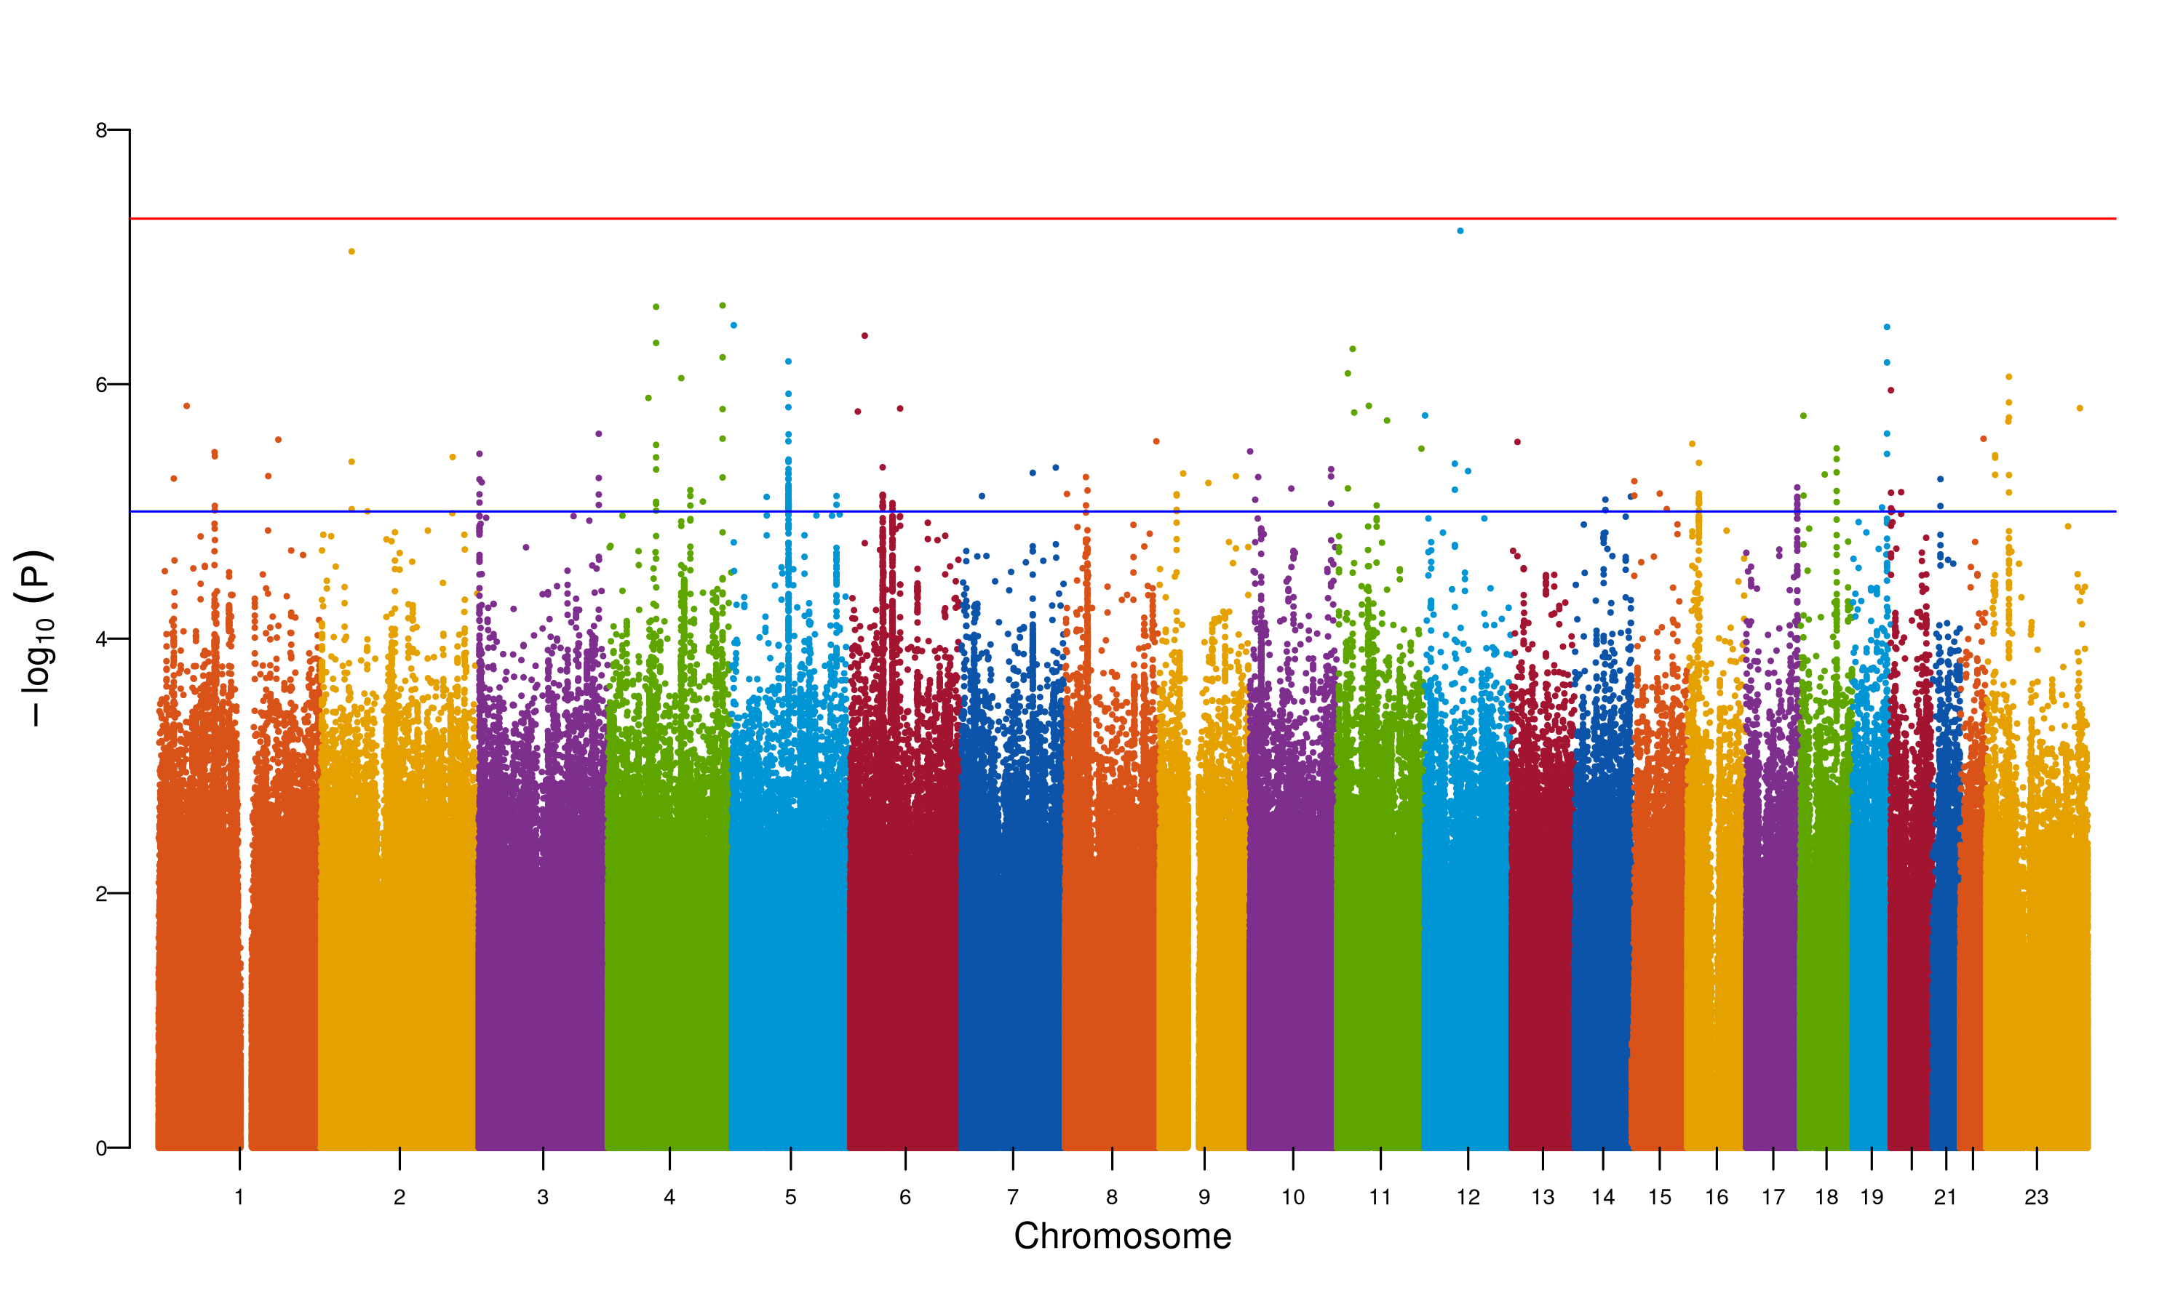

**Supplementary Figure 43. Manhattan plot for MR-MEGA meta-analysis for N06AB.** The Manhattan plot shows the association of SNPs with the antidepressant phenotype N06AB. The x-axis represents the chromosomal position of the SNP, and the y-axis represents the -log10(p-value) of the association. The red line represents the genome-wide significance threshold (p-value = 5e-8). The blue line represents the suggestive significance threshold (p-value = 1e-5).

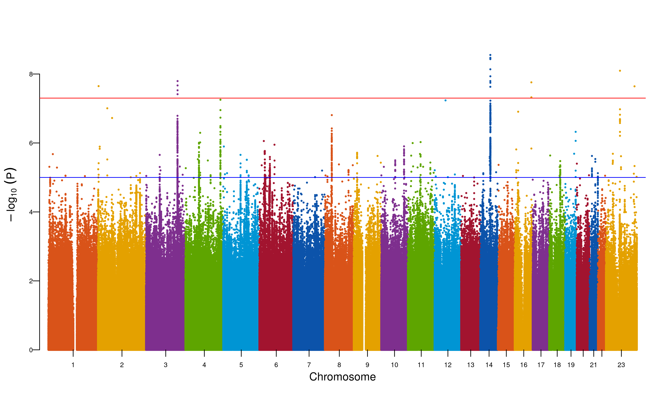

**Supplementary Figure 44. Manhattan plot for MR-MEGA meta-analysis for N06AB.** The Manhattan plot shows the association of SNPs with the antidepressant phenotype N06AB. The x-axis represents the chromosomal position of the SNP, and the y-axis represents the -log10(p-value) of the association. The red line represents the genome-wide significance threshold (p-value = 5e-8). The blue line represents the suggestive significance threshold (p-value = 1e-5).

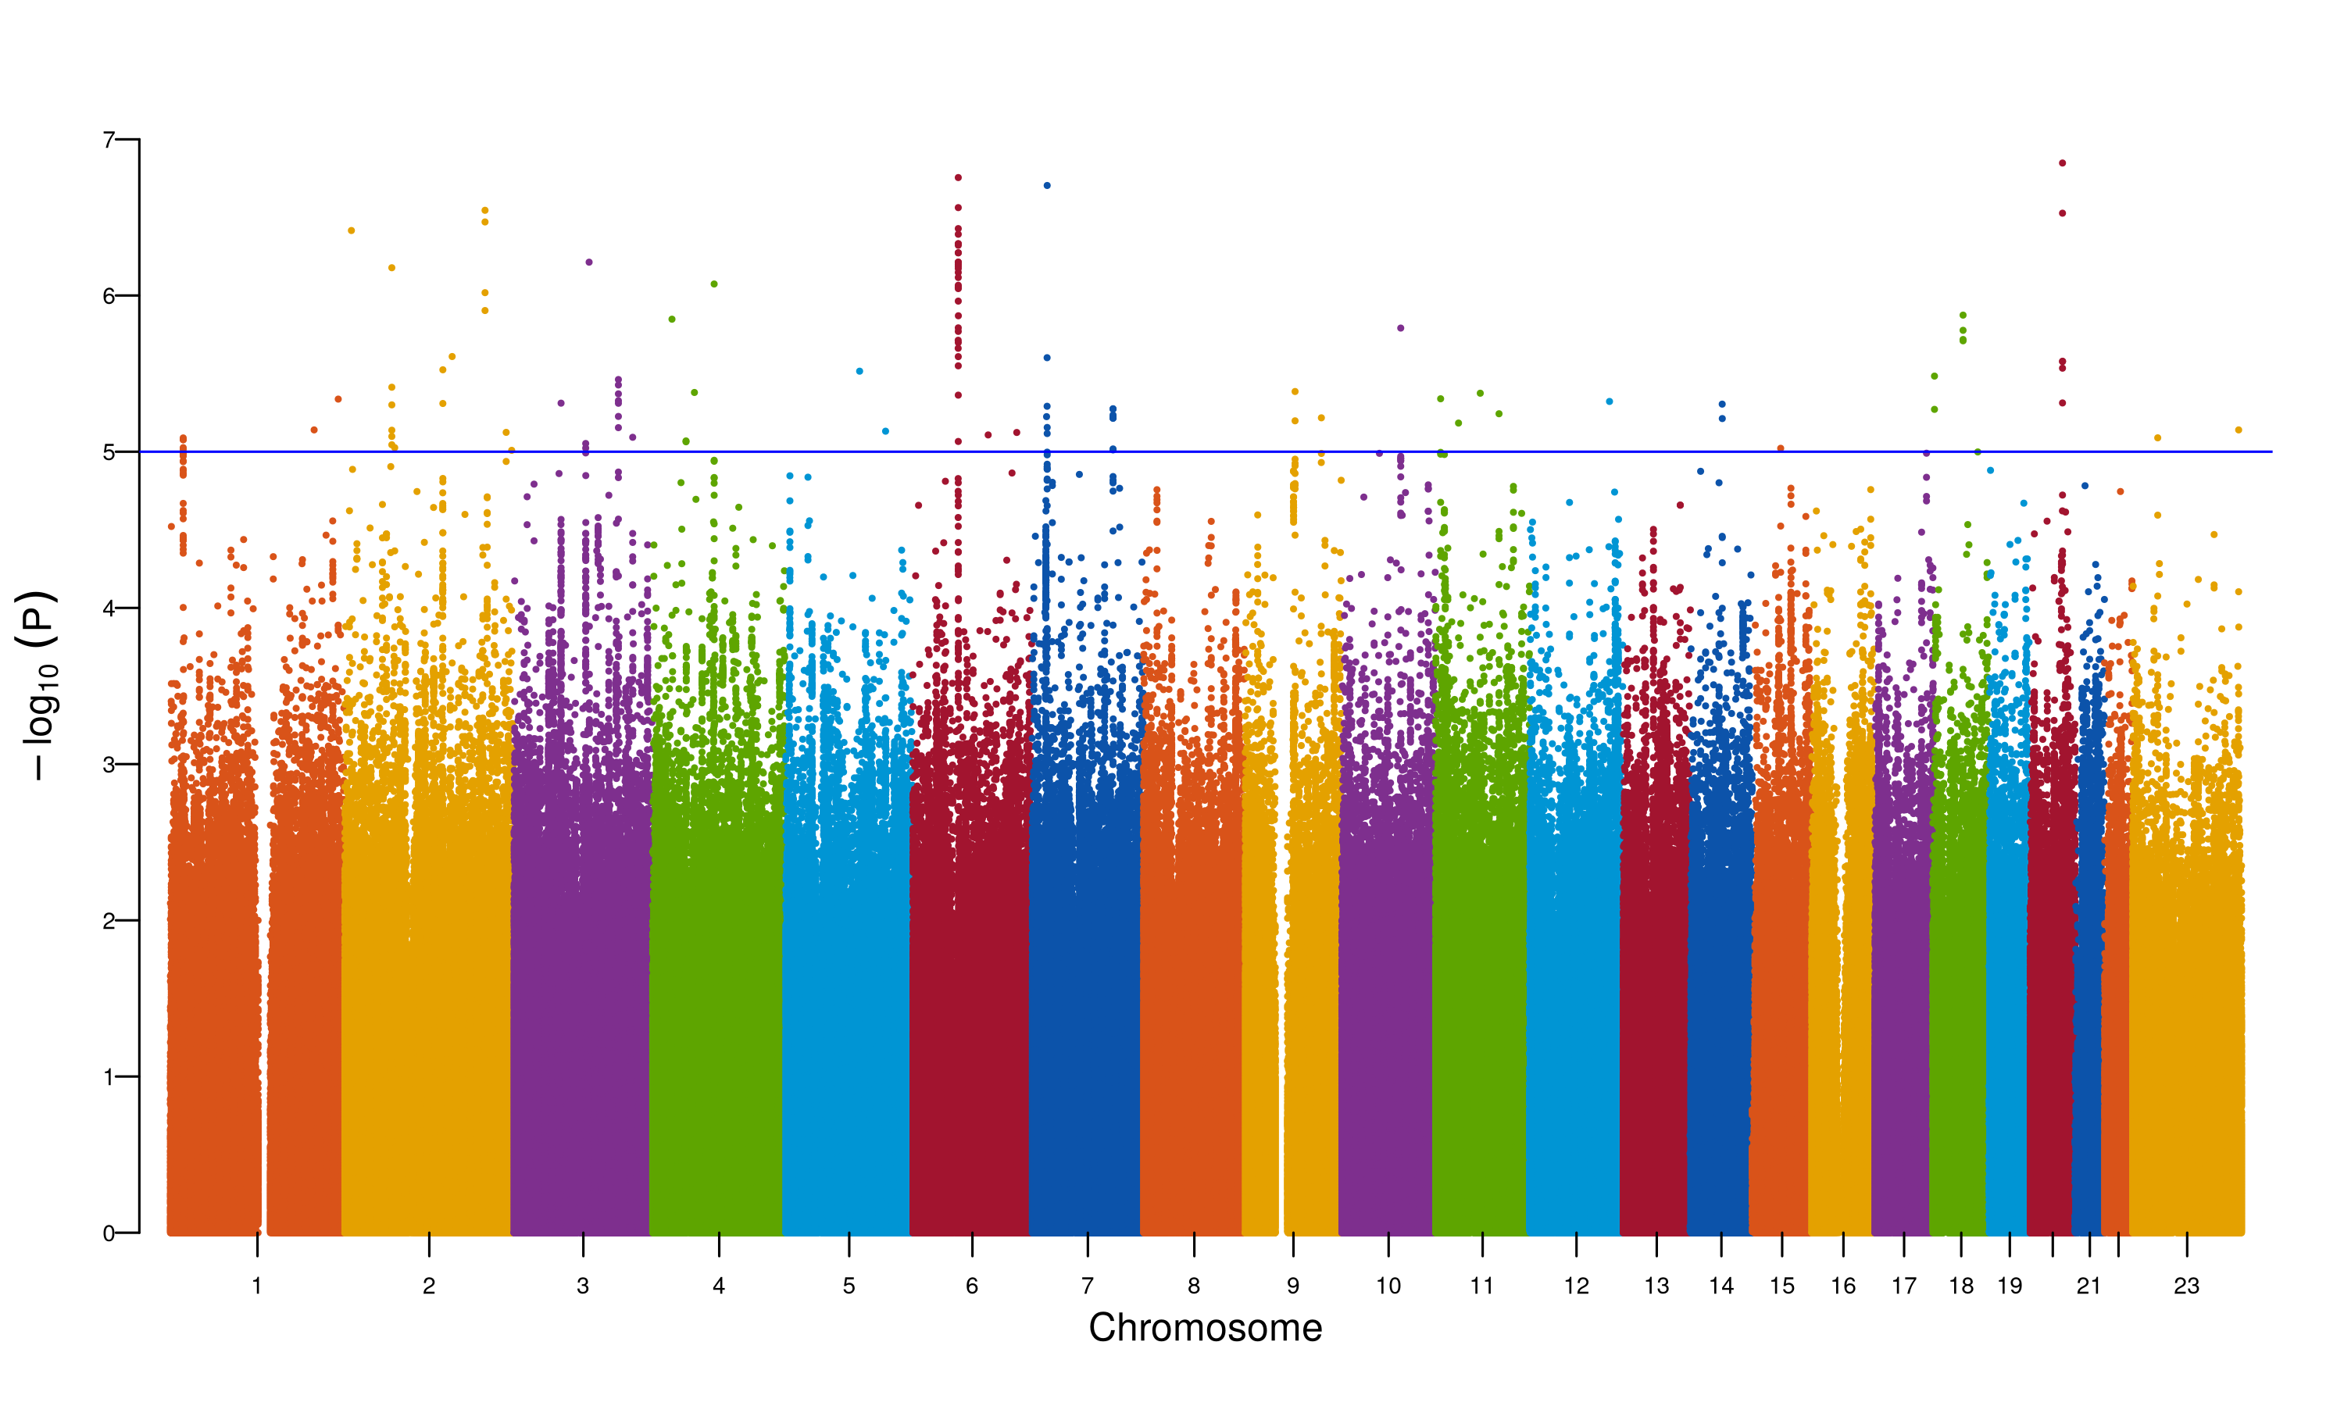

**Supplementary Figure 45. Manhattan plot for MR-MEGA meta-analysis for N06AB.** The Manhattan plot shows the association of SNPs with the antidepressant phenotype N06AB. The x-axis represents the chromosomal position of the SNP, and the y-axis represents the -log10(p-value) of the association. The red line represents the genome-wide significance threshold (p-value = 5e-8). The blue line represents the suggestive significance threshold (p-value = 1e-5).

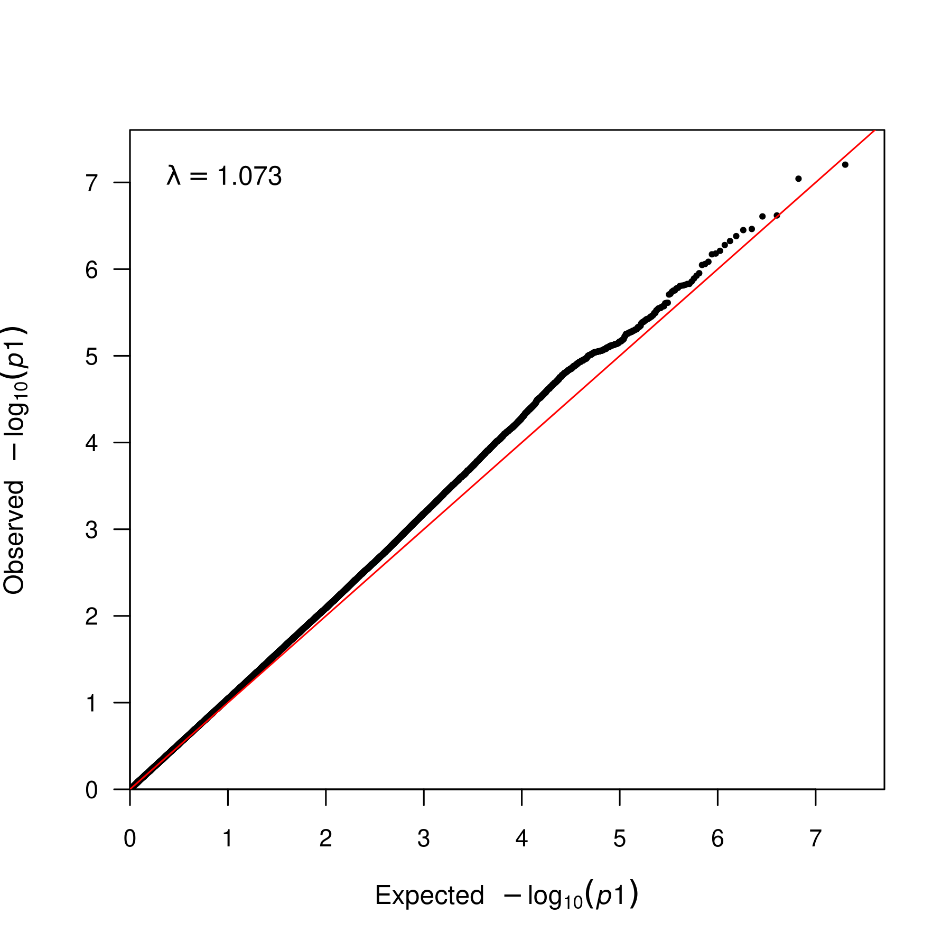

**Supplementary Figure 46. QQ plot for MR-MEGA meta-analysis for N06AB.** QQ plot for the association of SNPs with the antidepressant phenotype N06AB. The x-axis represents the expected -log10(p-value) of the association, and the y-axis represents the observed -log10(p-value) of the association. The lambda statistic (a measure of inflated p-values) is also reported on the plot.

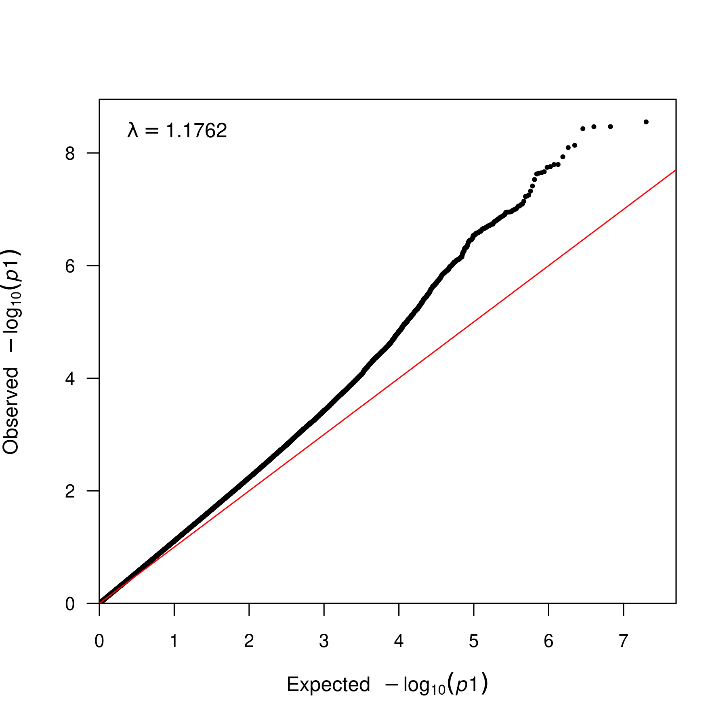

**Supplementary Figure 47. QQ plot for MR-MEGA meta-analysis for N06AB.** QQ plot for the association of SNPs with the antidepressant phenotype N06AB. The x-axis represents the expected -log10(p-value) of the association, and the y-axis represents the observed -log10(p-value) of the association. The lambda statistic (a measure of inflated p-values) is also reported on the plot.

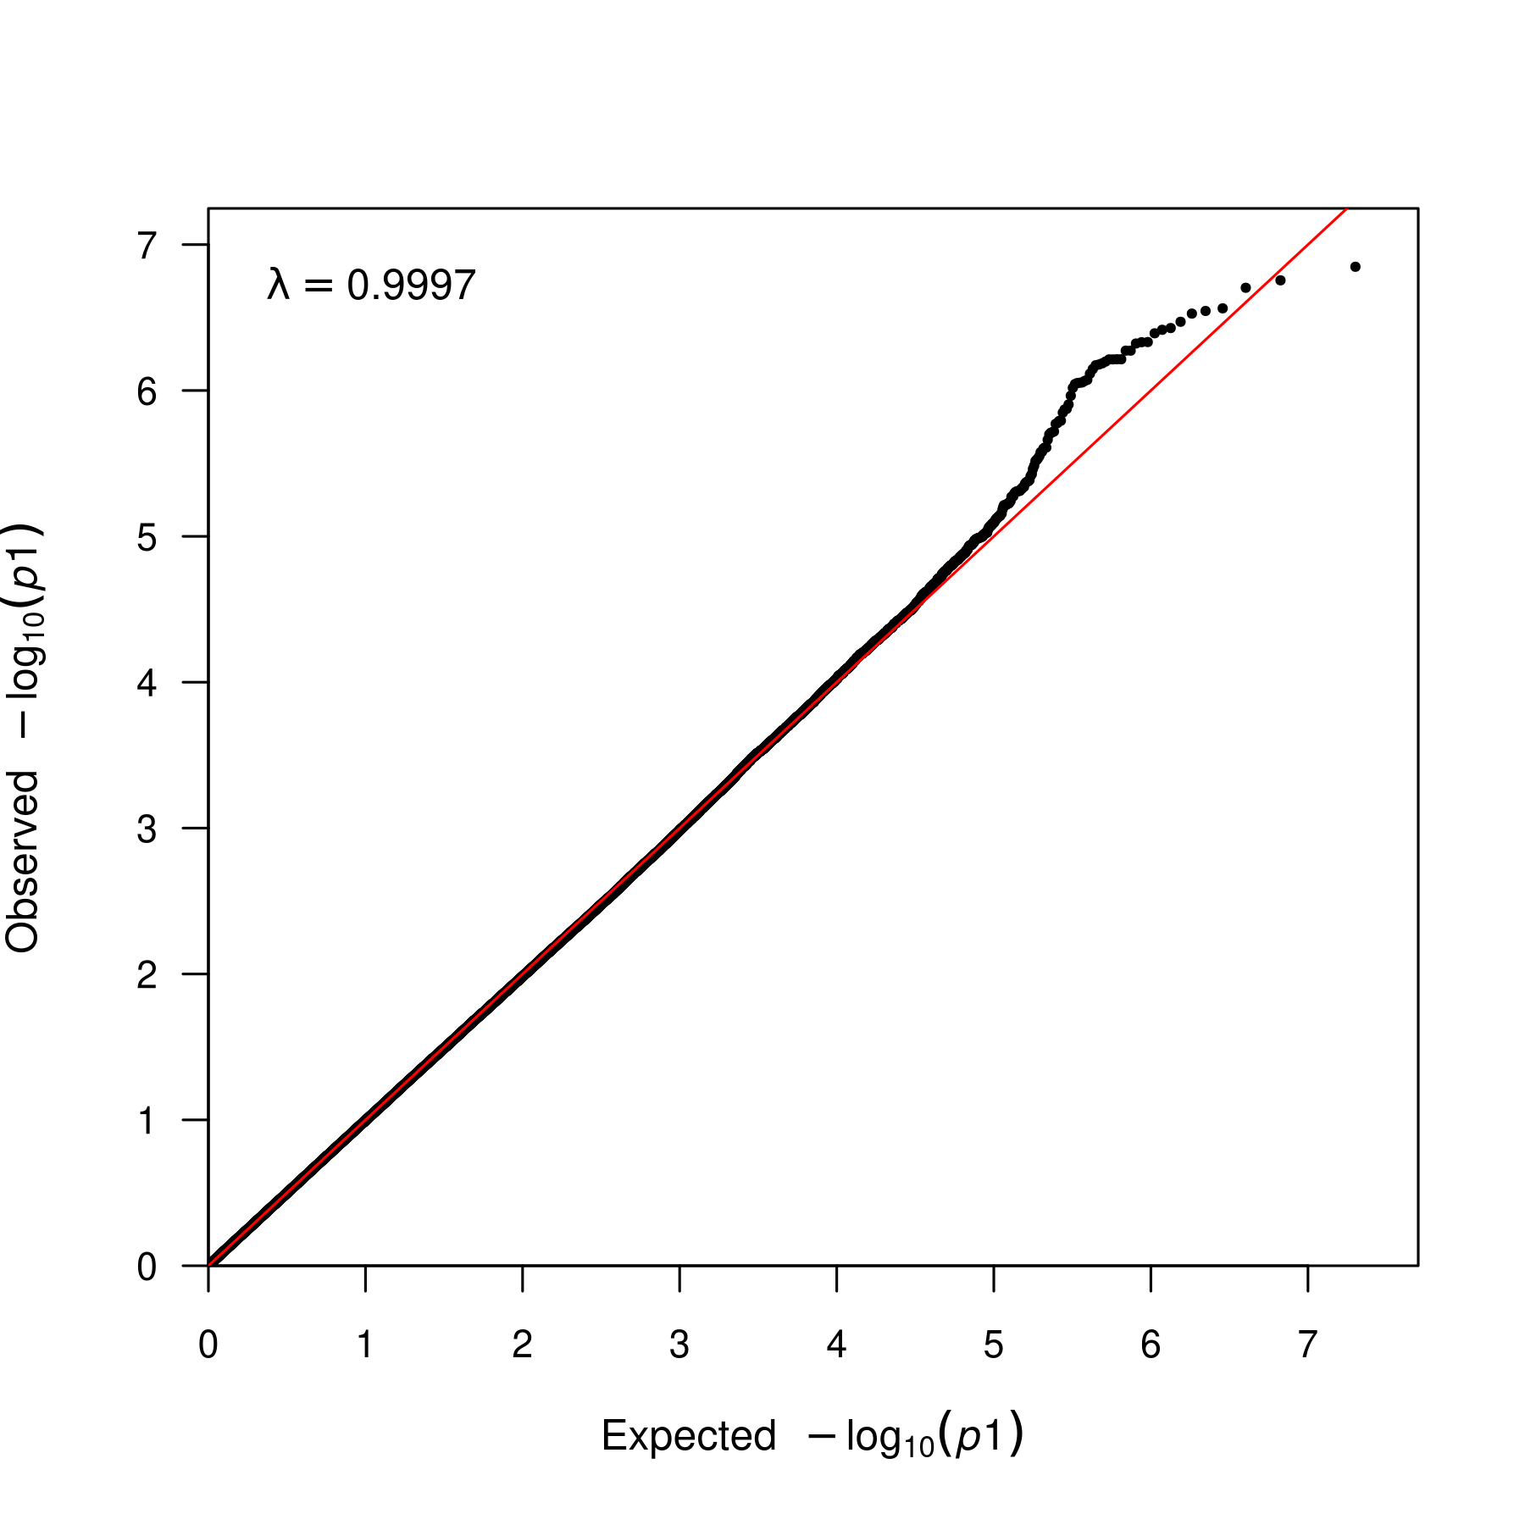

**Supplementary Figure 48. QQ plot for MR-MEGA meta-analysis for N06AB.** QQ plot for the association of SNPs with the antidepressant phenotype N06AB. The x-axis represents the expected -log10(p-value) of the association, and the y-axis represents the observed -log10(p-value) of the association. The lambda statistic (a measure of inflated p-values) is also reported on the plot.

## Fine-mapping using SuSiEx

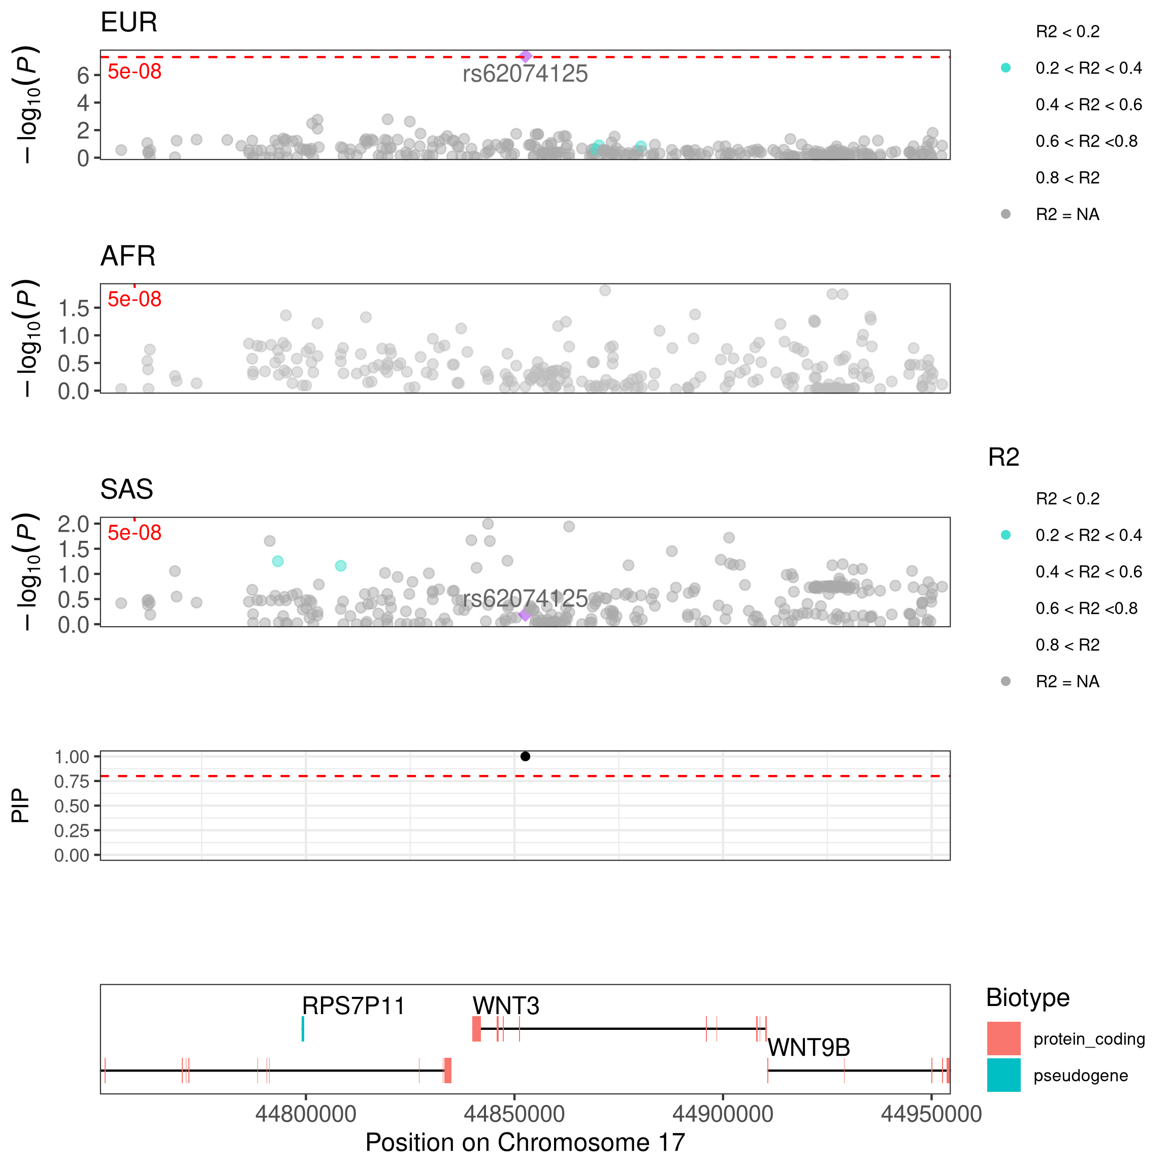

**Supplementary Figure 49. Locus zoom region plot of EUR, AFR, SAS N06A meta-analyses and credible sets for region 17:44752612:44952612.** Locus zoom region plot shows association of SNPs with the antidepressant phenotype N06A zoomed to the region 17:44752612:44952612 for each ancestry (EUR, AFR and SAS). The output from SuSiEx shows the Posterior Inclusion Probability (PIP). The horizontal red line on the credible set plot represents the threshold at which a credible set is defined and SNPs are considered potentially causal (PIP > 0.8), these SNPs are highlighted in the locus zoom plots.

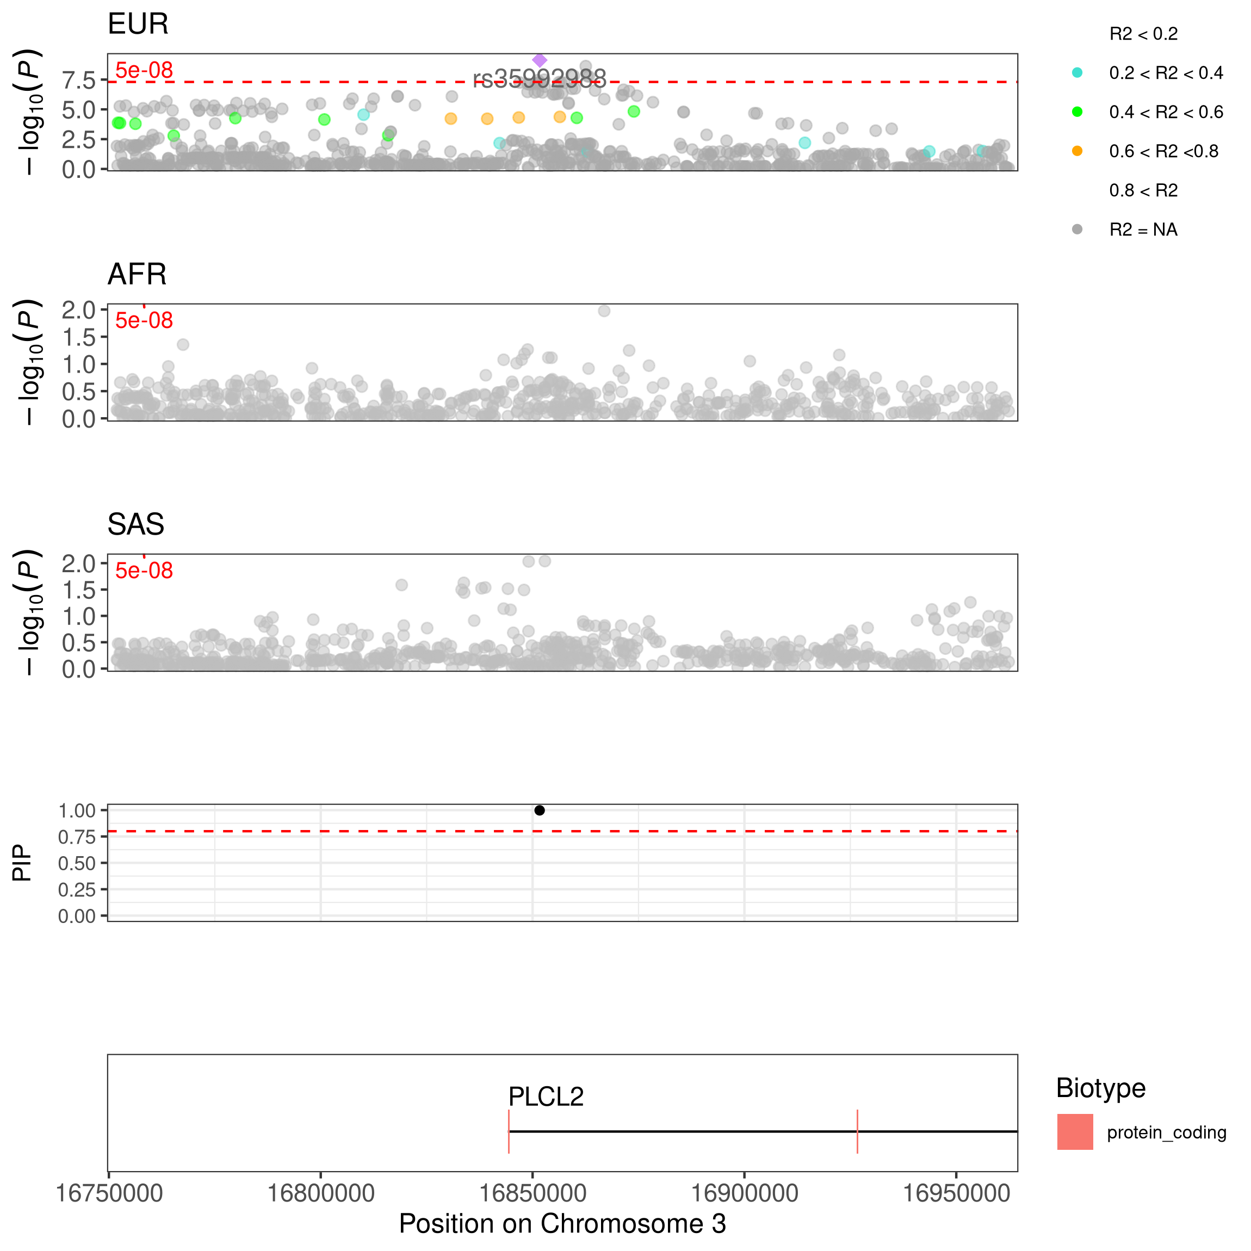

**Supplementary Figure 50. Locus zoom region plot of EUR, AFR, SAS N06A meta-analyses and credible sets for region 3:16751665:16962555.** Locus zoom region plot shows association of SNPs with the antidepressant phenotype N06A zoomed to the region 3:16751665:16962555 for each ancestry (EUR, AFR and SAS). The output from SuSiEx shows the Posterior Inclusion Probability (PIP). The horizontal red line on the credible set plot represents the threshold at which a credible set is defined and SNPs are considered potentially causal (PIP > 0.8), these SNPs are highlighted in the locus zoom plots.

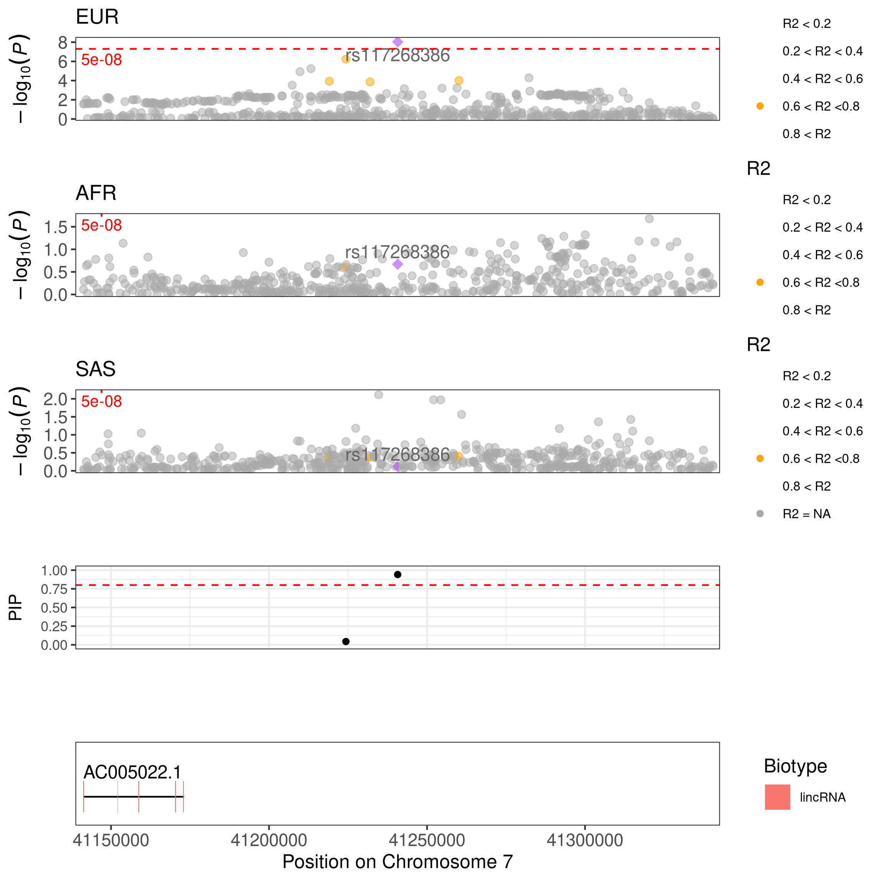

**Supplementary Figure 51. Locus zoom region plot of EUR, AFR, SAS N06A meta-analyses and credible sets for region 7:41140716:41340716.** Locus zoom region plot shows association of SNPs with the antidepressant phenotype N06A zoomed to the region 7:41140716:41340716 for each ancestry (EUR, AFR and SAS). The output from SuSiEx shows the Posterior Inclusion Probability (PIP). The horizontal red line on the credible set plot represents the threshold at which a credible set is defined and SNPs are considered potentially causal (PIP > 0.8), these SNPs are highlighted in the locus zoom plots.